**MIDTERM TEAM PROJECT**

**FOOD INSPECTIONS ASSIGNMENT - A DATA ANALYST JOURNEY**

**PROJECT OVERVIEW:**

The Food Inspections Assignment involves the analysis of food inspection data from the Department of Health Services of two cities – Chicago and Dallas. This documentation provides a comprehensive overview of the project's key components, data sources, and deliverables.

**TEAM MEMBERS- GROUP 17:**

Anisha Gandhi

Anushka Paradkar

Dhir Thacker

Lakshmi Kumar

**DELIVERABLES:**

**Part 1:**

* Get data in a delimited format (Recommended TSV)
* Load data into Stage table(s) (Prefix stage tables as stg_)
* Perform data profiling (Ydata profiling / Alteryx)

**Part 2**

* Design Dimensional Model
* Create DDL SQL script

**Part 3**

* Load dimensional model into Integration tables
* Using Talend read stage table(s) and load the model
* Name Dimensions and Facts with appropriate prefix such as dim_ / fact_

**Part 4**

* Create BI Dashboards

**DELIVERABLES - PART 1:**

**STEP 1:** GETTING THE DATA IN A DELIMITED FILE

Got the open data for Chicago and Dallas from the following links:

* **CHICAGO:** <https://data.cityofchicago.org/Health-Human-Services/Food-Inspections/4ijn-s7e5/data_preview>
* **DALLAS:** <https://www.dallasopendata.com/Services/Restaurant-and-Food-Establishment-Inspections-Octo/dri5-wcct/data_preview>

**STEP 2:** LOADING DATA INTO STAGE TABLES

Loaded the TSV file into Stage tables on Talend

**CHICAGO:**

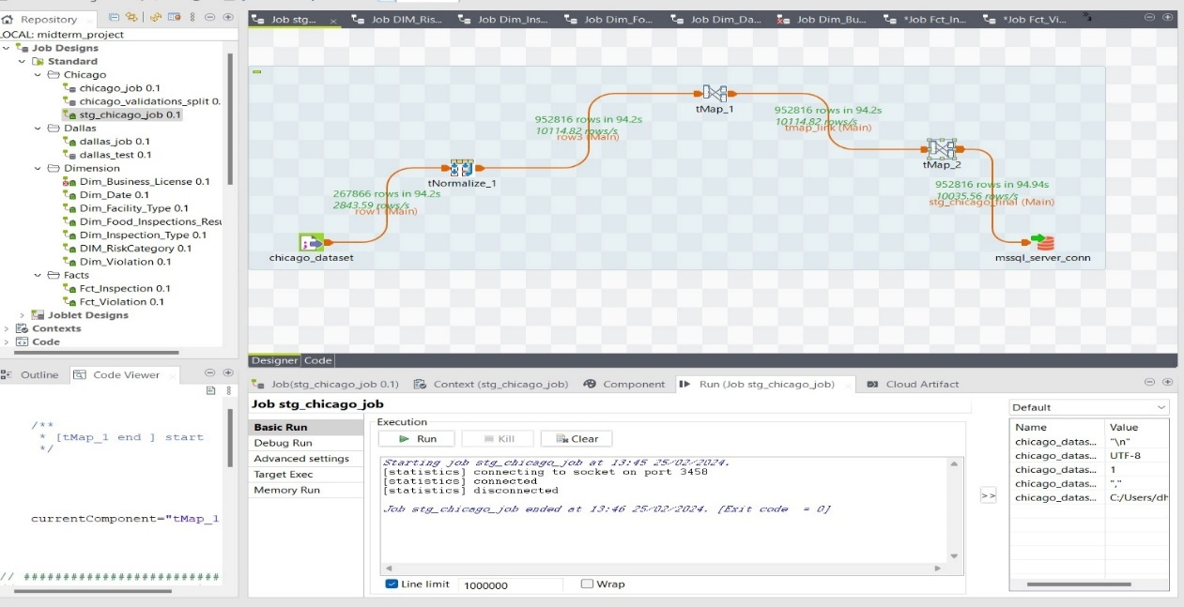

SQL OUTPUT:

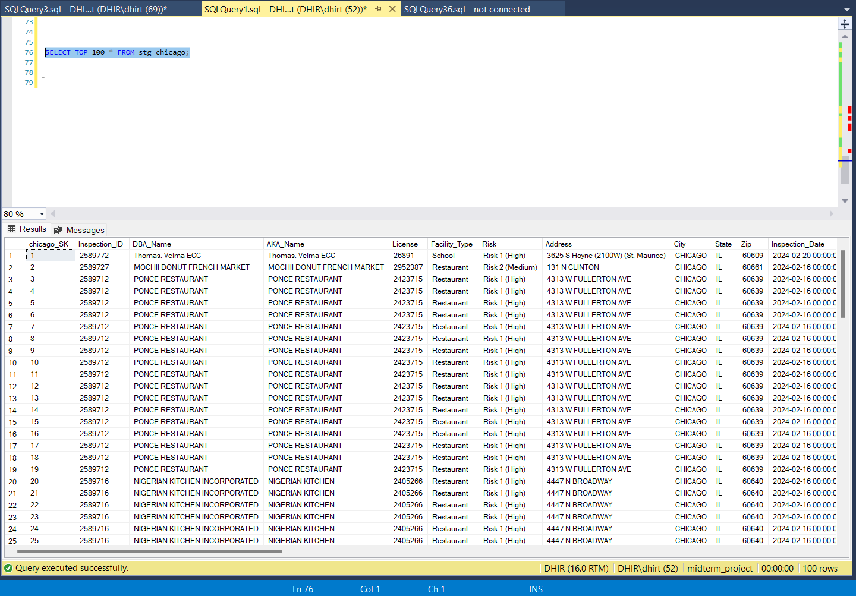

**COMPONENTS USED AND OBSERVATIONS:**

* Added the Chicago dataset in CSV format.
* Processed 952816 rows in 94.94 seconds.
* Used T-normalize to normalize data in Violations column. There was more than 1 violation found in the Violations cell, and hence we split it into 1 violation per record.

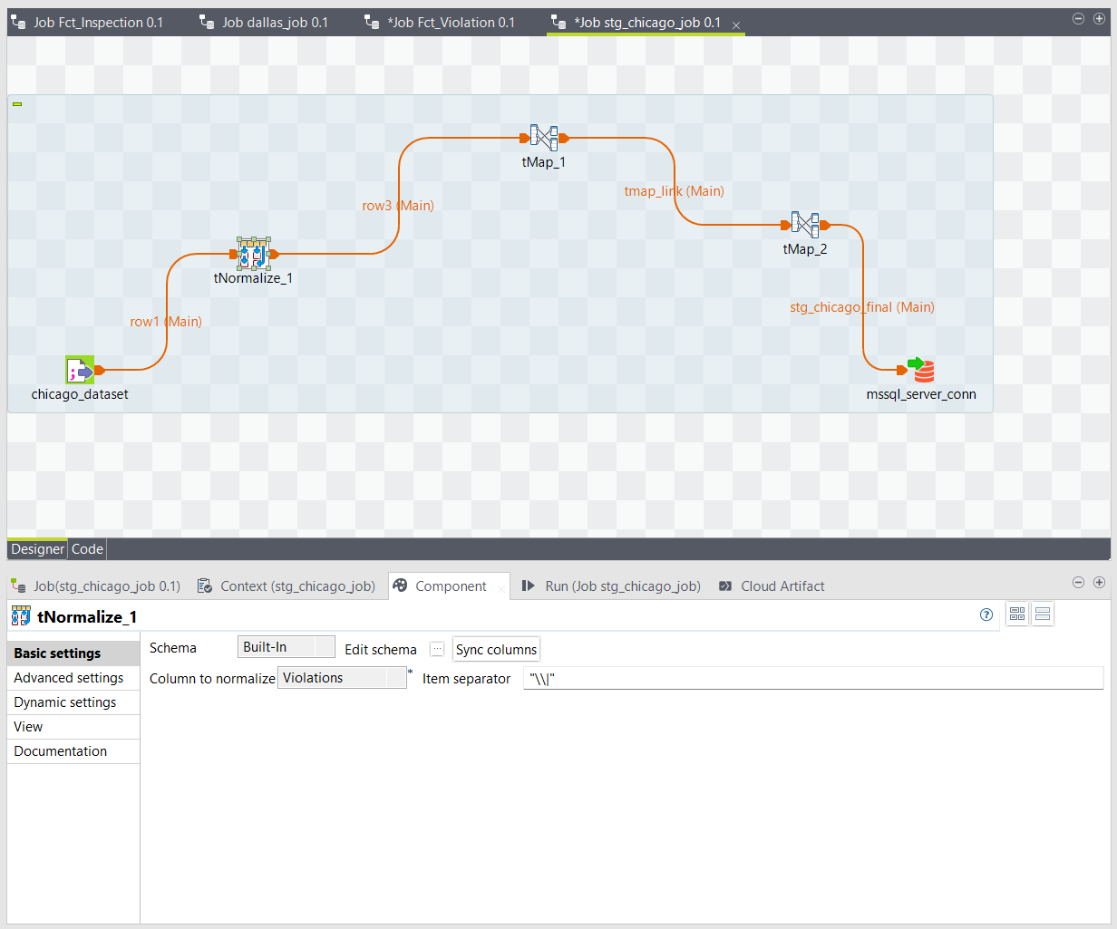

* Two T-map components have been used
* The first T-map: Added three functions (DI_Process_ID, DI_CurrentDate, DI_WorkflowFileName)- As shown in the below screenshots

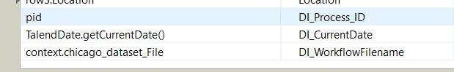

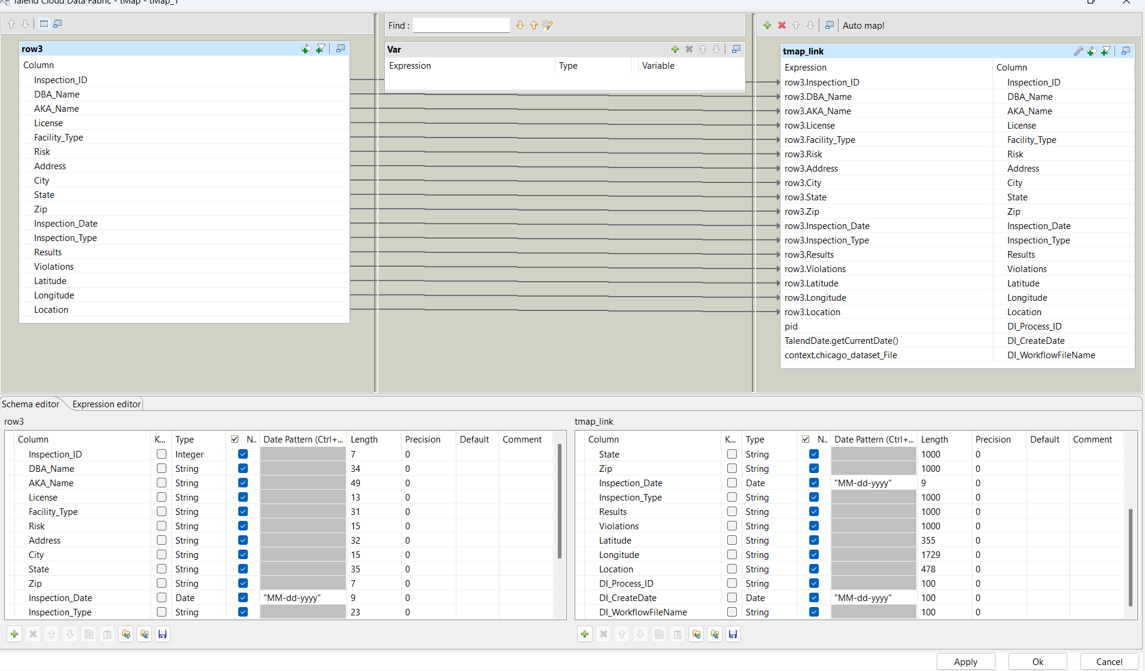

* Second T-map has been used to split the Violations into multiple columns (Violations, Violation Code, Violation Description, Violation Comment) – As shown in the below screenshot

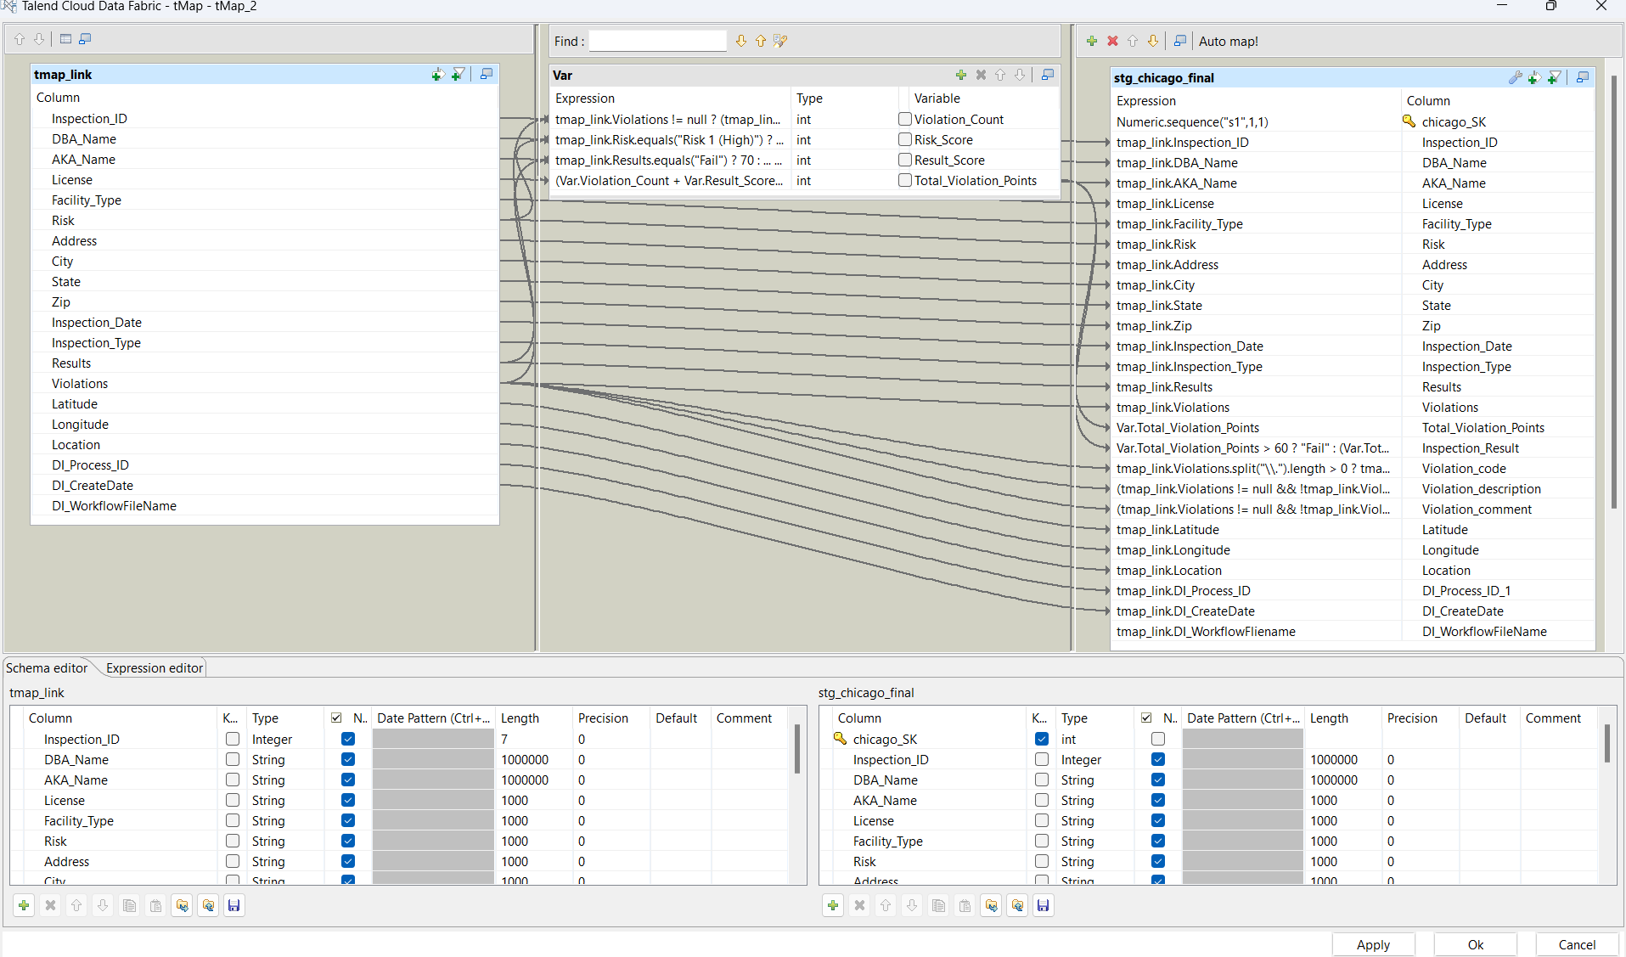

* Regex for Violation_Count, Risk_Score, Result_Score, Total_Violation_points.

Violation_Count

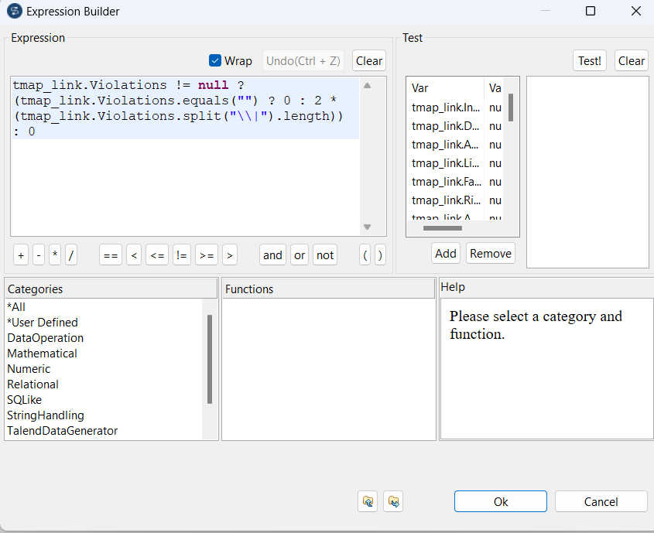

Risk_Score

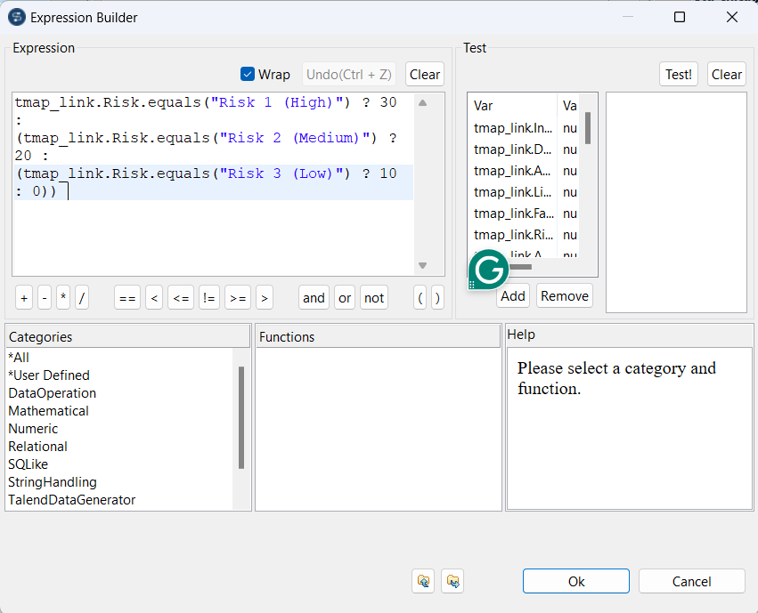

Result_Score

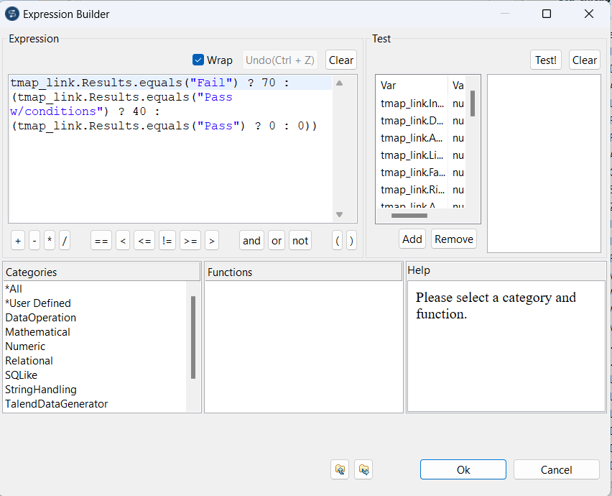

Total_Violation_Points

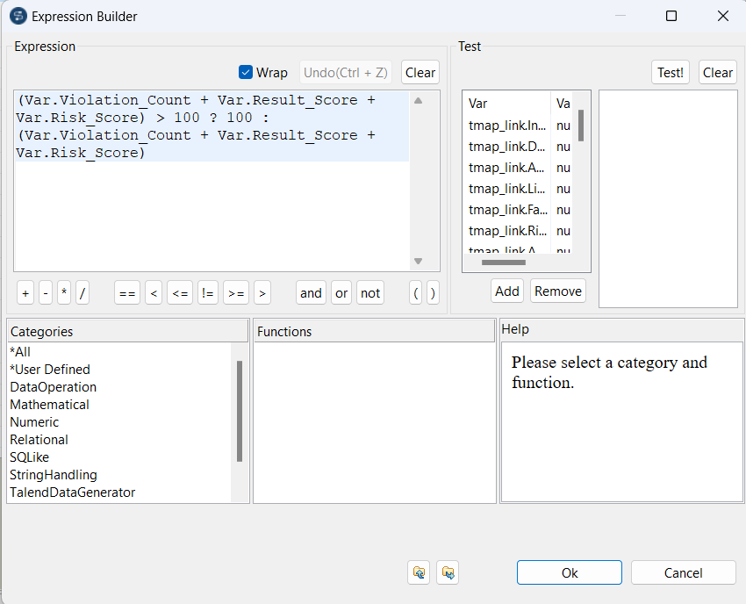

* Finally, everything has been mapped to the output server – Microsoft SQL Server

**DALLAS:**

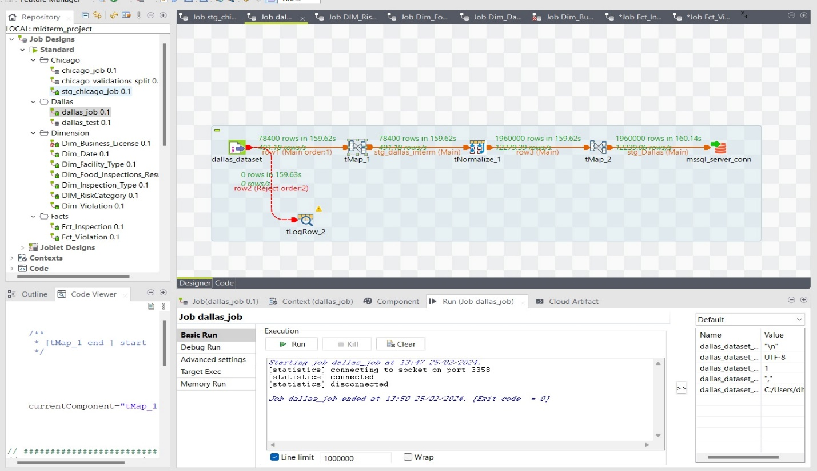

SQL OUTPUT:

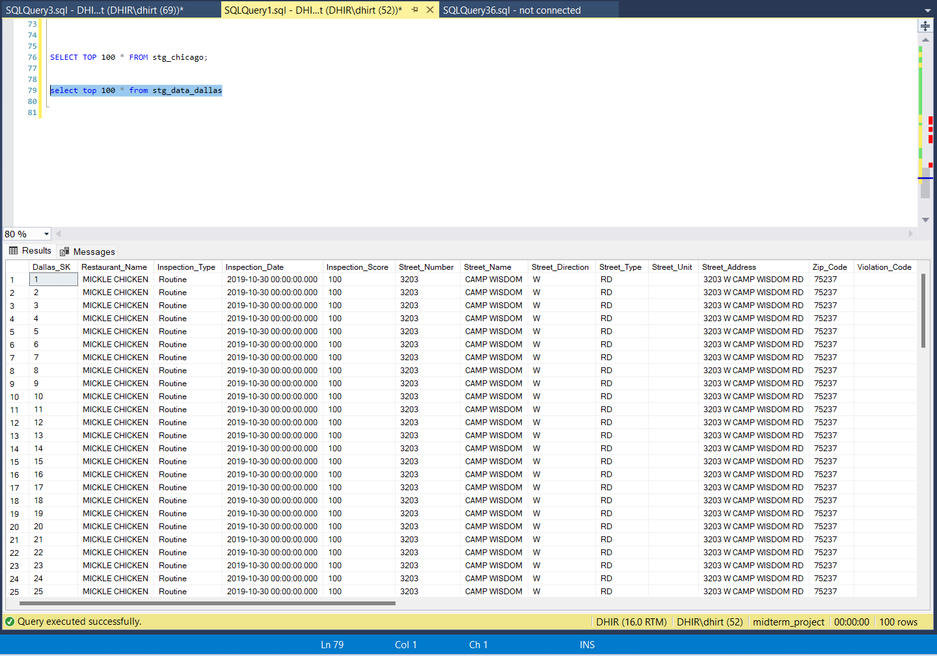

**COMPONENTS USED AND OBSERVATIONS:**

* Added the Dallas dataset in CSV format.
* Processed 1960000 rows in 160.14 seconds
* No reject rows have been found.
* Two T-map components have been used
* First T-map: All the violations are found in a split state in the CSV file (Violation Memo, Violation Detail, Violation Description, Violation Comment). Combines all of them into a single column (Violations All). Added a separate column (Violation Points) for calculations. – As shown in the below screenshot

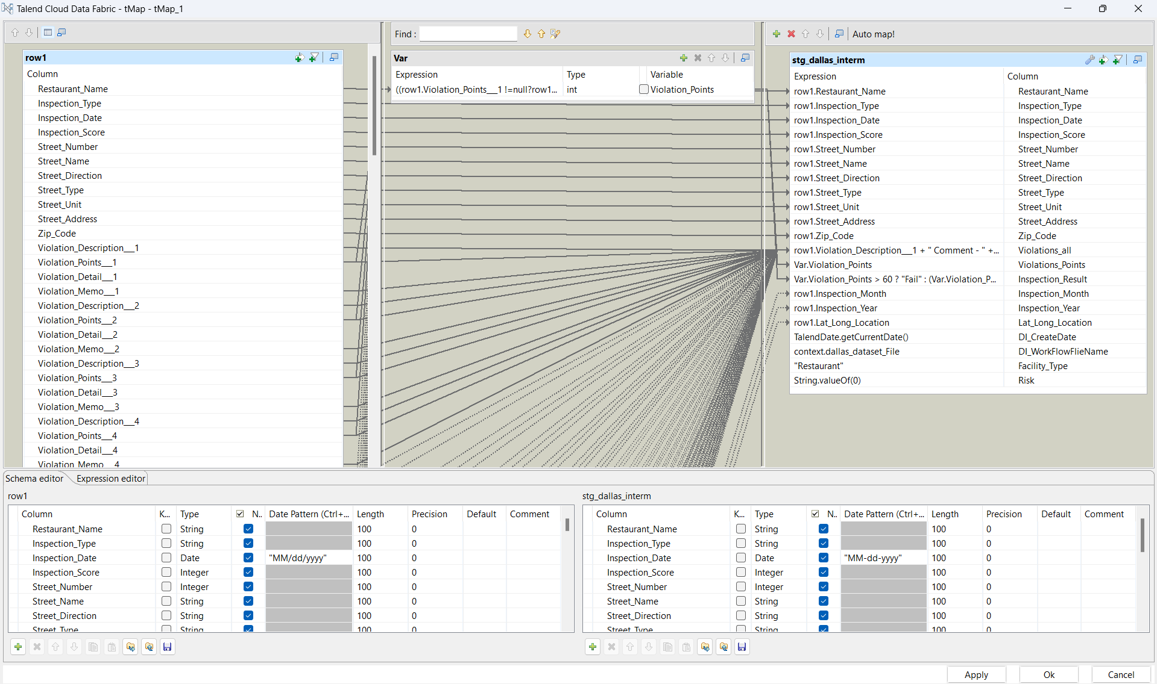

* Used the t-normalize component to Split the Violations in a cleaner manner, using item separator symbol ("\\|").

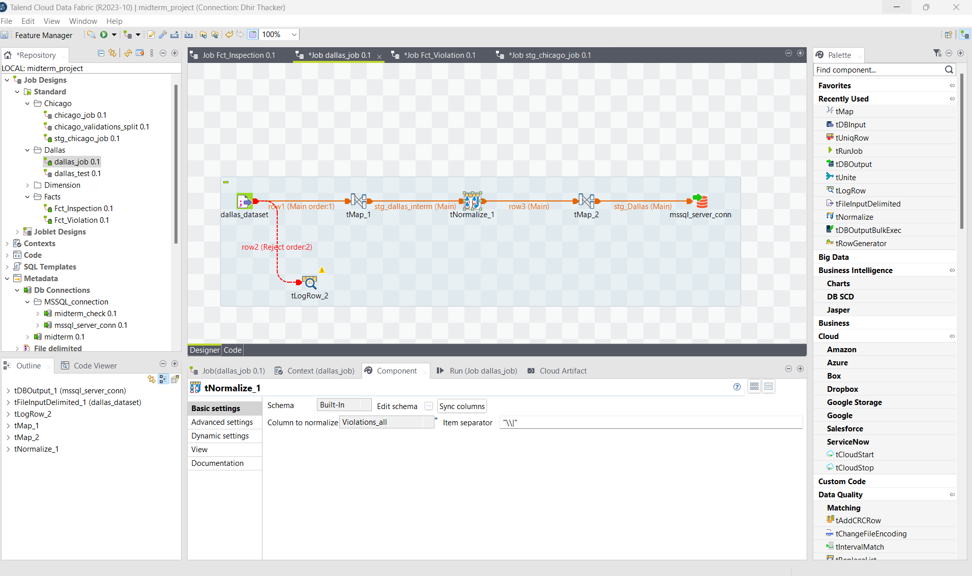

* Second T-map: The Violations All column has been split into four columns (Violation Code, Violation Description, Violation Comment, Violation Points) – As shown in the screenshot below.

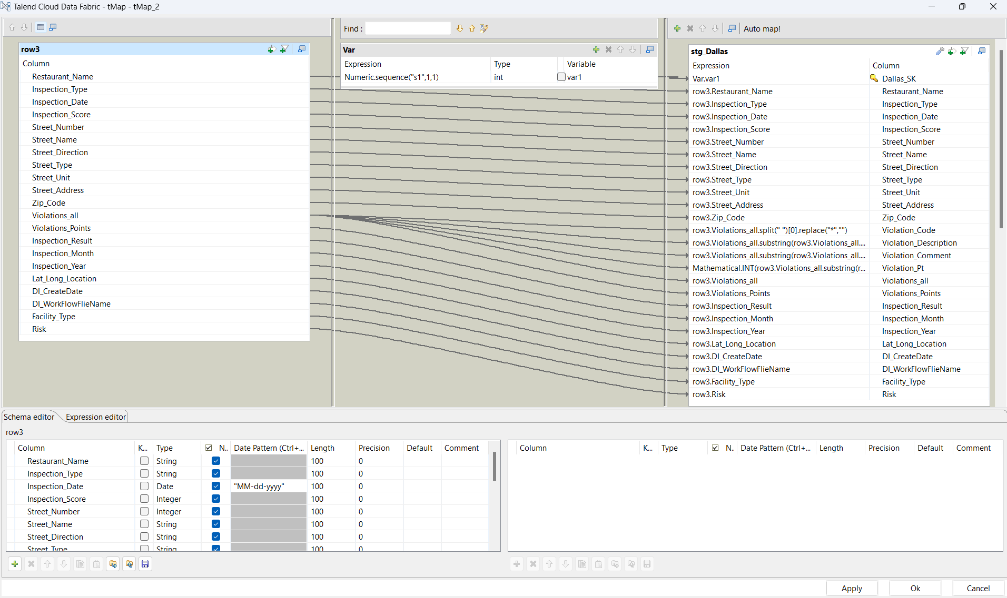

* Two functions (DI_CurrentDate and DI_WorkflowFileName) have been added.
* Created two columns Risk and Facility_Type and gave them a default value.
* Finally, everything has been mapped to the output server – Microsoft SQL Server.

**STEP 3:** DATA PROFILING

**USAGE:** Understood the layout of tables, fields, and the relationships between different data elements. It helped us in understanding how the data is organized.

**a) USING Y-DATA PROFILING**

1) FOOD INSPECTIONS – CHICAGO

**DATASET STATISTICS:**

* The given dataset consists of **17 variables** and **267866 observations**.
* There are **84184 missing cells**, which account up to **1.8%** of the total values
* There are **no duplicate** values.

**VARIABLES:**

* Numeric: 5 (Inspection ID, License#, Zip, Latitude, Longitude)
* Text: 8(DBA Name, AKA Name, Facility type, Address, City, Inspection Type, Violations, Location)
* Categorical: 3(Risk, State, Results)
* Date Time: 1(Inspection Date)

**OBSERVATIONS:**

* Facility type and Violations have 1.9% (5120) and 27.4 % (73445) missing values

2) FOOD INSPECTIONS – DALLAS

**DATASET STATISTICS:**

* The given dataset consists of **114 variables** and 78400 **observations**.
* There are **6454357 missing cells**, which account up to **72.2%** of the total values
* There are **42 duplicate** values.

**VARIABLES:**

* Numeric: 2 (Inspection Score, Street Number)
* Text: 82(75 records - Violation Description-1, Violation Memo-1, Violation Detail -1 through Violation Description-25, Violation Memo-25, Violation Detail -25, Restaurant Name, Street Name, Street Unit, Street Address, Zip code, Inspection Month, Lat Long Location)
* Date Time: 1(Inspection Date)
* Categorical: 29 (25 records - Violation Points-1 through Violation Points-25, Inspection Type, Street Direction, Street Type, Inspection Year)

**OBSERVATIONS:**

* The dataset has 42 duplicate rows, that accounts to 0.1% of the total data
* Total Missing values for Violation Description: 195,482, Violation Points: 195,482, Violation Detail: 195,489, Violation Memo: 195,513.
* Missing Percentage Violation Description: 99.534%, Violation Points: 99.534%,   
  Violation Detail: 99.535%, Violation Memo: 99.539%.

**b) USING ALTERYX**

1) FOOD INSPECTIONS - CHICAGO

**ISSUES FOUND AND RESOLUTION:**

* Inspection data was in String instead of date.
* Violations Column was getting truncated.

**ALTERYX PROFILING:**

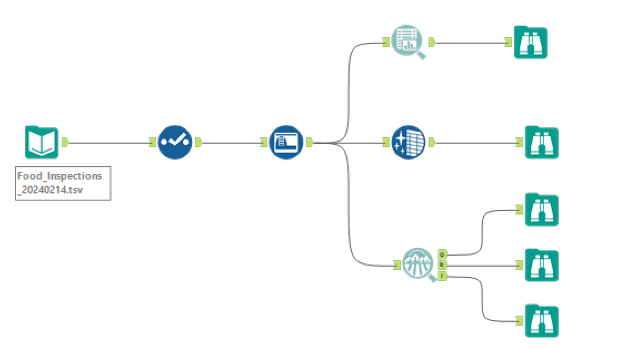

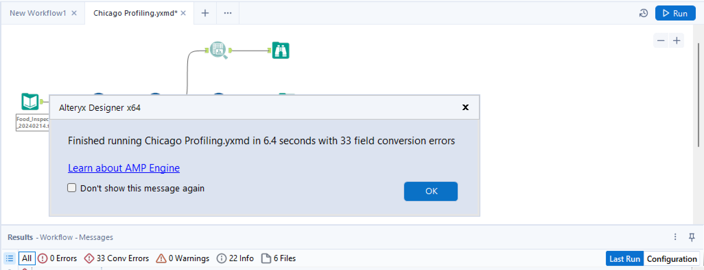

**REPORT:**

**NUMERIC VALUES:**

(Inspection ID, License#, Zip)

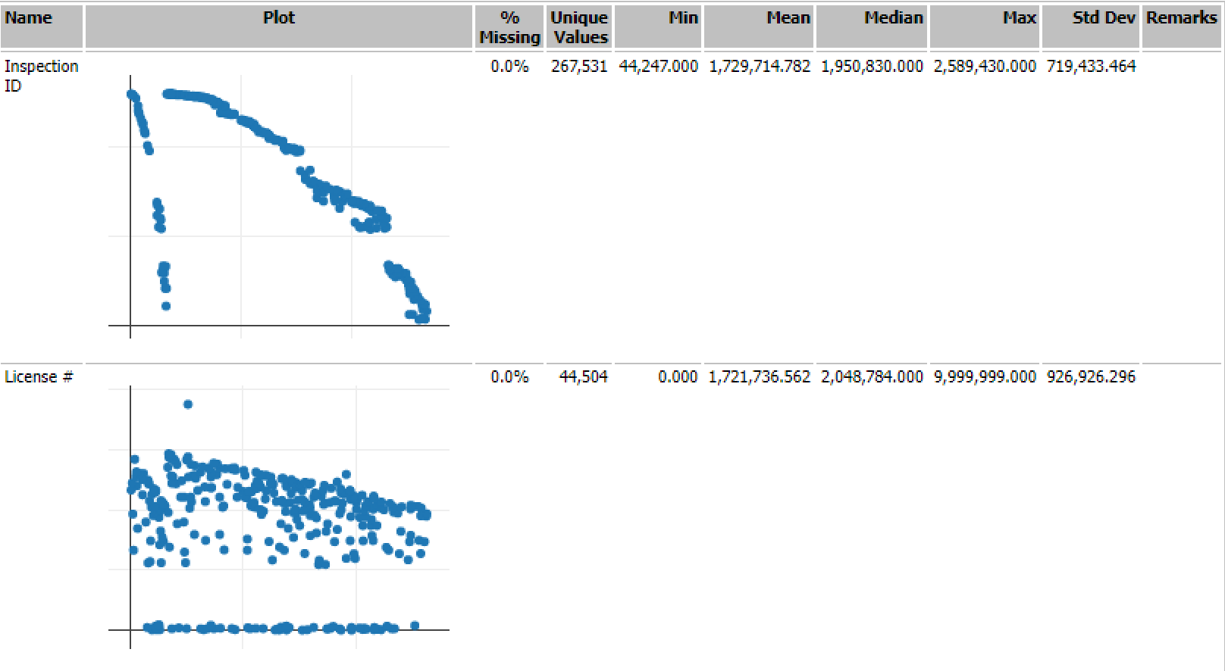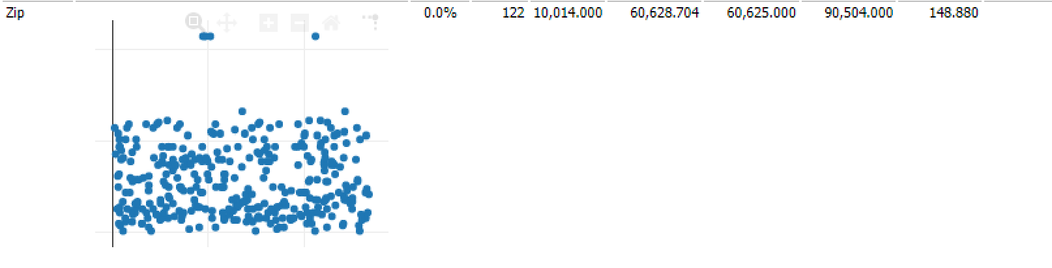

**CHARACTER/STRING FIELDS:**

|  |  |  |  |  |  |  |  |
| --- | --- | --- | --- | --- | --- | --- | --- |
| **Name** | **% Missing** | **Unique Values** | **Shortest Value** | **Longest Value** | **Min Value Count** | **Max Value Count** | **Remarks** |
| AKA Name | 0.9% | 30,615 | EL | MAE'S EARLY CHILDHOOD DEVELOPMENT AND THERAPEUTIC DAY CARE CENTER, INCORPORATED | 1 | 4,370 | Some values of this field have a small number of value counts. If Appropriate, consider combining some value levels together. |
| Longitude | 0.3% | 18,211 | -87.669464645 | -87.65901954921286 | 1 | 3,291 | Some values of this field have a small number of value counts. If Appropriate, consider combining some value levels together. |
| Address | 0.0% | 19,639 |  | 1400 S JEAN BAPTISTE POINTE DUSABLE LAKESHORE DRIVE | 1 | 3,273 | Some values of this field have a small number of value counts. If Appropriate, consider combining some value levels together. |
| State | 0.0% | 6 | IL | IL | 1 | 267,461 | Some values of this field have a small number of value counts. If Appropriate, consider combining some value levels together. |
| DBA Name | 0.0% | 32,165 | N | MAE'S EARLY CHILDHOOD DEVELOPMENT AND THERAPEUTIC DAY CARE CENTER, INCORPORATED | 1 | 3,552 | Some values of this field have a small number of value counts. If Appropriate, consider combining some value levels together. |
| Latitude | 0.3% | 18,211 | 41.786130727 | 41.677685065833224 | 1 | 3,291 | Some values of this field have a small number of value counts. If Appropriate, consider combining some value levels together. |
| City | 0.1% | 79 | alsip | BANNOCKBURNDEERFIELD | 1 | 266,472 | Some values of this field have a small number of value counts. If Appropriate, consider combining some value levels together. |
| Violations | 27.4% | 166,051 | 63. REMOVAL OF SUSPENSION SIGN | 2. CITY OF CHICAGO FOOD SERVICE SANITATION CERTIFICATE - Comments: OBSERVED FACILITY FOOD HANDLERS PREPARING AND HANDLING ï¿½TIME AND TEMPERATURE CONTROL FOR SAFETY(TCS) FOODS WITHOUT ORIGINAL CITY OF CHICAGO FOOD SERVICE MANAGER AND CERTIFICATE ON SITE. | 1 | 73,340 | This field has over 10% missing values. Consider imputing these values. Some values of this field have a small number of value counts. If Appropriate, consider combining some value levels together. |
| Risk | 0.0% | 5 | All | Risk 2 (Medium) | 52 | 196,048 | Some values of this field have a small number of value counts. If Appropriate, consider combining some value levels together. |
| Location | 0.3% | 18,211 | (41.9960984214, -87.7868769104594) | (41.677685065833224, -87.65901954921286) | 1 | 3,291 | Some values of this field have a small number of value counts. If Appropriate, consider combining some value levels together. |
| Inspection Type | 0.0% | 111 | SFP | LICENSE TASK FORCE / NOT -FOR-PROFIT CLUB | 1 | 139,061 | Some values of this field have a small number of value counts. If Appropriate, consider combining some value levels together. |
| Inspection Date | 0.0% | 3,562 | 02/08/2024 | 02/08/2024 | 1 | 185 | Some values of this field have a small number of value counts. If Appropriate, consider combining some value levels together. |
| Facility Type | 1.9% | 514 | bar | Mobile Frozen Dessert Dispenser_non Motorized. | 1 | 179,811 | Some values of this field have a small number of value counts. If Appropriate, consider combining some value levels together. |
| Results | 0.0% | 7 | Pass | Business Not Located | 86 | 137,733 | Some values of this field have a small number of value counts. If Appropriate, consider combining some value levels together. |

**2) FOOD INSPECTIONS - DALLAS**

**ALTERYX PROFILING:**

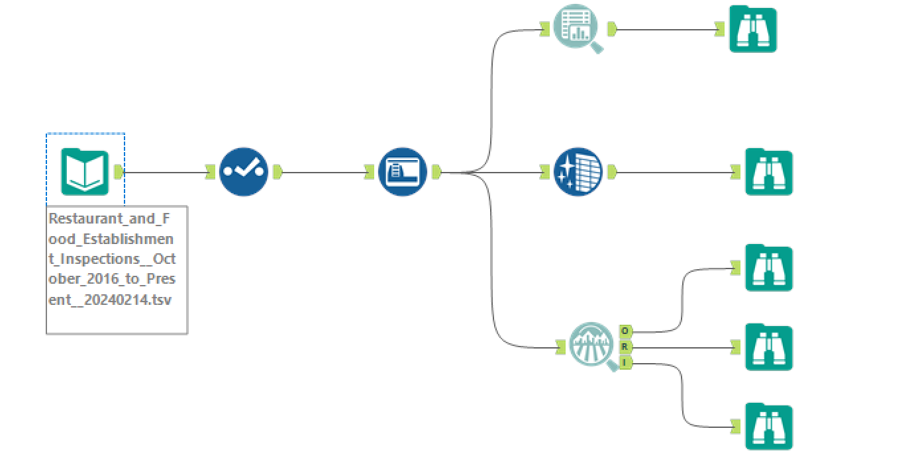

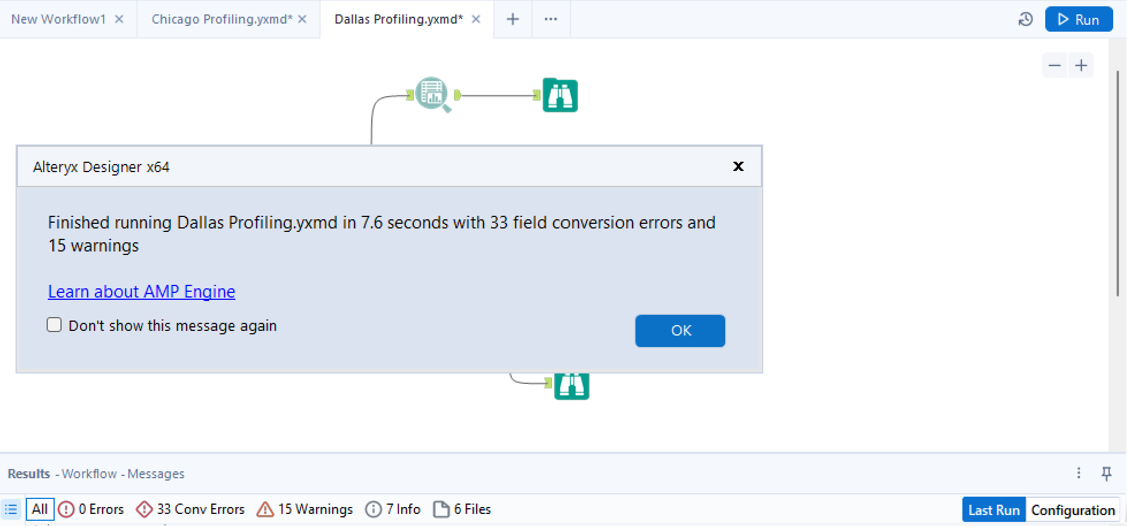

**REPORT:**

|  |  |  |  |  |  |  |  |
| --- | --- | --- | --- | --- | --- | --- | --- |
| **Name** | **% Missing** | **Unique Values** | **Shortest Value** | **Longest Value** | **Min Value Count** | **Max Value Count** | **Remarks** |
| Violation Points - 1 | 8.40% | 5 | 2 | 2 | 1 | 27,830 | Some values of this field have a small number of value counts. If Appropriate, consider combining some value levels together. |
| Street Unit | 64.40% | 987 | 3 | #3000 | 1 | 49,947 | This field has over 10% missing values. Consider imputing these values. Some values of this field have a small number of value counts. If Appropriate, consider combining some value levels together. |
| Violation Memo - 21 | 99.90% | 61 | salsa | Equipment and single use utensils contaminated by trash container located inside shelving area must be remove equipment and discard single use utensils contaminated by the trash receptacle inside shelving area | 1 | 77,462 | This field has over 10% missing values. Consider imputing these values. Some values of this field have a small number of value counts. If Appropriate, consider combining some value levels together. |
| Violation Memo - 11 | 92.80% | 4,696 | BAR | Reach in cooler near cooking line. Olives 48.6°F Cooked chopped chicken 48.2°F Make sure employees have probe thermometers (and the training to avoid contamination by improperly sanitized equipment) to audit foods such that foods out of temperature | 1 | 71,906 | This field has over 10% missing values. Consider imputing these values. Some values of this field have a small number of value counts. If Appropriate, consider combining some value levels together. |
| Violation Detail - 23 | 100.00% | 17 | 228.173 Physical Facilities. Floors, walls, and ceilings. (e) Floor covering, mats and duckboards. Mats and duckboards shall be designed to be removable and easily cleanable. | õ228.33. Certified Food Protection Manager and Food Handler Requirements (d) Except in a temporary food establishment and the certified food manager, all food employees shall successfully complete an accredited food handler training course, within 60 da | 1 | 77,506 | This field has over 10% missing values. Consider imputing these values. Some values of this field have a small number of value counts. If Appropriate, consider combining some value levels together. |
| Violation Points - 2 | 18.00% | 5 | 1 | 1 | 1 | 25,650 | This field has over 10% missing values. Consider imputing these values. Some values of this field have a small number of value counts. If Appropriate, consider combining some value levels together. |
| Violation Memo - 7 | 75.00% | 15,736 | LA | Need a choking poster in the dining area. “SEC. 17-11.2. ADDITIONAL REQUIREMENTS. [Reserved.] Amend Chapter 17, “Food Establishments” - Page 36 (a) General. All food establishments that provide dining areas shall post the Heimlich maneuver sign in | 1 | 58,179 | This field has over 10% missing values. Consider imputing these values. Some values of this field have a small number of value counts. If Appropriate, consider combining some value levels together. |
| Street Number | 0.00% | 3,442 | 0 | 10295 | 1 | 562 | Some values of this field have a small number of value counts. If Appropriate, consider combining some value levels together. |
| Violation Detail - 18 | 99.60% | 130 | 228.210 Poisonous or Toxic Materials. First Aid Supplies, Availability. A first aid kit shall be provided. | 228.35 Management and Personnel. Responsibilities and Reporting Symptoms and Diagnosis. (f) A food employee shall: (2) comply with a restriction as specified in õ228.36(4)(B), (5)(B), (6)(B), (7), (8)(B), or õ228.36 (8), (9), or (10) a | 1 | 77,184 | This field has over 10% missing values. Consider imputing these values. Some values of this field have a small number of value counts. If Appropriate, consider combining some value levels together. |
| Violation Memo - 19 | 99.80% | 161 | CLEAN ALL | cooler units in all areas including frame and gaskets doors dirty with mold, soils and grease deposits must be clean to avoid cross contamination WI cooler dirty with soils and grease accumulations must be clean to avoid cross contamination | 1 | 77,358 | This field has over 10% missing values. Consider imputing these values. Some values of this field have a small number of value counts. If Appropriate, consider combining some value levels together. |
| Street Type | 2.10% | 20 | RD | BLVD | 40 | 19,204 | Some values of this field have a small number of value counts. If Appropriate, consider combining some value levels together. |
| Violation Memo - 10 | 89.20% | 6,895 | PIC | missing skirt on wall prep area must be repair all gaps to avoid pest harboring missing weather strip at back exit door must have weather strip to avoid pest entry holes on walls in all areas must be repair or cover in all walls to avoid pest h | 1 | 69,126 | This field has over 10% missing values. Consider imputing these values. Some values of this field have a small number of value counts. If Appropriate, consider combining some value levels together. |
| Violation Detail - 14 | 97.60% | 249 | 228.120 Equipment, Utensils, and Linens. Laundering, Frequency, Specifications. (d) Wet wiping cloths shall be laundered daily. | 228.35 Management and Personnel. Responsibilities and Reporting Symptoms and Diagnosis. (f) A food employee shall: (2) comply with a restriction as specified in õ228.36(4)(B), (5)(B), (6)(B), (7), (8)(B), or õ228.36 (8), (9), or (10) a | 1 | 75,697 | This field has over 10% missing values. Consider imputing these values. Some values of this field have a small number of value counts. If Appropriate, consider combining some value levels together. |
| Violation Points - 6 | 60.30% | 4 | 1 | 1 | 6,587 | 46,765 | This field has over 10% missing values. Consider imputing these values. |
| Violation Memo - 4 | 54.20% | 28,436 | a | Reach in cooler thermometers are not accurate at back (SW corner) of store. One thermometer displays 58°F, another 33°F. The sensor for the thermometer displaying 33°F is directly attached to exhaust vent of condenser unit. this is the coldest area of refer | 1 | 41,982 | This field has over 10% missing values. Consider imputing these values. Some values of this field have a small number of value counts. If Appropriate, consider combining some value levels together. |
| Violation Description - 8 | 75.80% | 480 | *23 No Water | *05 Reheat from 41øF to 165øF within 2 hours and/or Commercially processed RTE foods reheated from 4 | 1 | 58,743 | This field has over 10% missing values. Consider imputing these values. Some values of this field have a small number of value counts. If Appropriate, consider combining some value levels together. |
| Violation Memo - 24 | 100.00% | 12 | Bulk items | reseal hand sink to wall near 3 com sink clean the floor throughout the kitchen area cover floor drain in grill area seal opening above the bag-n box check interior of walk-in cooler | 1 | 77,512 | This field has over 10% missing values. Consider imputing these values. Some values of this field have a small number of value counts. If Appropriate, consider combining some value levels together. |
| Restaurant Name | 0.00% | 9,101 | KFC | 50326 THE TRADITION-PRESTONWOOD ASSISTED LIVING AND MEMORY-4TH FL | 1 | 524 | Some values of this field have a small number of value counts. If Appropriate, consider combining some value levels together. |
| Violation Description - 10 | 87.00% | 411 | *23 No Water | *05 Reheat from 41øF to 165øF within 2 hours and/or Commercially processed RTE foods reheated from 4 | 1 | 67,479 | This field has over 10% missing values. Consider imputing these values. Some values of this field have a small number of value counts. If Appropriate, consider combining some value levels together. |
| Violation Description - 4 | 40.60% | 585 | *23 No Water | *05 Reheat from 41øF to 165øF within 2 hours and/or Commercially processed RTE foods reheated from 4 | 1 | 31,438 | This field has over 10% missing values. Consider imputing these values. Some values of this field have a small number of value counts. If Appropriate, consider combining some value levels together. |
| Violation Detail - 8 | 76.10% | 428 | 228.210 Poisonous or Toxic Materials. First Aid Supplies, Availability. A first aid kit shall be provided. | 228.35 Management and Personnel. Responsibilities and Reporting Symptoms and Diagnosis. (f) A food employee shall: (2) comply with a restriction as specified in õ228.36(4)(B), (5)(B), (6)(B), (7), (8)(B), or õ228.36 (8), (9), or (10) a | 1 | 58,991 | This field has over 10% missing values. Consider imputing these values. Some values of this field have a small number of value counts. If Appropriate, consider combining some value levels together. |
| Violation Detail - 2 | 18.70% | 548 | 228.210 Poisonous or Toxic Materials. First Aid Supplies, Availability. A first aid kit shall be provided. | 228.35 Management and Personnel. Responsibilities and Reporting Symptoms and Diagnosis. (f) A food employee shall: (2) comply with a restriction as specified in õ228.36(4)(B), (5)(B), (6)(B), (7), (8)(B), or õ228.36 (8), (9), or (10) a | 1 | 14,525 | This field has over 10% missing values. Consider imputing these values. Some values of this field have a small number of value counts. If Appropriate, consider combining some value levels together. |
| Violation Points - 16 | 98.90% | 4 | 1 | 1 | 184 | 76,650 | This field has over 10% missing values. Consider imputing these values. Some values of this field have a small number of value counts. If Appropriate, consider combining some value levels together. |
| Violation Detail - 11 | 91.50% | 341 | 228.210 Poisonous or Toxic Materials. First Aid Supplies, Availability. A first aid kit shall be provided. | 228.35 Management and Personnel. Responsibilities and Reporting Symptoms and Diagnosis. (f) A food employee shall: (2) comply with a restriction as specified in õ228.36(4)(B), (5)(B), (6)(B), (7), (8)(B), or õ228.36 (8), (9), or (10) a | 1 | 70,908 | This field has over 10% missing values. Consider imputing these values. Some values of this field have a small number of value counts. If Appropriate, consider combining some value levels together. |
| Violation Description - 22 | 100.00% | 25 | *23 No Water | *09 Food protected cross contamination separating types of raw animal food storage, preparation, hold | 1 | 77,492 | This field has over 10% missing values. Consider imputing these values. Some values of this field have a small number of value counts. If Appropriate, consider combining some value levels together. |
| Violation Description - 17 | 99.30% | 176 | *23 No Water | *39 In-use utensils, between-use storage. During pauses in food preparation or dispensing, food prep | 1 | 76,983 | This field has over 10% missing values. Consider imputing these values. Some values of this field have a small number of value counts. If Appropriate, consider combining some value levels together. |
| Zip Code | 0.00% | 155 | 75237 | 75238-2632 | 1 | 4,676 | Some values of this field have a small number of value counts. If Appropriate, consider combining some value levels together. |
| Violation Memo - 2 | 37.30% | 38,374 | d | Need NO Smoking sign at front door. Below is the City of Dallas Code: SECTION 2. That Subsection (a) of Section 4 1-2, “Smoking Prohibited in Certain Areas,” of Article II, “Smoking Prohibitions,” of Chapter 41, “Smoking,” of the Dallas City Code | 1 | 28,941 | This field has over 10% missing values. Consider imputing these values. Some values of this field have a small number of value counts. If Appropriate, consider combining some value levels together. |
| Violation Detail - 15 | 98.30% | 214 | 228.210 Poisonous or Toxic Materials. First Aid Supplies, Availability. A first aid kit shall be provided. | 228.80 Food. Consumer advisory. (a) Except as specified in õ228.71(a)(3), (a)(4)(D) and õ228.82(3) of this title, if an animal food such as beef, eggs, fish, lamb, milk, pork, poultry, or shellfish is served or sold raw, undercooked, or wit | 1 | 76,242 | This field has over 10% missing values. Consider imputing these values. Some values of this field have a small number of value counts. If Appropriate, consider combining some value levels together. |
| Violation Description - 7 | 68.60% | 494 | *23 No Water | *05 Reheat from 41øF to 165øF within 2 hours and/or Commercially processed RTE foods reheated from 4 | 1 | 53,208 | This field has over 10% missing values. Consider imputing these values. Some values of this field have a small number of value counts. If Appropriate, consider combining some value levels together. |
| Violation Memo - 13 | 97.20% | 1,966 | WIC | SEC. 17-11.2. ADDITIONAL REQUIREMENTS. (a) General. All food establishments that provide dining areas shall post the Heimlich maneuver sign in a place conspicuous to employees and customers. (b) Specifications: The sign shall: (1) be | 1 | 75,357 | This field has over 10% missing values. Consider imputing these values. Some values of this field have a small number of value counts. If Appropriate, consider combining some value levels together. |
| Violation Detail - 19 | 99.70% | 89 | 228.75 Food. Time and temperature control. (a) Frozen food. Stored frozen foods shall be maintained frozen. | 228.186 Physical Facilities. Premises, buildings, systems, rooms, fixtures, equipment, devices, and materials. (i) Closing toilet room doors. Toilet room doors as specified in õ228.174(d) of this title shall be kept closed except dur | 1 | 77,322 | This field has over 10% missing values. Consider imputing these values. Some values of this field have a small number of value counts. If Appropriate, consider combining some value levels together. |
| Violation Detail - 6 | 60.80% | 487 | 228.210 Poisonous or Toxic Materials. First Aid Supplies, Availability. A first aid kit shall be provided. | 228.35 Management and Personnel. Responsibilities and Reporting Symptoms and Diagnosis. (f) A food employee shall: (2) comply with a restriction as specified in õ228.36(4)(B), (5)(B), (6)(B), (7), (8)(B), or õ228.36 (8), (9), or (10) a | 1 | 47,147 | This field has over 10% missing values. Consider imputing these values. Some values of this field have a small number of value counts. If Appropriate, consider combining some value levels together. |
| Violation Memo - 22 | 100.00% | 30 | label 3 comp sink | light shields removed in back storage area replace missing vent a hood filters food employees must focus on one task at a time food staff recommend have cleaning bucket label mop sink recommend a small cart to store dirty dishes provide lids for b | 1 | 77,494 | This field has over 10% missing values. Consider imputing these values. Some values of this field have a small number of value counts. If Appropriate, consider combining some value levels together. |
| Violation Detail - 3 | 30.00% | 547 | 228.210 Poisonous or Toxic Materials. First Aid Supplies, Availability. A first aid kit shall be provided. | 228.35 Management and Personnel. Responsibilities and Reporting Symptoms and Diagnosis. (f) A food employee shall: (2) comply with a restriction as specified in õ228.36(4)(B), (5)(B), (6)(B), (7), (8)(B), or õ228.36 (8), (9), or (10) a | 1 | 23,233 | This field has over 10% missing values. Consider imputing these values. Some values of this field have a small number of value counts. If Appropriate, consider combining some value levels together. |
| Violation Points - 5 | 50.90% | 5 | 1 | 1 | 1 | 39,491 | This field has over 10% missing values. Consider imputing these values. Some values of this field have a small number of value counts. If Appropriate, consider combining some value levels together. |
| Violation Memo - 23 | 100.00% | 17 | PROVIDE | cooking equipment dirty with soils and grease accumulations must be clean to avoid cross contamination | 1 | 77,507 | This field has over 10% missing values. Consider imputing these values. Some values of this field have a small number of value counts. If Appropriate, consider combining some value levels together. |
| Violation Description - 14 | 97.60% | 271 | *23 No Water | *09 Food protected cross contamination by preparing each type of food at different times or in separate. | 1 | 75,667 | This field has over 10% missing values. Consider imputing these values. Some values of this field have a small number of value counts. If Appropriate, consider combining some value levels together. |
| Violation Memo - 1 | 29.30% | 43,237 | . | OBSERVED ROACH GEL STORED IN BACK ROOM, ALSO OBSERVED A GALLON OF ORTHO PESTICIDE IN KITCHEN, REMOVE ALL RESTRICTED USE PESTICIDE FROM ESTABLISHMENT. SE OBSERVÓ GEL PARA CUCARACHAS ALMACENADO EN EL CUARTO DE ATRÁS, TAMBIÉN SE OBSERVÓ UN GALÓN DE PES | 1 | 22,681 | This field has over 10% missing values. Consider imputing these values. Some values of this field have a small number of value counts. If Appropriate, consider combining some value levels together. |
| Violation Memo - 20 | 99.90% | 109 | EMPLOYEES | using recycle non approved containers must be use approved commercial containers to avoid chemical contamination use of thank you bags as food containers must be have use approved commercial food containers to avoid chemical contamination | 1 | 77,414 | This field has over 10% missing values. Consider imputing these values. Some values of this field have a small number of value counts. If Appropriate, consider combining some value levels together. |
| Violation Points - 25 | 100.00% | 4 | 3 | 3 | 2 | 77,517 | This field has over 10% missing values. Consider imputing these values. Some values of this field have a small number of value counts. If Appropriate, consider combining some value levels together. |
| Inspection Month | 0.00% | 88 | Oct-19 | Oct-19 | 248 | 1,347 | Some values of this field have a small number of value counts. If Appropriate, consider combining some value levels together. |
| Violation Description - 1 | 8.40% | 624 | *23 No Water | *05 Reheat from 41øF to 165øF within 2 hours and/or Commercially processed RTE foods reheated from 4 | 1 | 6,502 | Some values of this field have a small number of value counts. If Appropriate, consider combining some value levels together. |
| Violation Description - 12 | 94.60% | 329 | *23 No Water | *21 Person in charge. The person in charge shall ensure that õ228.34 (1-15) Relating to Duties of PI | 1 | 73,368 | This field has over 10% missing values. Consider imputing these values. Some values of this field have a small number of value counts. If Appropriate, consider combining some value levels together. |
| Violation Detail - 1 | 9.10% | 561 | 228.210 Poisonous or Toxic Materials. First Aid Supplies, Availability. A first aid kit shall be provided. | 228.35 Management and Personnel. Responsibilities and Reporting Symptoms and Diagnosis. (f) A food employee shall: (2) comply with a restriction as specified in õ228.36(4)(B), (5)(B), (6)(B), (7), (8)(B), or õ228.36 (8), (9), or (10) a | 1 | 7,045 | Some values of this field have a small number of value counts. If Appropriate, consider combining some value levels together. |
| Inspection Score | 0.00% | 58 | 0 | 100 | 1 | 6,487 | Some values of this field have a small number of value counts. If Appropriate, consider combining some value levels together. |
| Violation Detail - 4 | 41.20% | 529 | 228.210 Poisonous or Toxic Materials. First Aid Supplies, Availability. A first aid kit shall be provided. | 228.35 Management and Personnel. Responsibilities and Reporting Symptoms and Diagnosis. (f) A food employee shall: (2) comply with a restriction as specified in õ228.36(4)(B), (5)(B), (6)(B), (7), (8)(B), or õ228.36 (8), (9), or (10) a | 1 | 31,908 | This field has over 10% missing values. Consider imputing these values. Some values of this field have a small number of value counts. If Appropriate, consider combining some value levels together. |
| Violation Detail - 12 | 94.70% | 294 | 228.210 Poisonous or Toxic Materials. First Aid Supplies, Availability. A first aid kit shall be provided. | 228.35 Management and Personnel. Responsibilities and Reporting Symptoms and Diagnosis. (f) A food employee shall: (2) comply with a restriction as specified in õ228.36(4)(B), (5)(B), (6)(B), (7), (8)(B), or õ228.36 (8), (9), or (10) a | 1 | 73,447 | This field has over 10% missing values. Consider imputing these values. Some values of this field have a small number of value counts. If Appropriate, consider combining some value levels together. |
| Violation Description - 6 | 60.30% | 549 | *23 No Water | *05 Reheat from 41øF to 165øF within 2 hours and/or Commercially processed RTE foods reheated from 4 | 1 | 46,765 | This field has over 10% missing values. Consider imputing these values. Some values of this field have a small number of value counts. If Appropriate, consider combining some value levels together. |
| Violation Description - 21 | 99.90% | 50 | *34 Pest Control | *09 Cooked ready to eat - Food protected from cross contamination by separating, storage, preparation | 1 | 77,452 | This field has over 10% missing values. Consider imputing these values. Some values of this field have a small number of value counts. If Appropriate, consider combining some value levels together. |
| Violation Points - 19 | 99.70% | 4 | 1 | 1 | 34 | 77,319 | This field has over 10% missing values. Consider imputing these values. Some values of this field have a small number of value counts. If Appropriate, consider combining some value levels together. |
| Violation Description - 9 | 81.90% | 420 | *23 No Water | *21 Person in charge. The person in charge shall ensure that õ228.34 (1-15) Relating to Duties of PI | 1 | 63,490 | This field has over 10% missing values. Consider imputing these values. Some values of this field have a small number of value counts. If Appropriate, consider combining some value levels together. |
| Violation Description - 3 | 29.30% | 611 | *23 No Water | *05 Reheat from 41øF to 165øF within 2 hours and/or Commercially processed RTE foods reheated from 4 | 1 | 22,723 | This field has over 10% missing values. Consider imputing these values. Some values of this field have a small number of value counts. If Appropriate, consider combining some value levels together. |
| Violation Memo - 8 | 80.50% | 12,245 | CO | SALSA PREPARED ON 10/4 TEMPERATURE WAS 65°F CHICHARON PREPARED ON 10/4 TEMPERATURE WAS 75.6°F SOUP BROTH PREPARED ON 10/4 TEMPERATURE WAS 65.9°F WATERMELON 47°F COOLER THERMOMETER 47°F - DOOR WAS AJAR WHEN INSPECTION BEGAN COS - VOLUNTARY DESTRUCTION | 1 | 62,430 | This field has over 10% missing values. Consider imputing these values. Some values of this field have a small number of value counts. If Appropriate, consider combining some value levels together. |
| Violation Detail - 16 | 98.90% | 177 | 228.210 Poisonous or Toxic Materials. First Aid Supplies, Availability. A first aid kit shall be provided. | 228.80 Food. Consumer advisory. (a) Except as specified in õ228.71(a)(3), (a)(4)(D) and õ228.82(3) of this title, if an animal food such as beef, eggs, fish, lamb, milk, pork, poultry, or shellfish is served or sold raw, undercooked, or wit | 1 | 76,665 | This field has over 10% missing values. Consider imputing these values. Some values of this field have a small number of value counts. If Appropriate, consider combining some value levels together. |
| Violation Detail - 10 | 87.20% | 370 | 228.210 Poisonous or Toxic Materials. First Aid Supplies, Availability. A first aid kit shall be provided. | 228.35 Management and Personnel. Responsibilities and Reporting Symptoms and Diagnosis. (f) A food employee shall: (2) comply with a restriction as specified in õ228.36(4)(B), (5)(B), (6)(B), (7), (8)(B), or õ228.36 (8), (9), or (10) a | 1 | 67,633 | This field has over 10% missing values. Consider imputing these values. Some values of this field have a small number of value counts. If Appropriate, consider combining some value levels together. |
| Violation Points - 23 | 100.00% | 4 | 1 | 1 | 3 | 77,506 | This field has over 10% missing values. Consider imputing these values. Some values of this field have a small number of value counts. If Appropriate, consider combining some value levels together. |
| Violation Description - 25 | 100.00% | 7 | *47 Other Violations | *29 Cold/hot hold unit thermometer easily viewable | 1 | 77,517 | This field has over 10% missing values. Consider imputing these values. Some values of this field have a small number of value counts. If Appropriate, consider combining some value levels together. |
| Street Direction | 67.00% | 5 | W | W | 3,460 | 51,930 | This field has over 10% missing values. Consider imputing these values. Some values of this field have a small number of value counts. If Appropriate, consider combining some value levels together. |
| Violation Memo - 5 | 61.90% | 23,874 | 33 | Need a choking poster in the dining area. “SEC. 17-11.2. ADDITIONAL REQUIREMENTS. [Reserved.] Amend Chapter 17, “Food Establishments” - Page 36 (a) General. All food establishments that provide dining areas shall post the Heimlich maneuver sign in | 1 | 47,967 | This field has over 10% missing values. Consider imputing these values. Some values of this field have a small number of value counts. If Appropriate, consider combining some value levels together. |
| Violation Memo - 14 | 98.00% | 1,399 | Raid | a/c vents and fan cover inside WI cooler units dirty with soils deposits, grease accumulations and dust must be clean to avoid cross contamination a/c filters dirty with dust, grease accumulations and soils deposits must be clean to avoid cross con | 1 | 75,993 | This field has over 10% missing values. Consider imputing these values. Some values of this field have a small number of value counts. If Appropriate, consider combining some value levels together. |
| Violation Points - 4 | 40.60% | 4 | 1 | 1 | 10,550 | 31,438 | This field has over 10% missing values. Consider imputing these values. |
| Violation Memo - 25 | 100.00% | 7 | CLEAN ALL | Dirty dust on fans and vents above food prep areas and counters. dirty food containers, outside RIC doors, stoves, ovens, walls, vents, vent filters. Ice on freezer floor. | 1 | 77,517 | This field has over 10% missing values. Consider imputing these values. Some values of this field have a small number of value counts. If Appropriate, consider combining some value levels together. |
| Violation Detail - 7 | 69.00% | 447 | 228.210 Poisonous or Toxic Materials. First Aid Supplies, Availability. A first aid kit shall be provided. | 228.35 Management and Personnel. Responsibilities and Reporting Symptoms and Diagnosis. (f) A food employee shall: (2) comply with a restriction as specified in õ228.36(4)(B), (5)(B), (6)(B), (7), (8)(B), or õ228.36 (8), (9), or (10) a | 1 | 53,521 | This field has over 10% missing values. Consider imputing these values. Some values of this field have a small number of value counts. If Appropriate, consider combining some value levels together. |
| Violation Description - 13 | 96.60% | 287 | *23 No Water | *21 Person in charge. The person in charge shall ensure that õ228.34 (1-15) Relating to Duties of PI | 1 | 74,891 | This field has over 10% missing values. Consider imputing these values. Some values of this field have a small number of value counts. If Appropriate, consider combining some value levels together. |
| Violation Memo - 6 | 68.90% | 19,536 | T | RAW GROUND BEEF 47.2°F, ROAST BEEF 50°F (COOLER DRAWER THERMOMETER READING 49°F) HARD BOILED EGGS 46.9°F, TUNA SALAD 49.3°F, CHORIZO 45.3°F, RICE 46.0°F, SALSA 50.1°F, DICED HAM 45.1°F (COOLER THERMOMETER READING 41°F) RANCH DRESSING 46.6°F (THERMOMETER) | 1 | 53,409 | This field has over 10% missing values. Consider imputing these values. Some values of this field have a small number of value counts. If Appropriate, consider combining some value levels together. |
| Violation Description - 11 | 91.30% | 376 | *23 No Water | *21 Person in charge. The person in charge shall ensure that õ228.34 (1-15) Relating to Duties of PI | 1 | 70,810 | This field has over 10% missing values. Consider imputing these values. Some values of this field have a small number of value counts. If Appropriate, consider combining some value levels together. |
| Violation Description - 20 | 99.80% | 70 | *47 Other Violations | *05 Reheat from 41øF to 165øF within 2 hours and/or Commercially processed RTE foods reheated from 4 | 1 | 77,394 | This field has over 10% missing values. Consider imputing these values. Some values of this field have a small number of value counts. If Appropriate, consider combining some value levels together. |
| Violation Points - 24 | 100.00% | 3 | 1 | 1 | 3 | 77,512 | This field has over 10% missing values. Consider imputing these values. Some values of this field have a small number of value counts. If Appropriate, consider combining some value levels together. |
| Street Name | 0.00% | 841 | TI | MOUNTAIN CREEK PKWY #BU23 | 1 | 2,299 | Some values of this field have a small number of value counts. If Appropriate, consider combining some value levels together. |
| Violation Points - 13 | 96.60% | 5 | 1 | 1 | 1 | 74,891 | This field has over 10% missing values. Consider imputing these values. Some values of this field have a small number of value counts. If Appropriate, consider combining some value levels together. |
| Violation Points - 15 | 98.30% | 4 | 2 | 2 | 267 | 76,218 | This field has over 10% missing values. Consider imputing these values. Some values of this field have a small number of value counts. If Appropriate, consider combining some value levels together. |
| Violation Detail - 22 | 100.00% | 24 | 228.224 REQUIREMENTS APPLICABLE TO CERTAIN ESTABLISHMENTS Outfitter Operations. (i) Equipment. All equipment and utensils intended for food contact shall be approved for food use. | 228.35 Management and Personnel. Responsibilities and Reporting Symptoms and Diagnosis. (f) A food employee shall: (2) comply with a restriction as specified in õ228.36(4)(B), (5)(B), (6)(B), (7), (8)(B), or õ228.36 (8), (9), or (10) a | 1 | 77,495 | This field has over 10% missing values. Consider imputing these values. Some values of this field have a small number of value counts. If Appropriate, consider combining some value levels together. |
| Violation Detail - 24 | 100.00% | 10 | 228.149 Water, Plumbing, and Waste. Plumbing, operation and maintenance. (e) System maintained in good repair. A plumbing system shall be: (2) maintained in good repair. | 228.106 Equipment, Utensils, and Linens. Functionality of equipment. (a) Ventilation hood systems, drip prevention. Exhaust ventilation hood systems in food preparation and ware washing areas including components such as hoods, fans, g | 1 | 77,512 | This field has over 10% missing values. Consider imputing these values. Some values of this field have a small number of value counts. If Appropriate, consider combining some value levels together. |
| Violation Points - 17 | 99.30% | 4 | 1 | 1 | 108 | 76,983 | This field has over 10% missing values. Consider imputing these values. Some values of this field have a small number of value counts. If Appropriate, consider combining some value levels together. |
| Violation Memo - 16 | 99.10% | 672 | TILE | Cooked beef brisket on counter showed temperature of 96.5°F No temperature logs were available at time of inspection. Cooling sauces of large number in walk in cooler were located adjacent to one another. With the number of foods prepared from a | 1 | 76,797 | This field has over 10% missing values. Consider imputing these values. Some values of this field have a small number of value counts. If Appropriate, consider combining some value levels together. |
| Violation Points - 18 | 99.60% | 4 | 2 | 2 | 72 | 77,176 | This field has over 10% missing values. Consider imputing these values. Some values of this field have a small number of value counts. If Appropriate, consider combining some value levels together. |
| Violation Memo - 18 | 99.60% | 278 | 90 F | obtain rfsm certificate from City of Dallas within 45 days Bring learn 2 serv certificate, DL or ID and money (cash, check, money order no credit or debit cards), $30.00 per year. 7901 Goforth RD Dallas TX 75238 214 670 8083 | 1 | 77,237 | This field has over 10% missing values. Consider imputing these values. Some values of this field have a small number of value counts. If Appropriate, consider combining some value levels together. |
| Inspection Year | 0.00% | 8 | FY2020 | FY2020 | 1,880 | 14,412 | Some values of this field have a small number of value counts. If Appropriate, consider combining some value levels together. |
| Violation Detail - 5 | 51.50% | 504 | 228.210 Poisonous or Toxic Materials. First Aid Supplies, Availability. A first aid kit shall be provided. | 228.35 Management and Personnel. Responsibilities and Reporting Symptoms and Diagnosis. (f) A food employee shall: (2) comply with a restriction as specified in õ228.36(4)(B), (5)(B), (6)(B), (7), (8)(B), or õ228.36 (8), (9), or (10) a | 1 | 39,957 | This field has over 10% missing values. Consider imputing these values. Some values of this field have a small number of value counts. If Appropriate, consider combining some value levels together. |
| Violation Memo - 3 | 45.90% | 33,505 | p | Reach in cooler near ice machine temperature showed 60°F, 59.4°F, and 58°F throughout inspection. Please service equipment such that it maintains a temperature of 41°F or below. Also make sure doors remain closed as much as possible. Additionally, if | 1 | 35,545 | This field has over 10% missing values. Consider imputing these values. Some values of this field have a small number of value counts. If Appropriate, consider combining some value levels together. |
| Violation Description - 24 | 100.00% | 10 | *39 Equipment and Utensils Storage | *46 Water, Plumbing, and Waste Plumbing Systems-good repair | 1 | 77,512 | This field has over 10% missing values. Consider imputing these values. Some values of this field have a small number of value counts. If Appropriate, consider combining some value levels together. |
| Violation Memo - 17 | 99.40% | 415 | 70 | CLEAN INTERIOR OF COMPARTMENT SINK EXTERIOR OF REACH IN COOLERS MUST BE CLEANED & SANITIZED (INCLUDING EXTERIOR OF BLUE CONTAINERS) EXTERIOR OF COOKING EQUIPMENT MUST BE CLEANED &SANITIZED CLEAN MICROWAVE OVEN/ SMALL OVEN | 1 | 77,086 | This field has over 10% missing values. Consider imputing these values. Some values of this field have a small number of value counts. If Appropriate, consider combining some value levels together. |
| Violation Points - 21 | 99.90% | 4 | 3 | 3 | 15 | 77,452 | This field has over 10% missing values. Consider imputing these values. Some values of this field have a small number of value counts. If Appropriate, consider combining some value levels together. |
| Violation Description - 16 | 98.90% | 190 | *45 First Aid | *05 Reheat from 41øF to 165øF within 2 hours and/or Commercially processed RTE foods reheated from 4 | 1 | 76,650 | This field has over 10% missing values. Consider imputing these values. Some values of this field have a small number of value counts. If Appropriate, consider combining some value levels together. |
| Lat Long Location | 0.00% | 18,949 | 907 ELM ST | 4351 DALLAS FORT WORTH TPKE #110 (32.768615587000056, -96.82313404199994) | 1 | 147 | Some values of this field have a small number of value counts. If Appropriate, consider combining some value levels together. |
| Violation Points - 3 | 29.30% | 5 | 1 | 1 | 3 | 24,360 | This field has over 10% missing values. Consider imputing these values. Some values of this field have a small number of value counts. If Appropriate, consider combining some value levels together. |
| Inspection Type | 0.00% | 3 | Routine | Complaint | 30 | 76,571 | Some values of this field have a small number of value counts. If Appropriate, consider combining some value levels together. |
| Violation Points - 12 | 94.60% | 4 | 1 | 1 | 810 | 73,368 | This field has over 10% missing values. Consider imputing these values. Some values of this field have a small number of value counts. If Appropriate, consider combining some value levels together. |
| Violation Description - 15 | 98.30% | 235 | *45 First Aid | *39 In-use utensils, between-use storage. During pauses in food preparation or dispensing, food prep | 1 | 76,218 | This field has over 10% missing values. Consider imputing these values. Some values of this field have a small number of value counts. If Appropriate, consider combining some value levels together. |
| Violation Description - 5 | 50.90% | 563 | *23 No Water | *05 Reheat from 41øF to 165øF within 2 hours and/or Commercially processed RTE foods reheated from 4 | 1 | 39,491 | This field has over 10% missing values. Consider imputing these values. Some values of this field have a small number of value counts. If Appropriate, consider combining some value levels together. |
| Violation Detail - 25 | 100.00% | 6 | 228.175 Physical Facilities. Handwashing Sinks. (c) Hand drying provision. Each handwashing lavatory or group of adjacent lavatories shall be provided with: (1) individual, disposable towels; | 228.114 Equipment, Utensils, and Linens. Frequency of cleaning. (a) Equipment food-contact surfaces and utensils. (1) Equipment food-contact surfaces and utensils shall be cleaned: (E) at any time during the operation | 1 | 77,518 | This field has over 10% missing values. Consider imputing these values. Some values of this field have a small number of value counts. If Appropriate, consider combining some value levels together. |
| Violation Description - 23 | 100.00% | 17 | *47 OTHER VIOLATIONS | *21 A establishment shall have written procedures for employees to follow when responding to vomiting | 1 | 77,506 | This field has over 10% missing values. Consider imputing these values. Some values of this field have a small number of value counts. If Appropriate, consider combining some value levels together. |
| Violation Detail - 17 | 99.30% | 166 | 228.75 Food. Time and temperature control. (a) Frozen food. Stored frozen foods shall be maintained frozen. | 228.35 Management and Personnel. Responsibilities and Reporting Symptoms and Diagnosis. (f) A food employee shall: (2) comply with a restriction as specified in õ228.36(4)(B), (5)(B), (6)(B), (7), (8)(B), or õ228.36 (8), (9), or (10) a | 1 | 76,993 | This field has over 10% missing values. Consider imputing these values. Some values of this field have a small number of value counts. If Appropriate, consider combining some value levels together. |
| Violation Description - 19 | 99.70% | 94 | *47 Other Violations | *09 Food protected cross contamination separating types of raw animal food storage, preparation, hol | 1 | 77,319 | This field has over 10% missing values. Consider imputing these values. Some values of this field have a small number of value counts. If Appropriate, consider combining some value levels together. |
| Violation Points - 11 | 91.30% | 4 | 1 | 1 | 1,345 | 70,810 | This field has over 10% missing values. Consider imputing these values. Some values of this field have a small number of value counts. If Appropriate, consider combining some value levels together. |
| Inspection Date | 0.00% | 2,263 | 10/30/2019 | 10/30/2019 | 1 | 117 | Some values of this field have a small number of value counts. If Appropriate, consider combining some value levels together. |
| Violation Description - 2 | 18.00% | 610 | *23 No Water | *05 Reheat from 41øF to 165øF within 2 hours and/or Commercially processed RTE foods reheated from 4 | 1 | 13,943 | This field has over 10% missing values. Consider imputing these values. Some values of this field have a small number of value counts. If Appropriate, consider combining some value levels together. |
| Violation Detail - 21 | 99.90% | 47 | 228.176 Physical Facilities. Toilets and urinals. (b) Toilet tissue, availability. A supply of toilet tissue shall be available at each toilet. | 228.35 Management and Personnel. Responsibilities and Reporting Symptoms and Diagnosis. (f) A food employee shall: (2) comply with a restriction as specified in õ228.36(4)(B), (5)(B), (6)(B), (7), (8)(B), or õ228.36 (8), (9), or (10) a | 1 | 77,457 | This field has over 10% missing values. Consider imputing these values. Some values of this field have a small number of value counts. If Appropriate, consider combining some value levels together. |
| Violation Detail - 20 | 99.80% | 67 | 228.61 Food. Condition safe, unadulterated, and honestly presented. Food shall be safe, unadulterated, and, as specified in õ228.78(b) of this title, honestly presented. | õ228.33. Certified Food Protection Manager and Food Handler Requirements (d) Except in a temporary food establishment and the certified food manager, all food employees shall successfully complete an accredited food handler training course, within 60 da | 1 | 77,400 | This field has over 10% missing values. Consider imputing these values. Some values of this field have a small number of value counts. If Appropriate, consider combining some value levels together. |
| Violation Points - 20 | 99.80% | 4 | 2 | 2 | 22 | 77,394 | This field has over 10% missing values. Consider imputing these values. Some values of this field have a small number of value counts. If Appropriate, consider combining some value levels together. |
| Violation Points - 9 | 81.90% | 5 | 3 | 3 | 1 | 63,490 | This field has over 10% missing values. Consider imputing these values. Some values of this field have a small number of value counts. If Appropriate, consider combining some value levels together. |
| Violation Detail - 13 | 96.70% | 256 | 228.210 Poisonous or Toxic Materials. First Aid Supplies, Availability. A first aid kit shall be provided. | 228.80 Food. Consumer advisory. (a) Except as specified in õ228.71(a)(3), (a)(4)(D) and õ228.82(3) of this title, if an animal food such as beef, eggs, fish, lamb, milk, pork, poultry, or shellfish is served or sold raw, undercooked, or wit | 1 | 74,945 | This field has over 10% missing values. Consider imputing these values. Some values of this field have a small number of value counts. If Appropriate, consider combining some value levels together. |
| Violation Memo - 15 | 98.60% | 971 | NONE | SEC. 17-11.2. ADDITIONAL REQUIREMENTS. (a) General. All food establishments that provide dining areas shall post the Heimlich maneuver sign in a place conspicuous to employees and customers. (b) Specifications: The sign shall: (1) be | 1 | 76,459 | This field has over 10% missing values. Consider imputing these values. Some values of this field have a small number of value counts. If Appropriate, consider combining some value levels together. |
| Street Address | 0.00% | 7,798 | 605 ELM ST | 2310 MARTIN LUTHER KING JR BLVD #101 | 1 | 181 | Some values of this field have a small number of value counts. If Appropriate, consider combining some value levels together. |
| Violation Points - 14 | 97.60% | 4 | 1 | 1 | 412 | 75,667 | This field has over 10% missing values. Consider imputing these values. Some values of this field have a small number of value counts. If Appropriate, consider combining some value levels together. |
| Violation Points - 22 | 100.00% | 4 | 2 | 2 | 2 | 77,492 | This field has over 10% missing values. Consider imputing these values. Some values of this field have a small number of value counts. If Appropriate, consider combining some value levels together. |
| Violation Memo - 9 | 85.20% | 9,355 | ALL | Raw shell eggs stored on the counter had temperature of 75.2°F. Management indicated that they are brought up to temperature prior to baking. If time is used as a control, written procedures should be in place, and logs maintained so as to ensure foods a | 1 | 66,068 | This field has over 10% missing values. Consider imputing these values. Some values of this field have a small number of value counts. If Appropriate, consider combining some value levels together. |
| Violation Points - 7 | 68.60% | 5 | 1 | 1 | 1 | 53,208 | This field has over 10% missing values. Consider imputing these values. Some values of this field have a small number of value counts. If Appropriate, consider combining some value levels together. |
| Violation Points - 8 | 75.80% | 4 | 2 | 2 | 4,002 | 58,743 | This field has over 10% missing values. Consider imputing these values. |
| Violation Description - 18 | 99.60% | 137 | *45 First Aid | *21 Person in charge. The person in charge shall ensure that õ228.34 (1-15) Relating to Duties of PI | 1 | 77,176 | This field has over 10% missing values. Consider imputing these values. Some values of this field have a small number of value counts. If Appropriate, consider combining some value levels together. |
| Violation Detail - 9 | 82.20% | 383 | 228.210 Poisonous or Toxic Materials. First Aid Supplies, Availability. A first aid kit shall be provided. | 228.35 Management and Personnel. Responsibilities and Reporting Symptoms and Diagnosis. (f) A food employee shall: (2) comply with a restriction as specified in õ228.36(4)(B), (5)(B), (6)(B), (7), (8)(B), or õ228.36 (8), (9), or (10) a | 1 | 63,699 | This field has over 10% missing values. Consider imputing these values. Some values of this field have a small number of value counts. If Appropriate, consider combining some value levels together. |
| Violation Memo - 12 | 95.60% | 2,961 | l | Employees did not follow the city amended regulations passed by the city of Dallas due to Covid 19. Employee had two kids ages 10 and 8 in the dining section for extended periods while she was in the kitchen. I spoke to the employee about this issue and s | 1 | 74,108 | This field has over 10% missing values. Consider imputing these values. Some values of this field have a small number of value counts. If Appropriate, consider combining some value levels together. |
| Violation Points - 10 | 87.00% | 4 | 3 | 3 | 2,144 | 67,479 | This field has over 10% missing values. Consider imputing these values. Some values of this field have a small number of value counts. If Appropriate, consider combining some value levels together. |

**DELIVERABLES – PART 2:**

**STEP 1:** DESIGN DIMENSIONAL MODEL

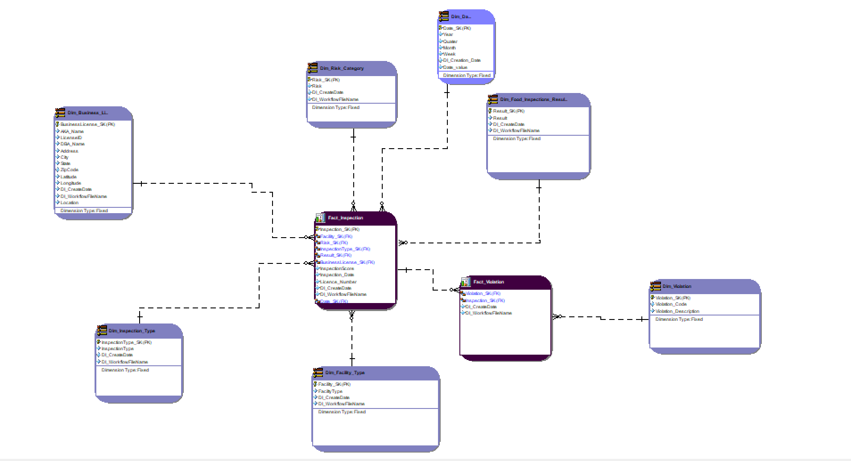

Fact Tables:

* There are two fact tables – Inspection and Violation

Dimensions:

* There are seven dimensions connected to the fact tables – Business License, Inspection Type, Facility Type, Violation, Date, Risk Category and Food Inspection Results.

Schema:

* The dimensional model is designed using a star schema

**STEP 2:** CREATE DDL SQL SCRIPT

**CREATE SCRIPT - DDL SQL SCRIPT GENERATED FROM ER STUDIO**

/*

* ER/Studio Data Architect SQL Code Generation

* Project : DimensionModel_Midterm.DM1

*

* Date Created : Sunday, February 25, 2024 06:28:00

* Target DBMS : Microsoft SQL Server 2019

*/

USE midterm_project

go

/*

* TABLE: Dim_Business_License

*/

CREATE TABLE Dim_Business_License(

BusinessLicense_SK int NOT NULL,

AKA_Name char(10) NULL,

LicenseID int NULL,

LegalName varchar(255) NULL,

DBA_Name varchar(255) NULL,

Address varchar(255) NULL,

City varchar(255) NULL,

State varchar(255) NULL,

ZipCode varchar(255) NULL,

Latitude real NULL,

Longitude real NULL,

DI_CreateDate date NULL,

DI_WorkflowFileName varchar(255) NULL,

Location varchar(255) NULL,

CONSTRAINT PK5 PRIMARY KEY NONCLUSTERED (BusinessLicense_SK)

)

go

IF OBJECT_ID('Dim_Business_License') IS NOT NULL

PRINT '<<< CREATED TABLE Dim_Business_License >>>'

ELSE

PRINT '<<< FAILED CREATING TABLE Dim_Business_License >>>'

go

/*

* TABLE: Dim_Date

*/

CREATE TABLE Dim_Date(

Date_SK char(10) NOT NULL,

Year char(10) NULL,

Quater char(10) NULL,

Month char(10) NULL,

Week char(10) NULL,

DI_Creation_Date char(10) NULL,

DI_workflowFileName char(10) NULL,

CONSTRAINT PK11 PRIMARY KEY NONCLUSTERED (Date_SK)

)

go

IF OBJECT_ID('Dim_Date') IS NOT NULL

PRINT '<<< CREATED TABLE Dim_Date >>>'

ELSE

PRINT '<<< FAILED CREATING TABLE Dim_Date >>>'

go

/*

* TABLE: Dim_Facility_Type

*/

CREATE TABLE Dim_Facility_Type(

Facility_SK int NOT NULL,

FaciltyType varchar(255) NULL,

DI_CreateDate datetime NULL,

DI_WorkflowFileName varchar(255) NULL,

CONSTRAINT PK10 PRIMARY KEY NONCLUSTERED (Facility_SK)

)

go

IF OBJECT_ID('Dim_Facility_Type') IS NOT NULL

PRINT '<<< CREATED TABLE Dim_Facility_Type >>>'

ELSE

PRINT '<<< FAILED CREATING TABLE Dim_Facility_Type >>>'

go

/*

* TABLE: Dim_Food_Inspections_Results

*/

CREATE TABLE Dim_Food_Inspections_Results(

Result_SK int NOT NULL,

Result varchar(255) NULL,

DI_CreateDate date NULL,

DI_WorkflowFileName varchar(255) NULL,

CONSTRAINT PK8 PRIMARY KEY NONCLUSTERED (Result_SK)

)

go

IF OBJECT_ID('Dim_Food_Inspections_Results') IS NOT NULL

PRINT '<<< CREATED TABLE Dim_Food_Inspections_Results >>>'

ELSE

PRINT '<<< FAILED CREATING TABLE Dim_Food_Inspections_Results >>>'

go

/*

* TABLE: Dim_Inspection_Type

*/

CREATE TABLE Dim_Inspection_Type(

InspectionType_SK int NOT NULL,

InspectionType varchar(255) NULL,

DI_CreateDate datetime NULL,

DI_WorkflowFileName varchar(255) NULL,

CONSTRAINT PK1 PRIMARY KEY NONCLUSTERED (InspectionType_SK)

)

go

IF OBJECT_ID('Dim_Inspection_Type') IS NOT NULL

PRINT '<<< CREATED TABLE Dim_Inspection_Type >>>'

ELSE

PRINT '<<< FAILED CREATING TABLE Dim_Inspection_Type >>>'

go

/*

* TABLE: Dim_Risk_Category

*/

CREATE TABLE Dim_Risk_Category(

Risk_SK int NOT NULL,

Risk varchar(255) NULL,

DI_CreateDate datetime NULL,

DI_WorkflowFlieName varchar(255) NULL,

CONSTRAINT PK3 PRIMARY KEY NONCLUSTERED (Risk_SK)

)

go

IF OBJECT_ID('Dim_Risk_Category') IS NOT NULL

PRINT '<<< CREATED TABLE Dim_Risk_Category >>>'

ELSE

PRINT '<<< FAILED CREATING TABLE Dim_Risk_Category >>>'

go

/*

* TABLE: Dim_Violation

*/

CREATE TABLE Dim_Violation(

Violation_SK int NOT NULL,

Violation_Code varchar(255) NULL,

Violation_Description varchar(255) NULL,

Violation_Comment varchar(255) NULL,

version varchar(255) NULL,

CONSTRAINT PK9 PRIMARY KEY NONCLUSTERED (Violation_SK)

)

go

IF OBJECT_ID('Dim_Violation') IS NOT NULL

PRINT '<<< CREATED TABLE Dim_Violation >>>'

ELSE

PRINT '<<< FAILED CREATING TABLE Dim_Violation >>>'

go

/*

* TABLE: Fact_Inspection

*/

CREATE TABLE Fact_Inspection(

Inspection_SK int NOT NULL,

Facility_SK int NOT NULL,

Risk_SK int NOT NULL,

InspectionType_SK int NOT NULL,

Result_SK int NOT NULL,

BusinessLicense_SK int NOT NULL,

InspectionScore varchar(255) NULL,

Inspection_Date date NULL,

Licence_Number varchar(255) NULL,

DI_CreateDate datetime NULL,

DI_WorkflowFileName varchar(255) NULL,

Date_SK char(10) NOT NULL,

CONSTRAINT PK2 PRIMARY KEY NONCLUSTERED (Inspection_SK)

)

go

IF OBJECT_ID('Fact_Inspection') IS NOT NULL

PRINT '<<< CREATED TABLE Fact_Inspection >>>'

ELSE

PRINT '<<< FAILED CREATING TABLE Fact_Inspection >>>'

go

/*

* TABLE: Fact_Violation

*/

CREATE TABLE Fact_Violation(

FactViolationSK int NOT NULL,

Violation_SK int NOT NULL,

Inspection_SK int NOT NULL,

Violation_Points varchar(255) NULL,

DI_CreateDate date NULL,

DI_WorkflowFileName varchar(255) NULL,

CONSTRAINT PK7 PRIMARY KEY NONCLUSTERED (FactViolationSK)

)

go

IF OBJECT_ID('Fact_Violation') IS NOT NULL

PRINT '<<< CREATED TABLE Fact_Violation >>>'

ELSE

PRINT '<<< FAILED CREATING TABLE Fact_Violation >>>'

go

/*

* TABLE: Fact_Inspection

*/

ALTER TABLE Fact_Inspection ADD CONSTRAINT RefDim_Risk_Category2

FOREIGN KEY (Risk_SK)

REFERENCES Dim_Risk_Category(Risk_SK)

go

ALTER TABLE Fact_Inspection ADD CONSTRAINT RefDim_Business_License4

FOREIGN KEY (BusinessLicense_SK)

REFERENCES Dim_Business_License(BusinessLicense_SK)

go

ALTER TABLE Fact_Inspection ADD CONSTRAINT RefDim_Food_Inspections_Results6

FOREIGN KEY (Result_SK)

REFERENCES Dim_Food_Inspections_Results(Result_SK)

go

ALTER TABLE Fact_Inspection ADD CONSTRAINT RefDim_Facility_Type7

FOREIGN KEY (Facility_SK)

REFERENCES Dim_Facility_Type(Facility_SK)

go

ALTER TABLE Fact_Inspection ADD CONSTRAINT RefDim_Date11

FOREIGN KEY (Date_SK)

REFERENCES Dim_Date(Date_SK)

go

ALTER TABLE Fact_Inspection ADD CONSTRAINT RefDim_Inspection_Type1

FOREIGN KEY (InspectionType_SK)

REFERENCES Dim_Inspection_Type(InspectionType_SK)

go

/*

* TABLE: Fact_Violation

*/

ALTER TABLE Fact_Violation ADD CONSTRAINT RefFact_Inspection9

FOREIGN KEY (Inspection_SK)

REFERENCES Fact_Inspection(Inspection_SK)

go

ALTER TABLE Fact_Violation ADD CONSTRAINT RefDim_Violation10

FOREIGN KEY (Violation_SK)

REFERENCES Dim_Violation(Violation_SK)

go

**DELIVERABLES – PART 3:**

**STEP 1:** LOAD DIMENSIONAL MODEL INTO INTEGRATION TABLES

* Stage tables have been read from Talend and model was loaded.
* Dimensions and facts have been prefixed with dim_ /fact_.

**SCREENSHOTS OF DIMENSIONAL AND FACT TABLES AND RESPECTIVE SQL COUNT**

1. **Dim_Business_License**

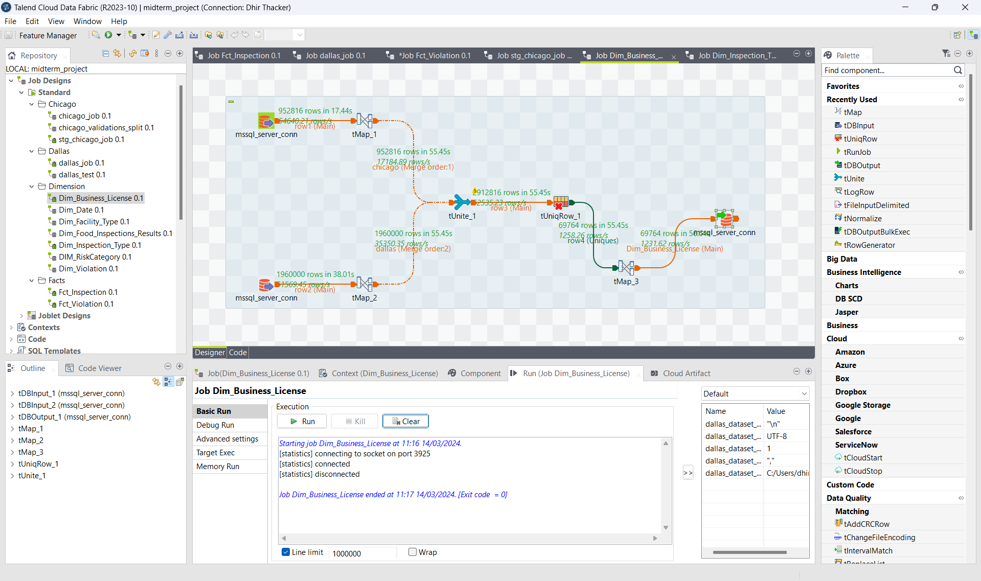

T-map 1 of Dim_Business_License

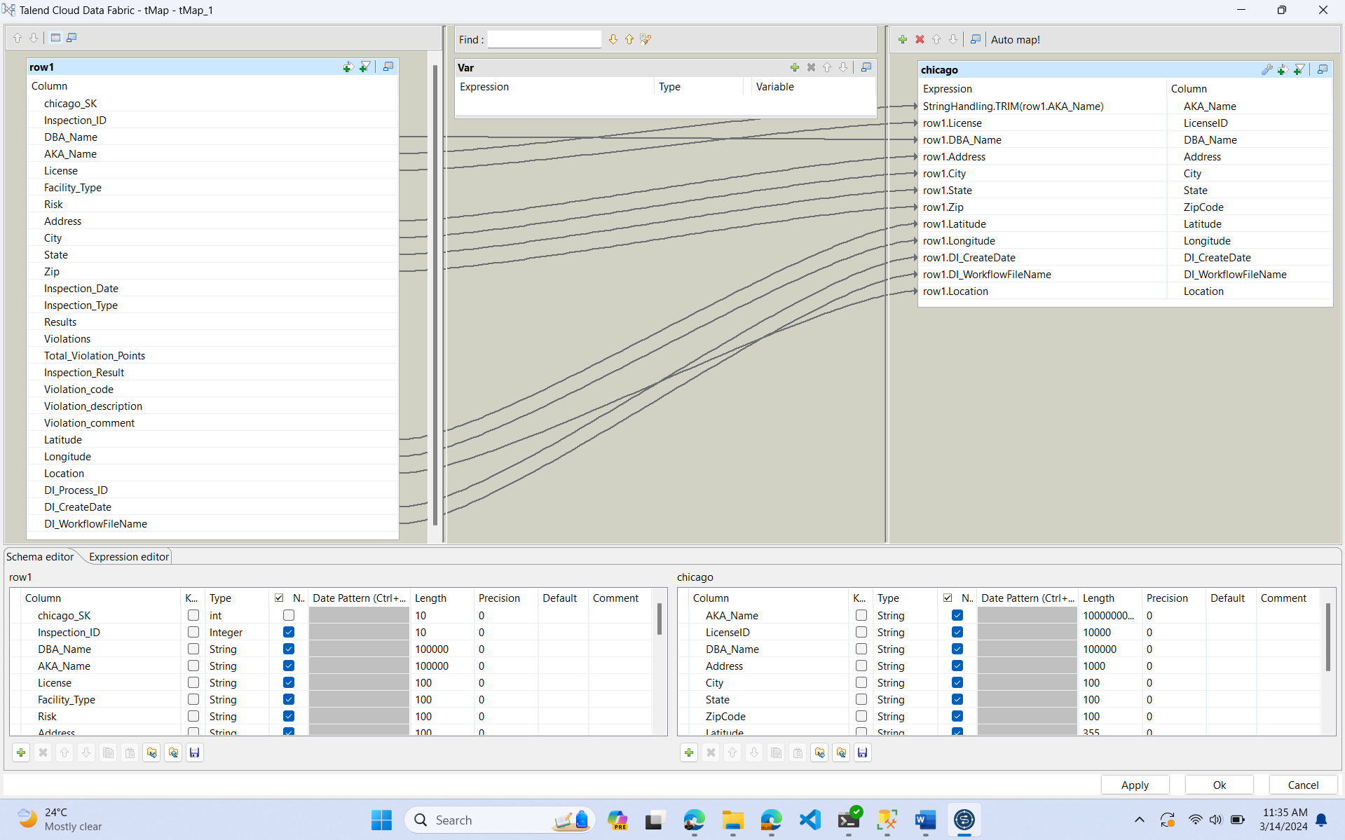

T-map 2 of Dim_Business_License

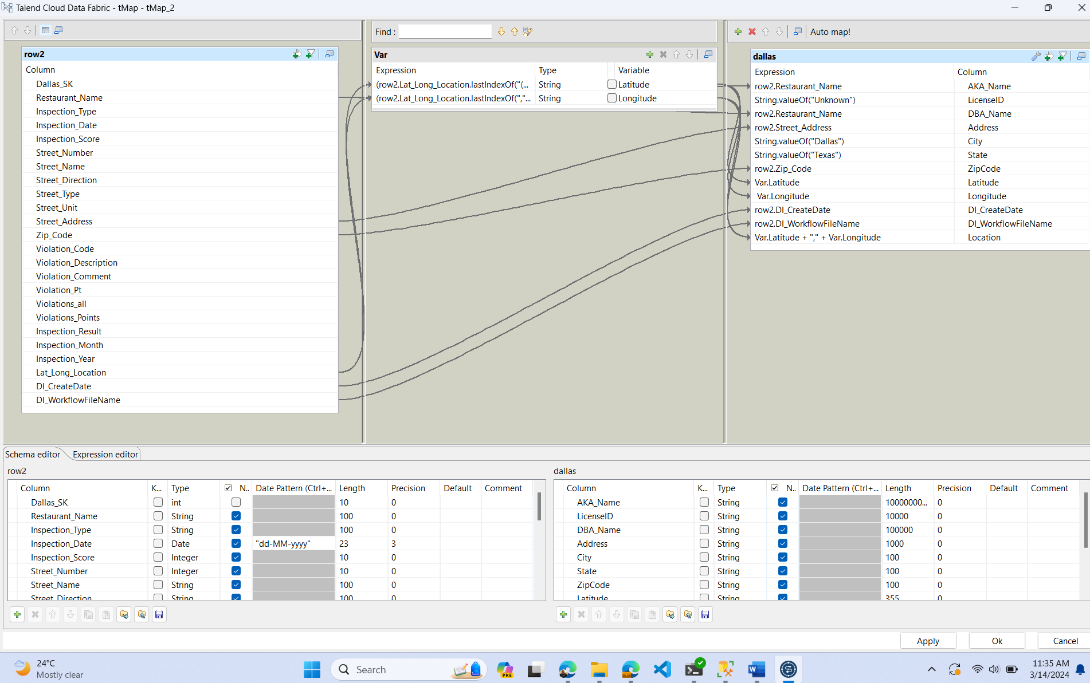

T-Map 3 of Dim_Business_License

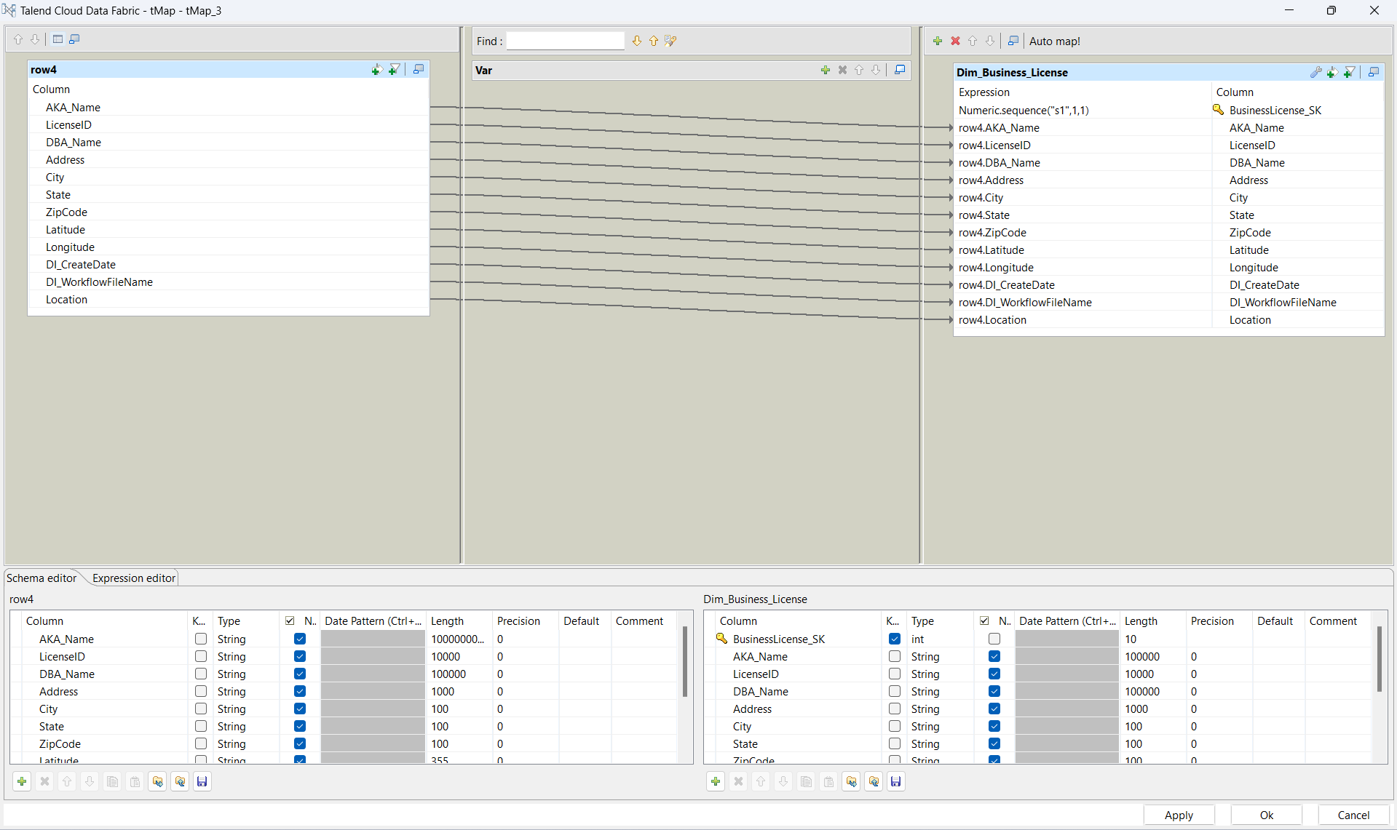

T-UniqRow of Dim_Business_License

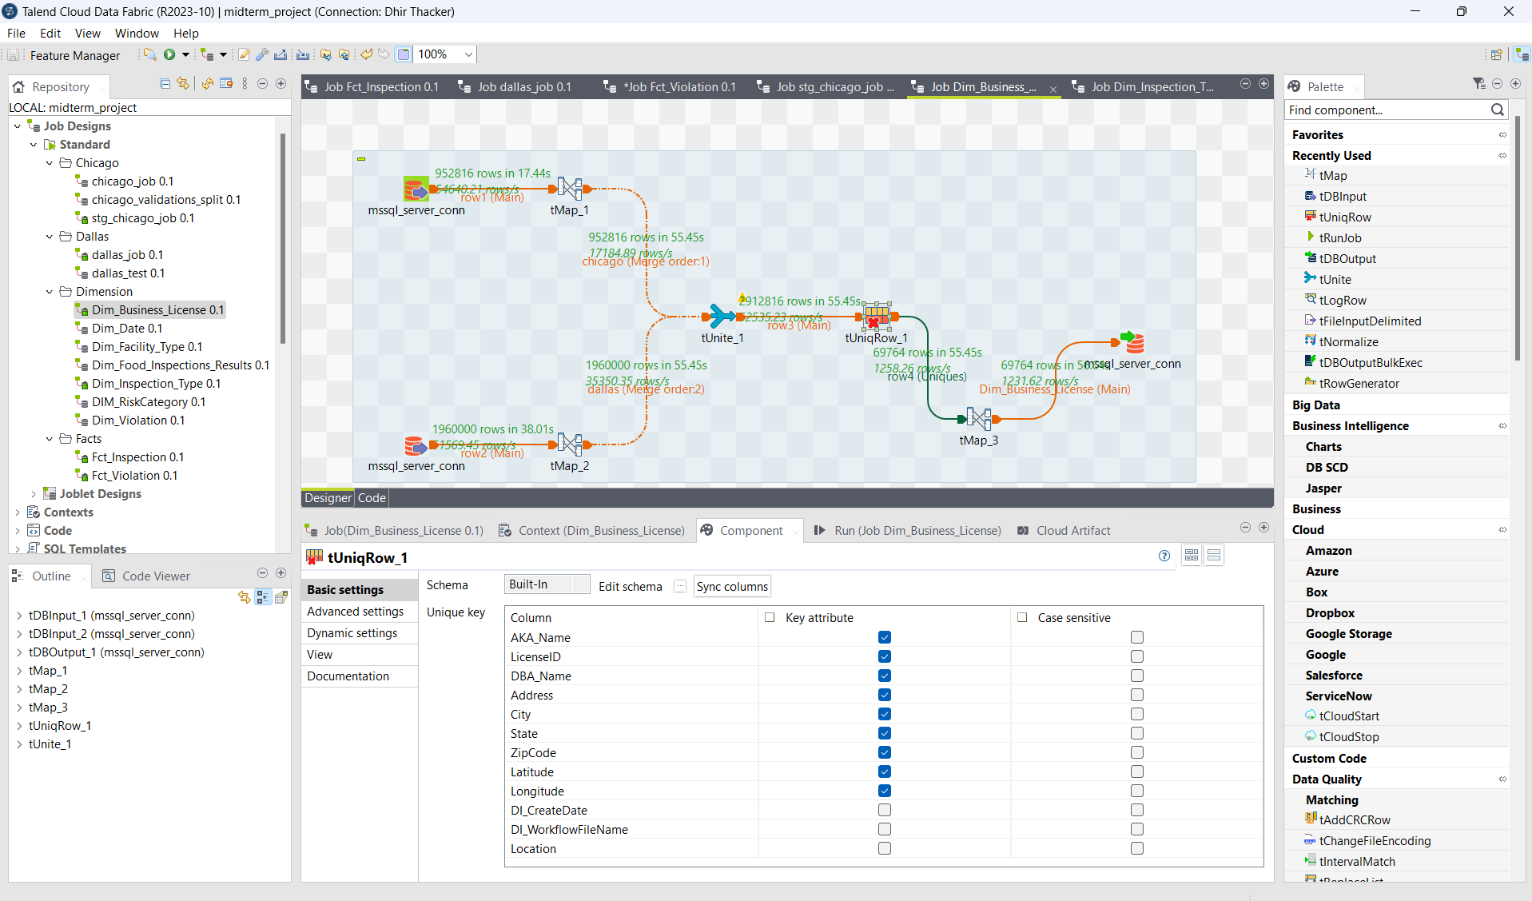

SQL Output:



1. **Dim_Date**

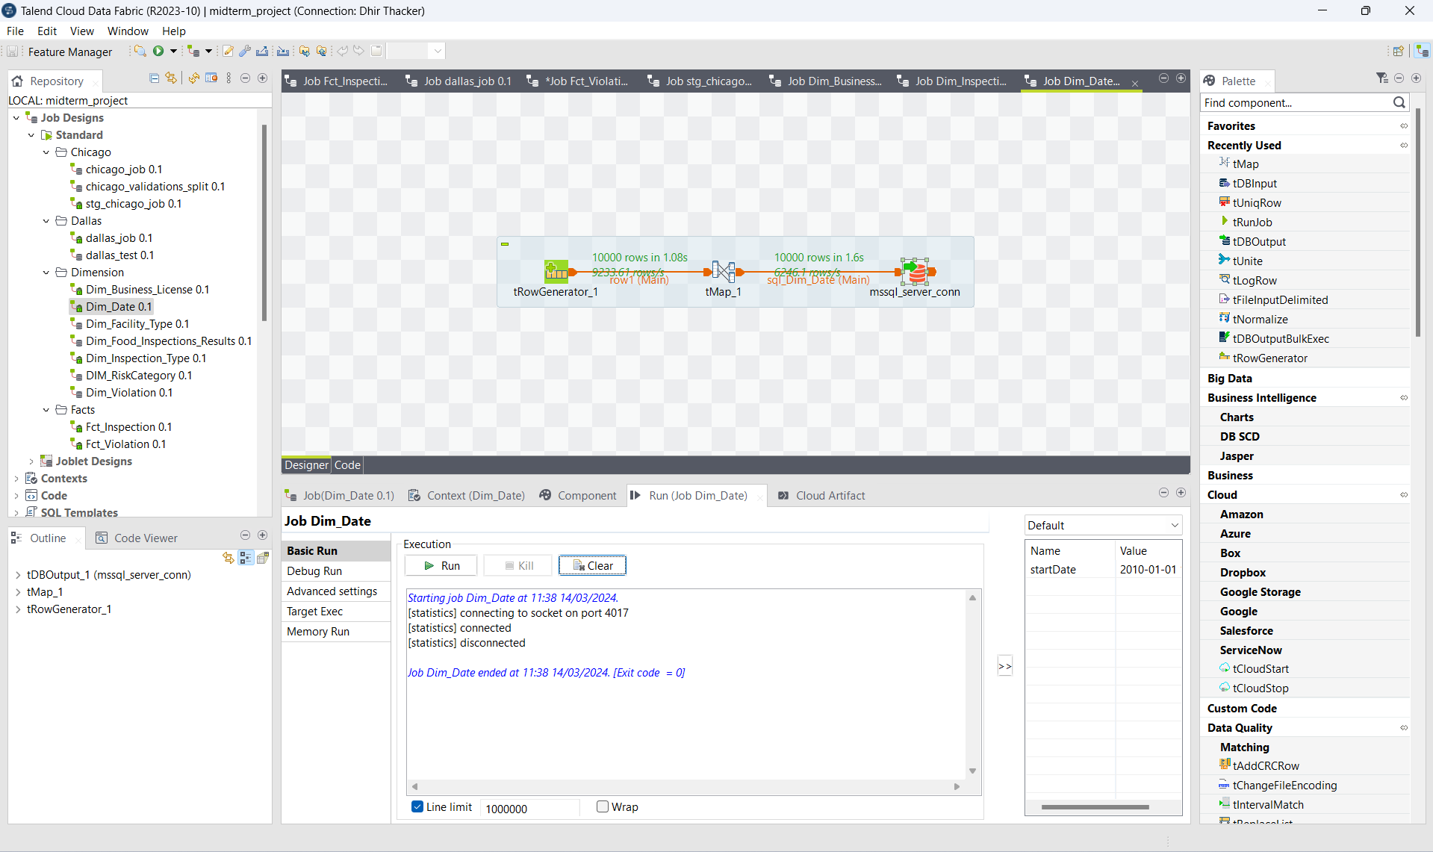

T-Map of Dim_Date

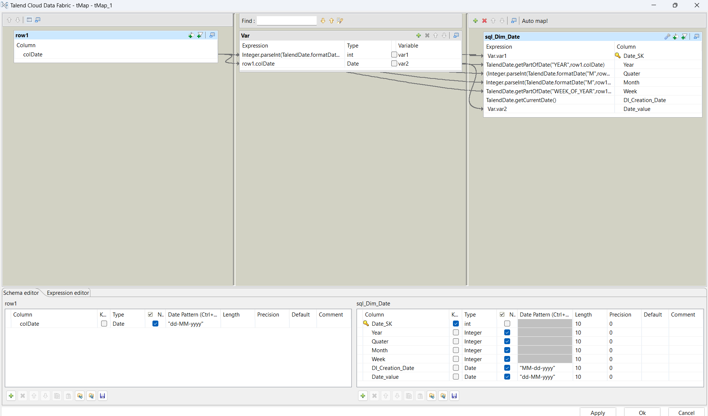

SQL Output:

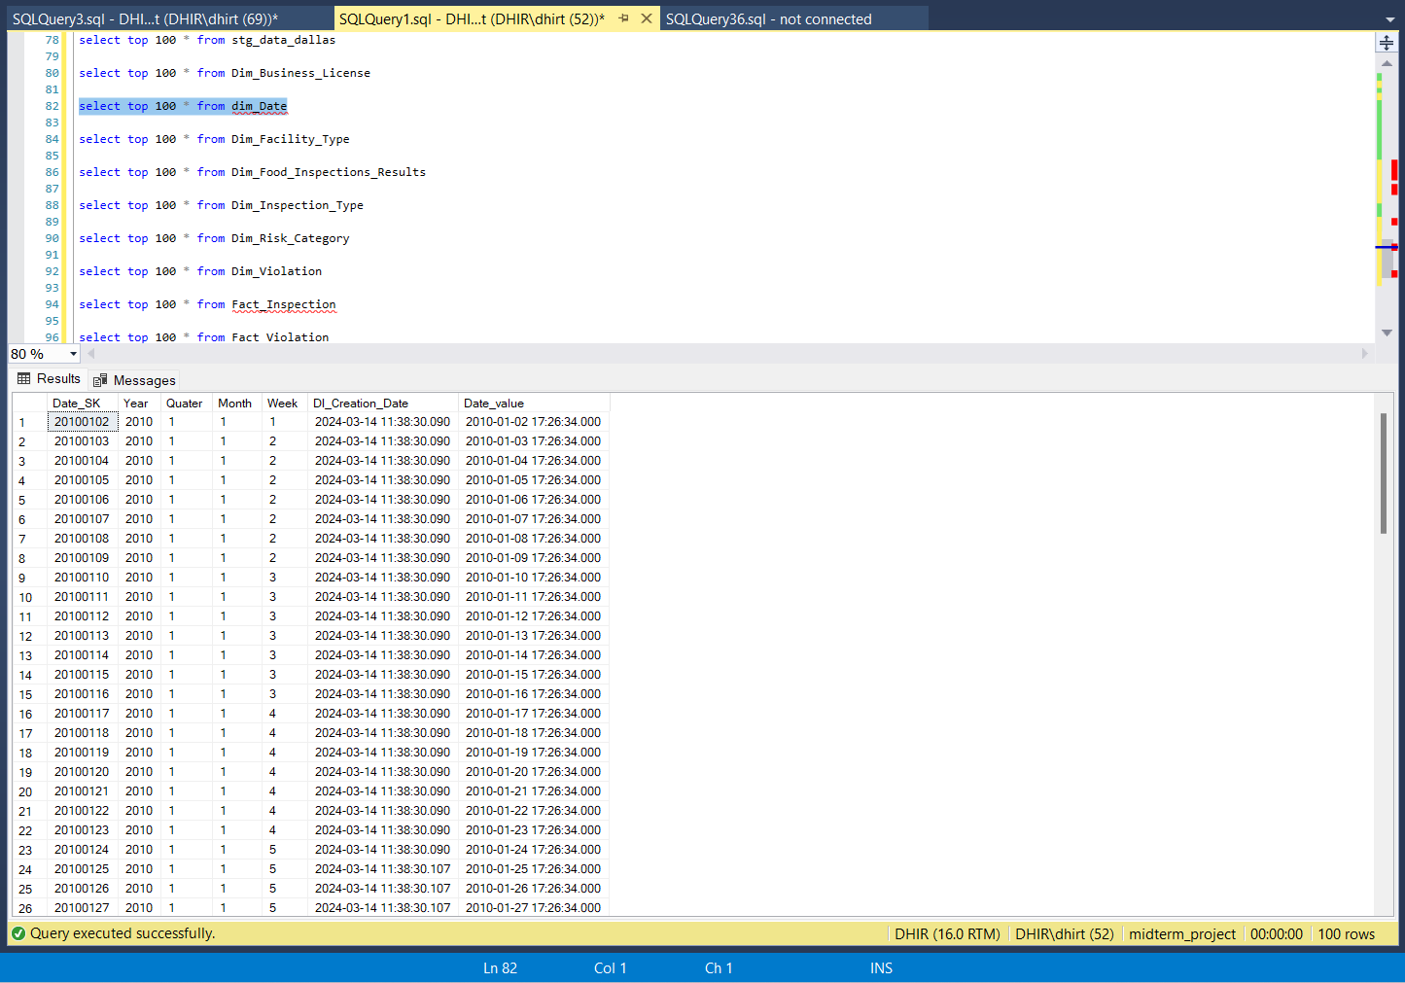

1. **Dim_Facility_Type**

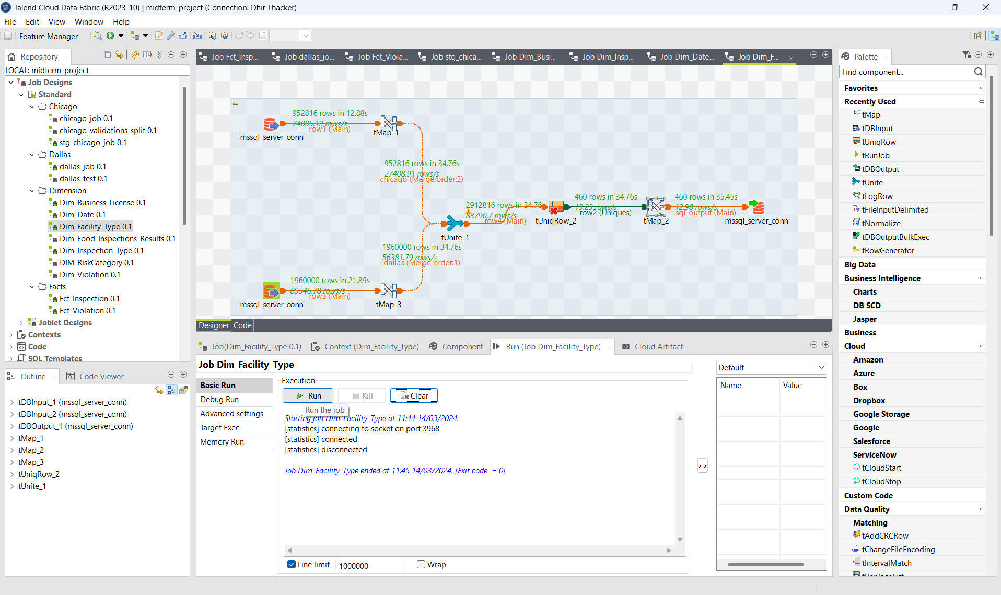

T-Map 1 of Dim_Facility_Type

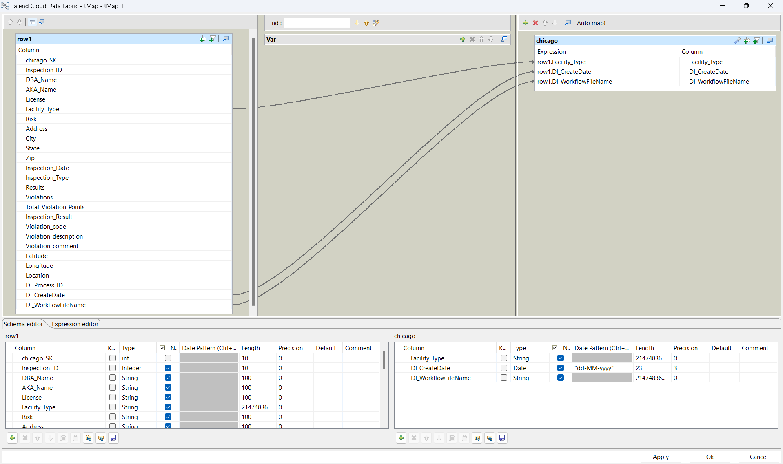

T-Map 2 of Dim_Facility_Type

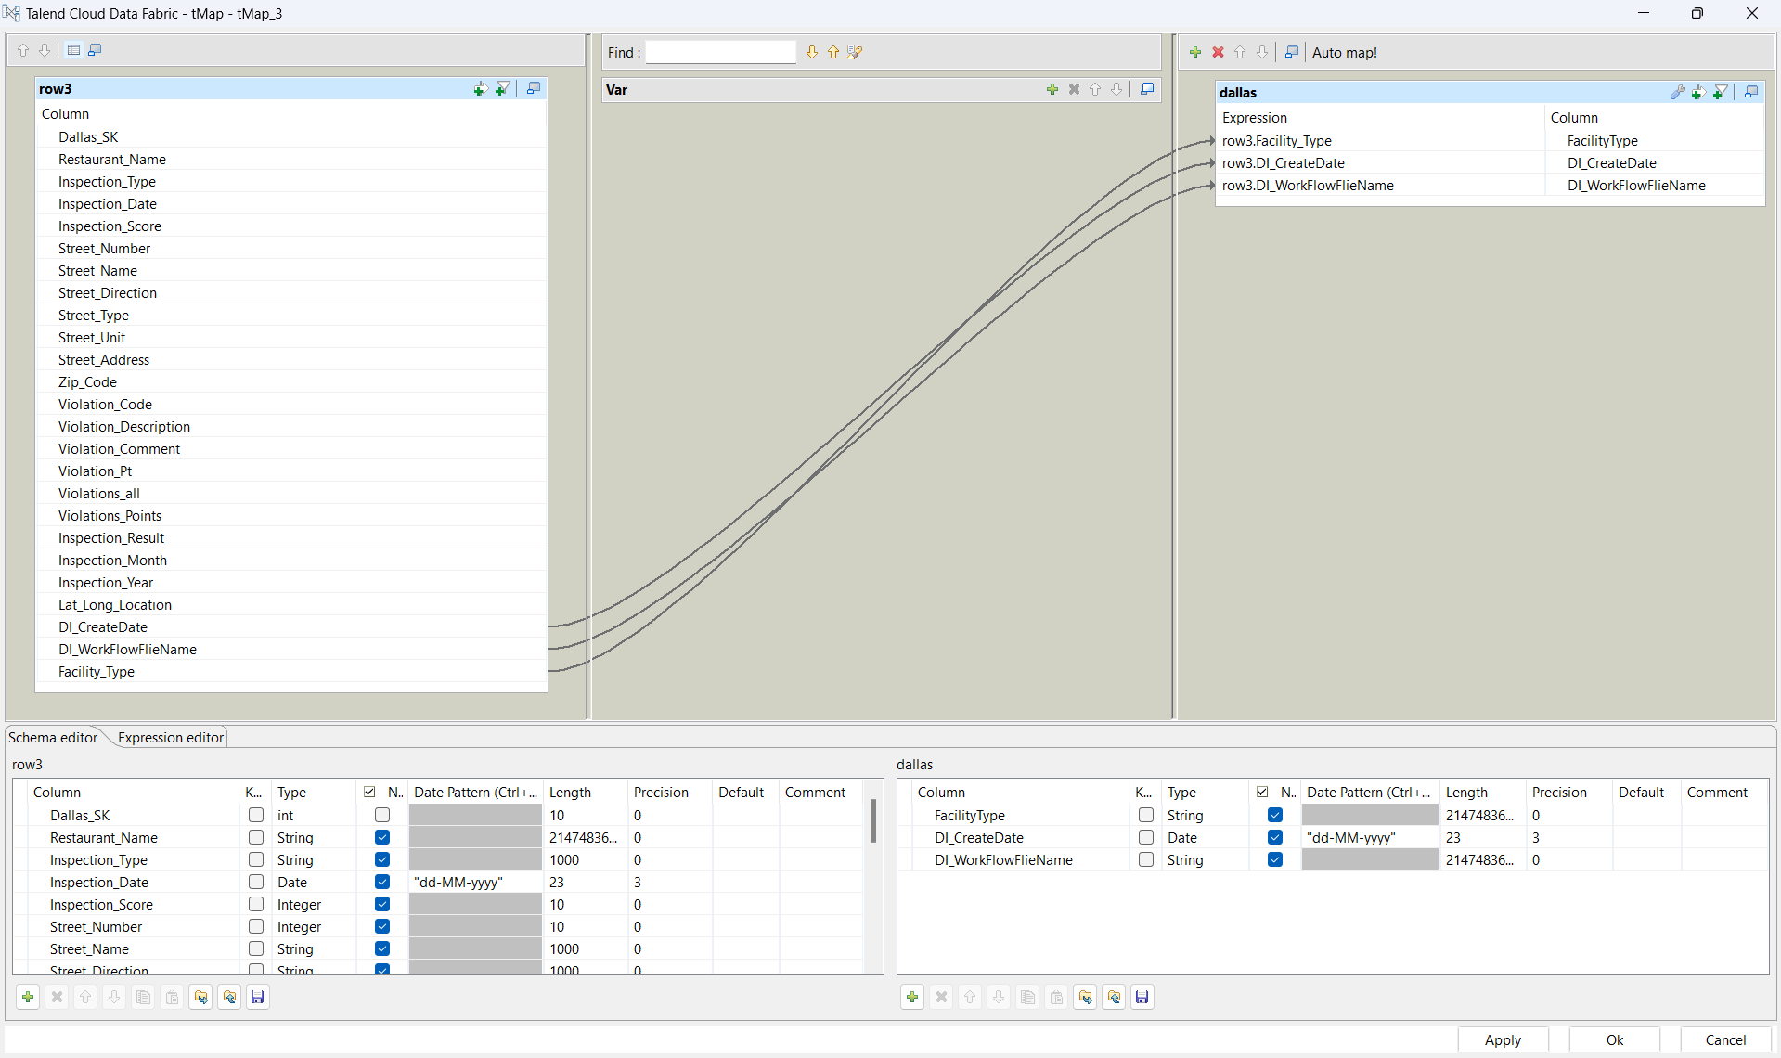

T-Map 3 of Dim_Facility_Type

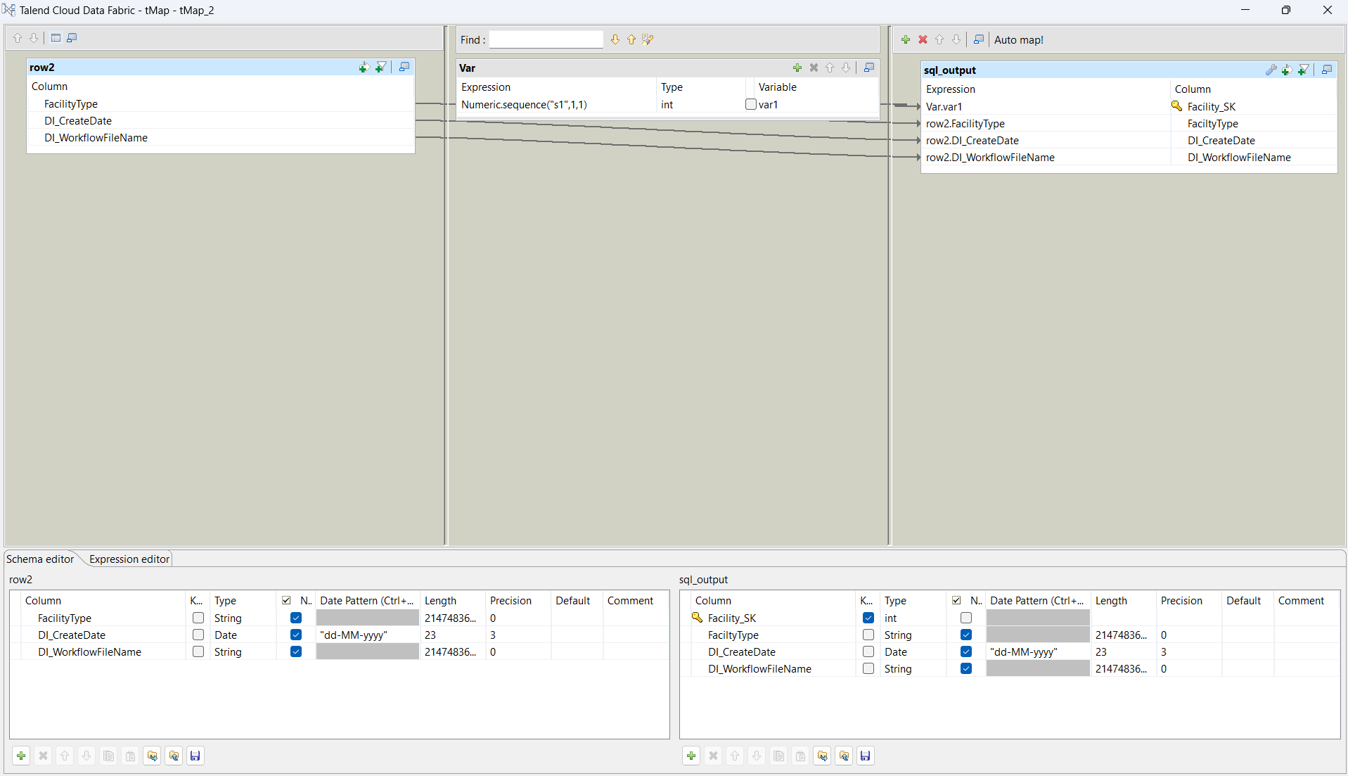

T-UniqRow of Dim_Facility_Type

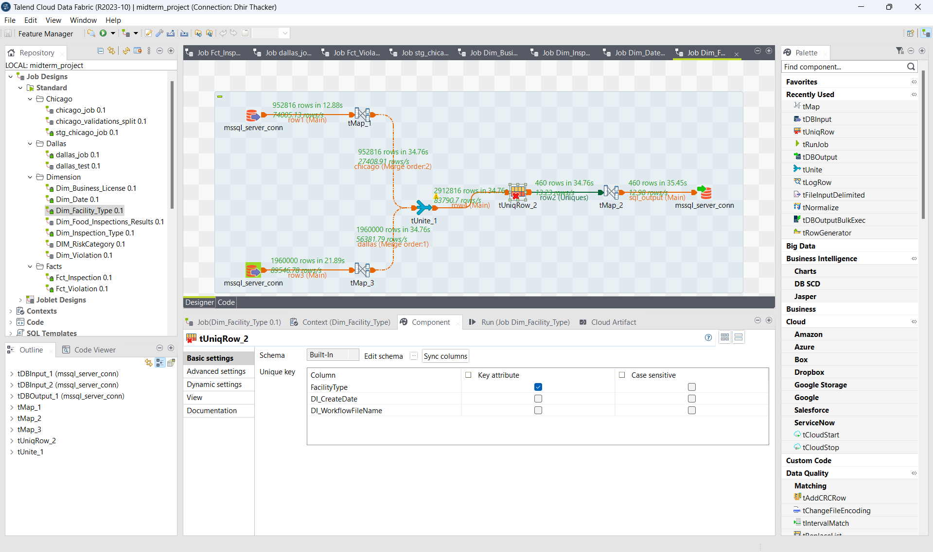

SQL Output:

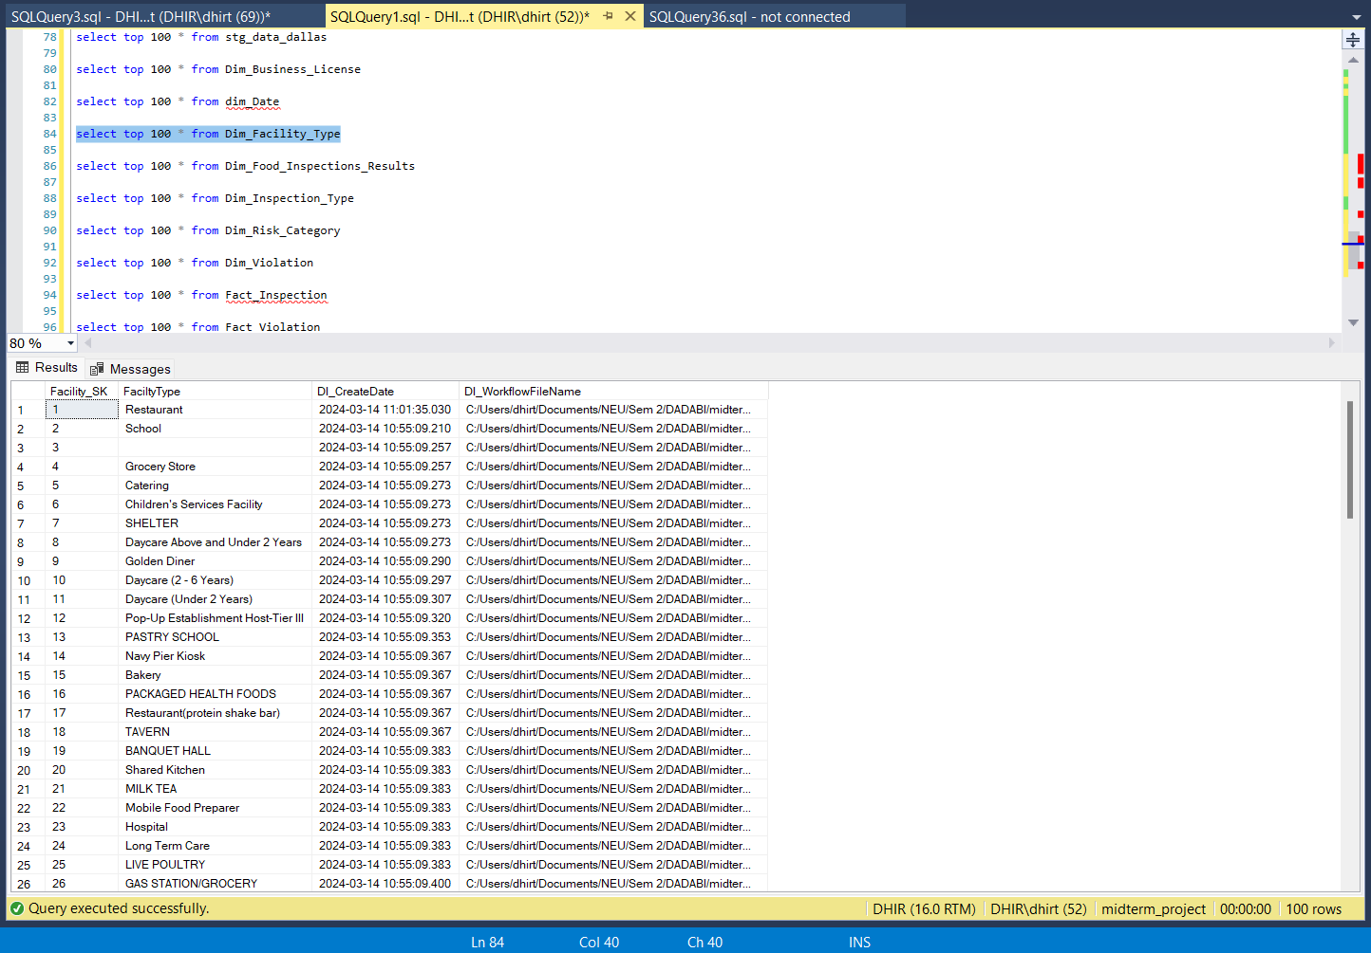

1. **Dim_Food_Inspections_Results**

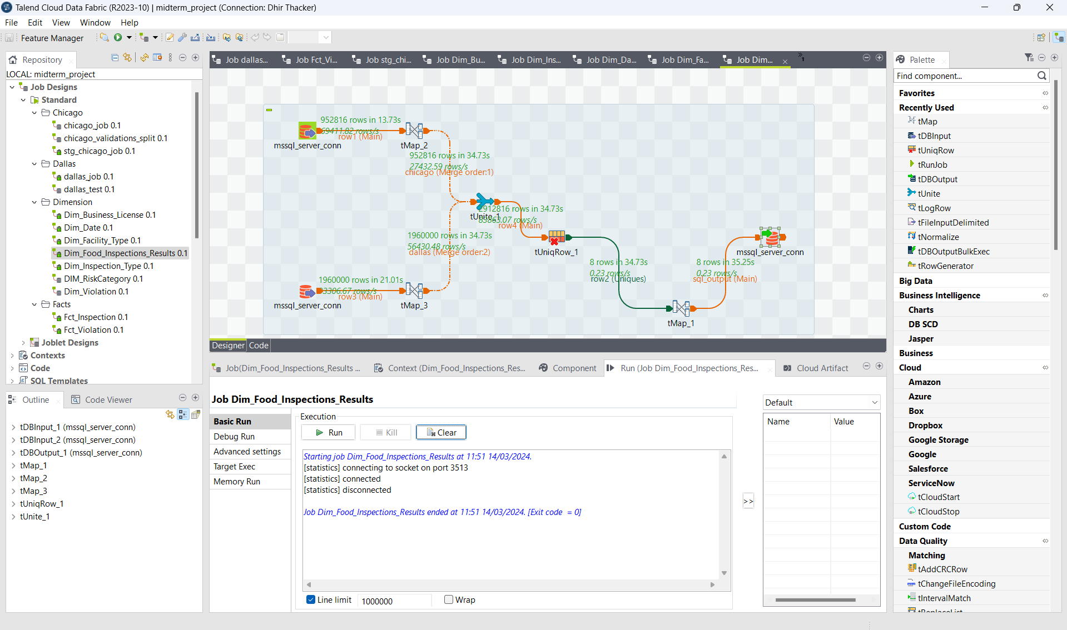

T-Map 1 of Dim_Food_Inspections_Results

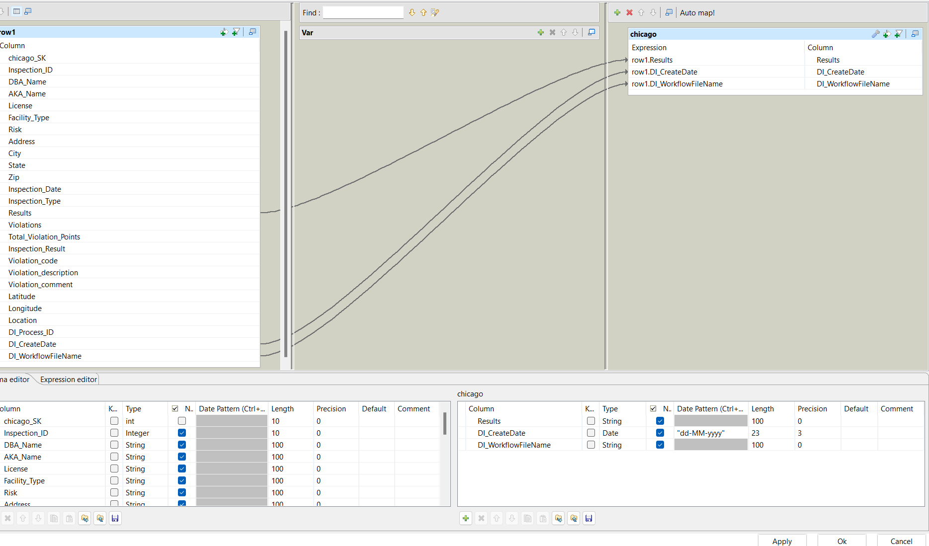

T-Map 2 of Dim_Food_Inspections_Results

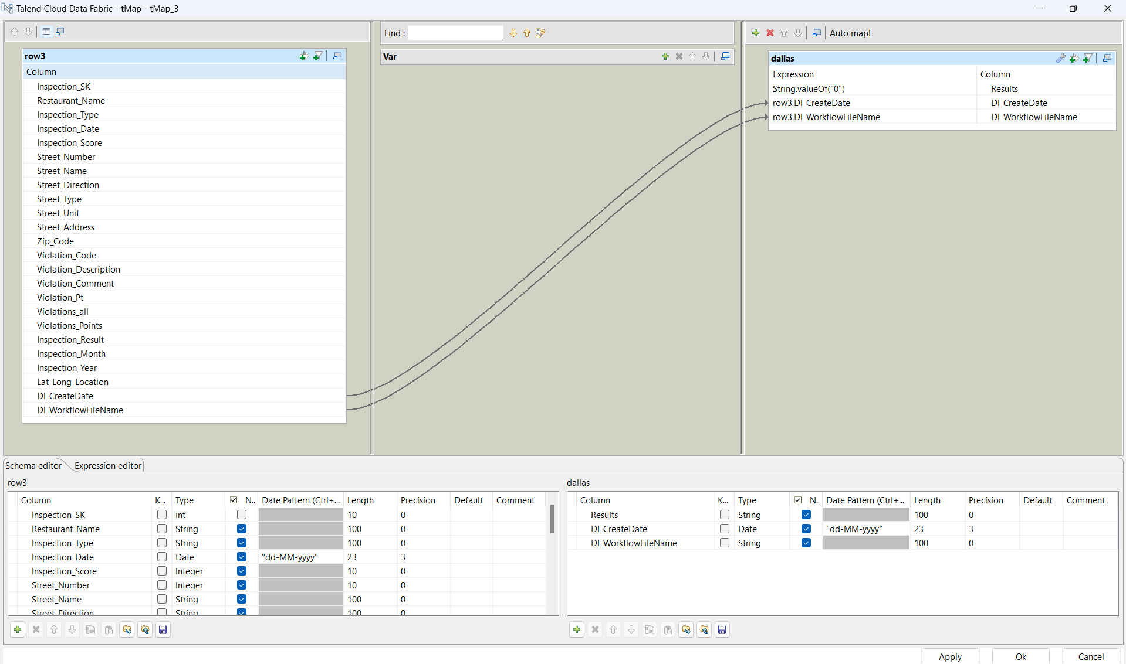

T-Map 3 of Dim_Food_Inspections_Results

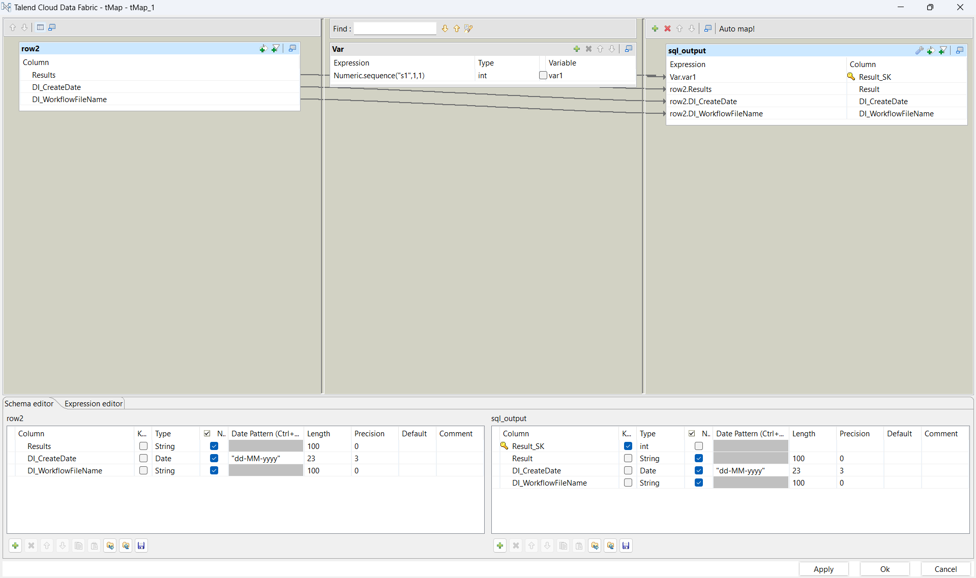

T-UniqRow of Dim_Food_Inspections_Results

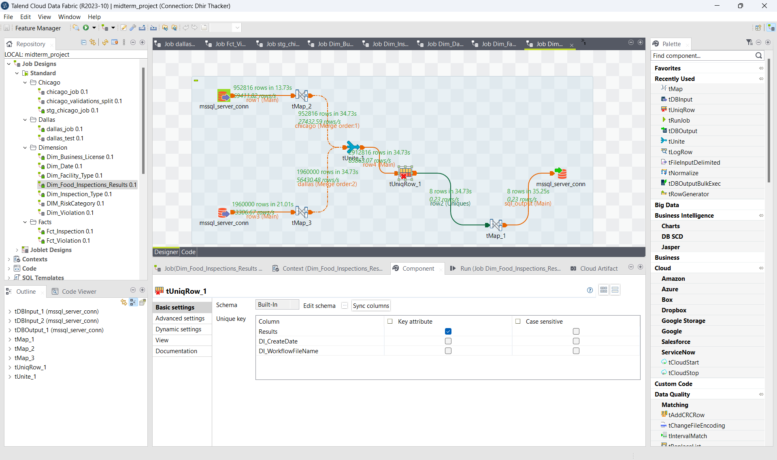

SQL Output:

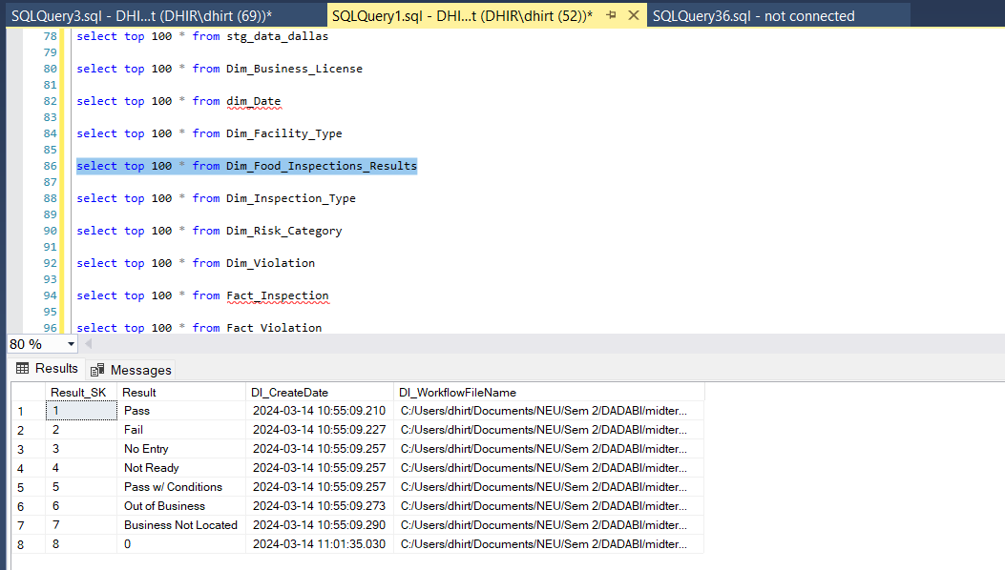

1. **Dim_InspectionType**

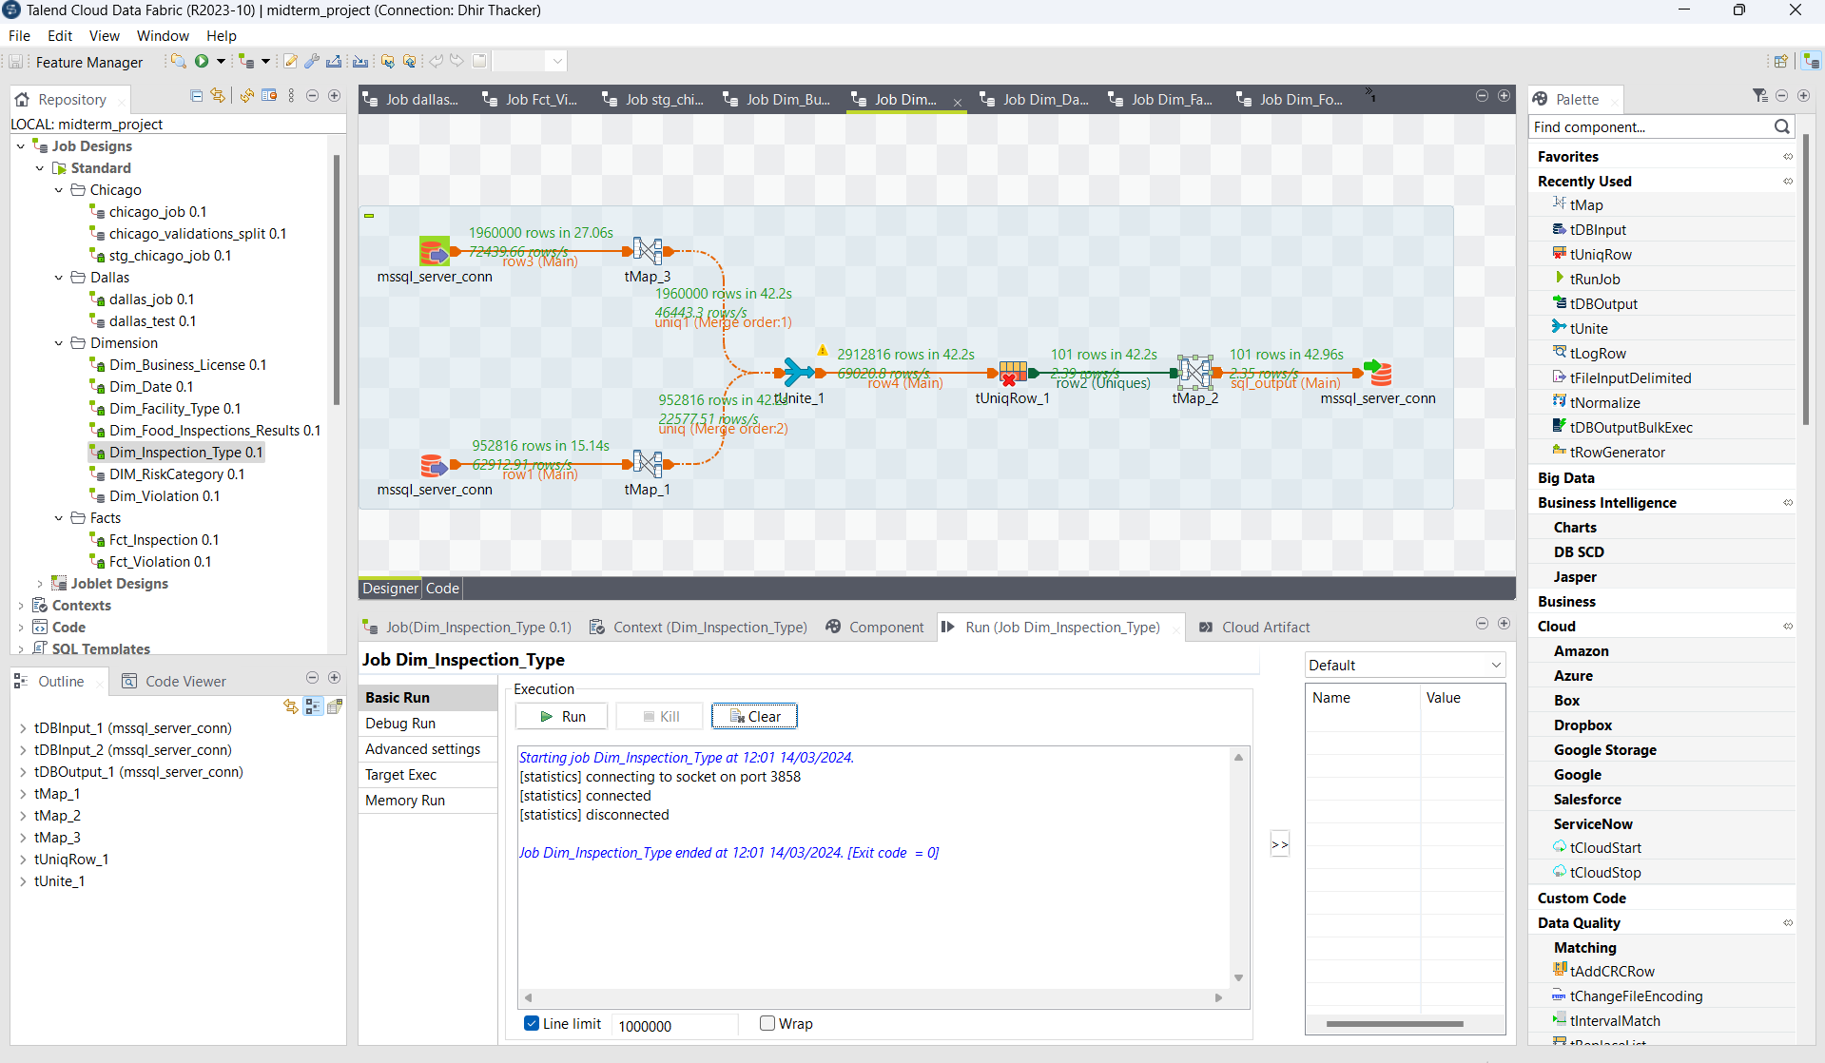

T-Map 1 of Dim_InspectionType

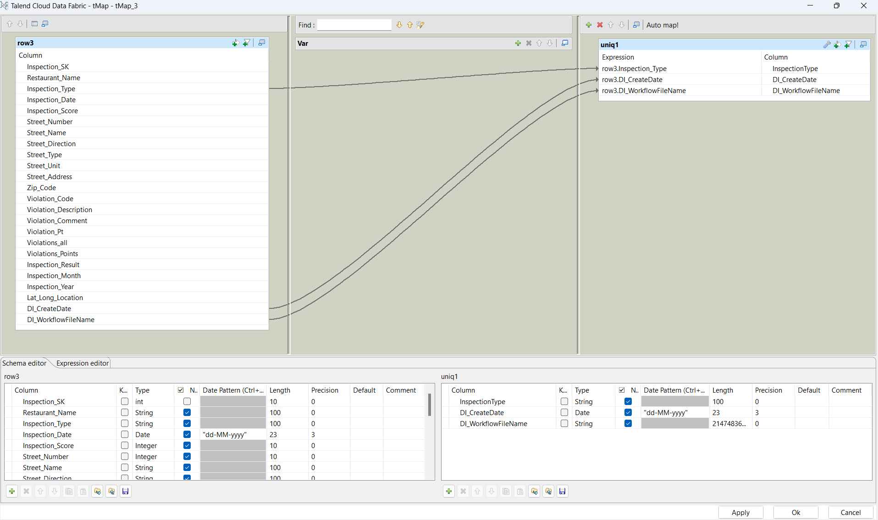

T-Map 2 of Dim_InspectionType

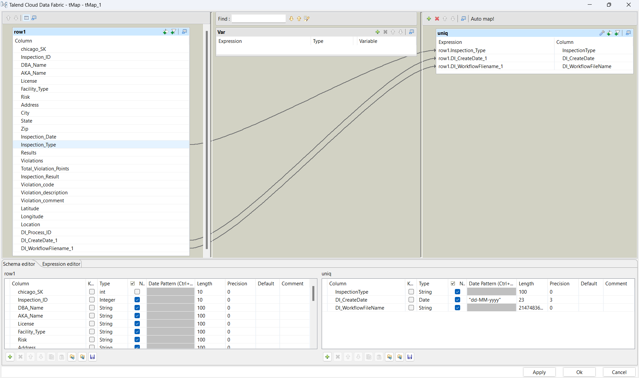

T-Map 3 of Dim_InspectionType

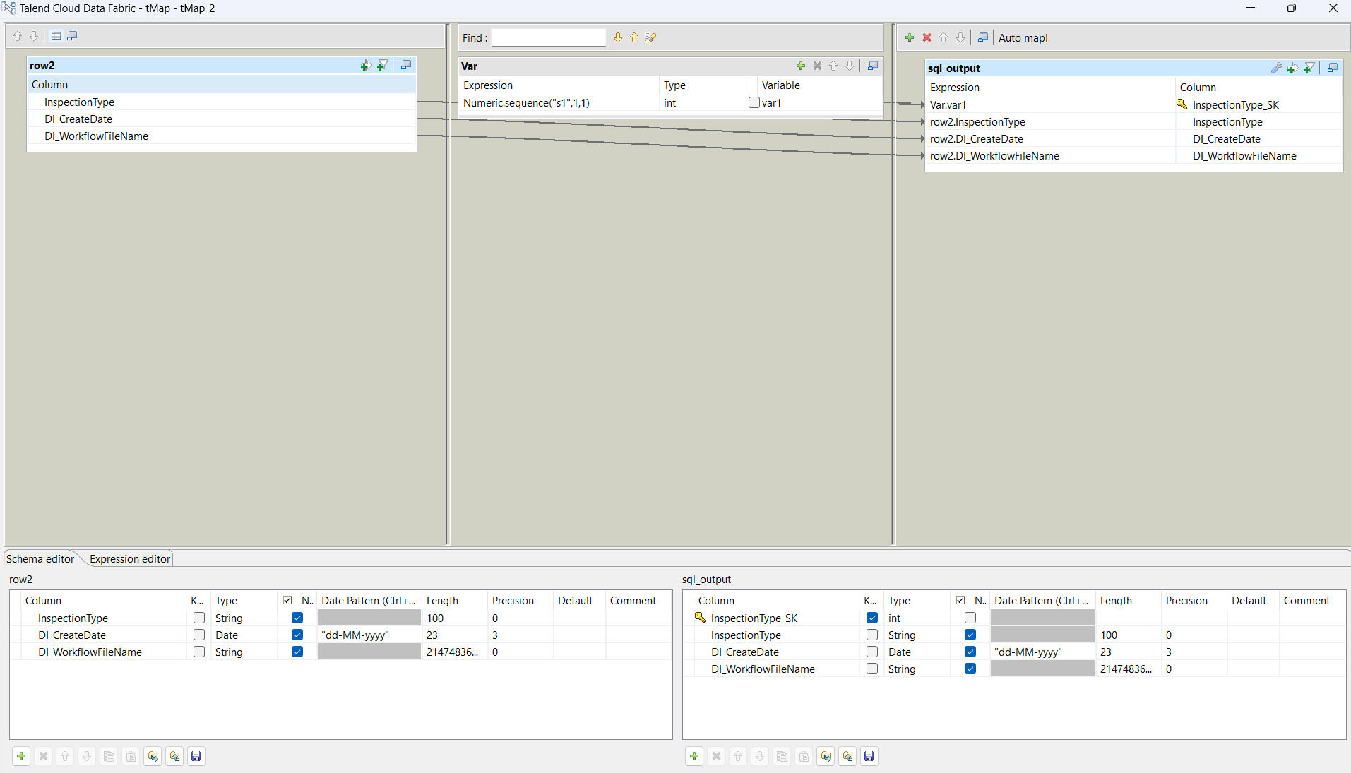

T-UniqRow of Dim_InspectionType

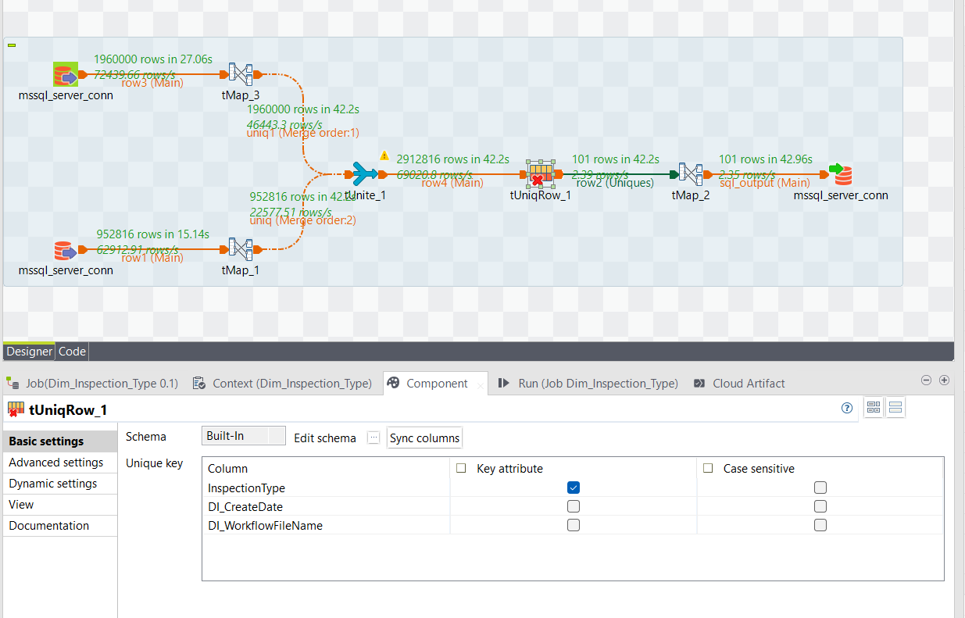

SQL Output:

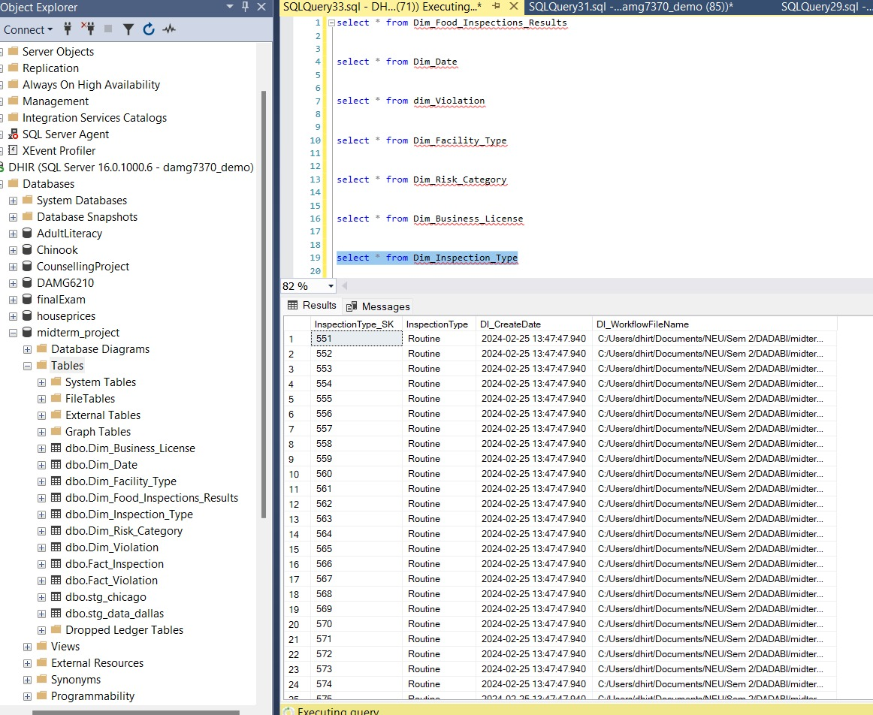

1. **Dim_Risk_Category**

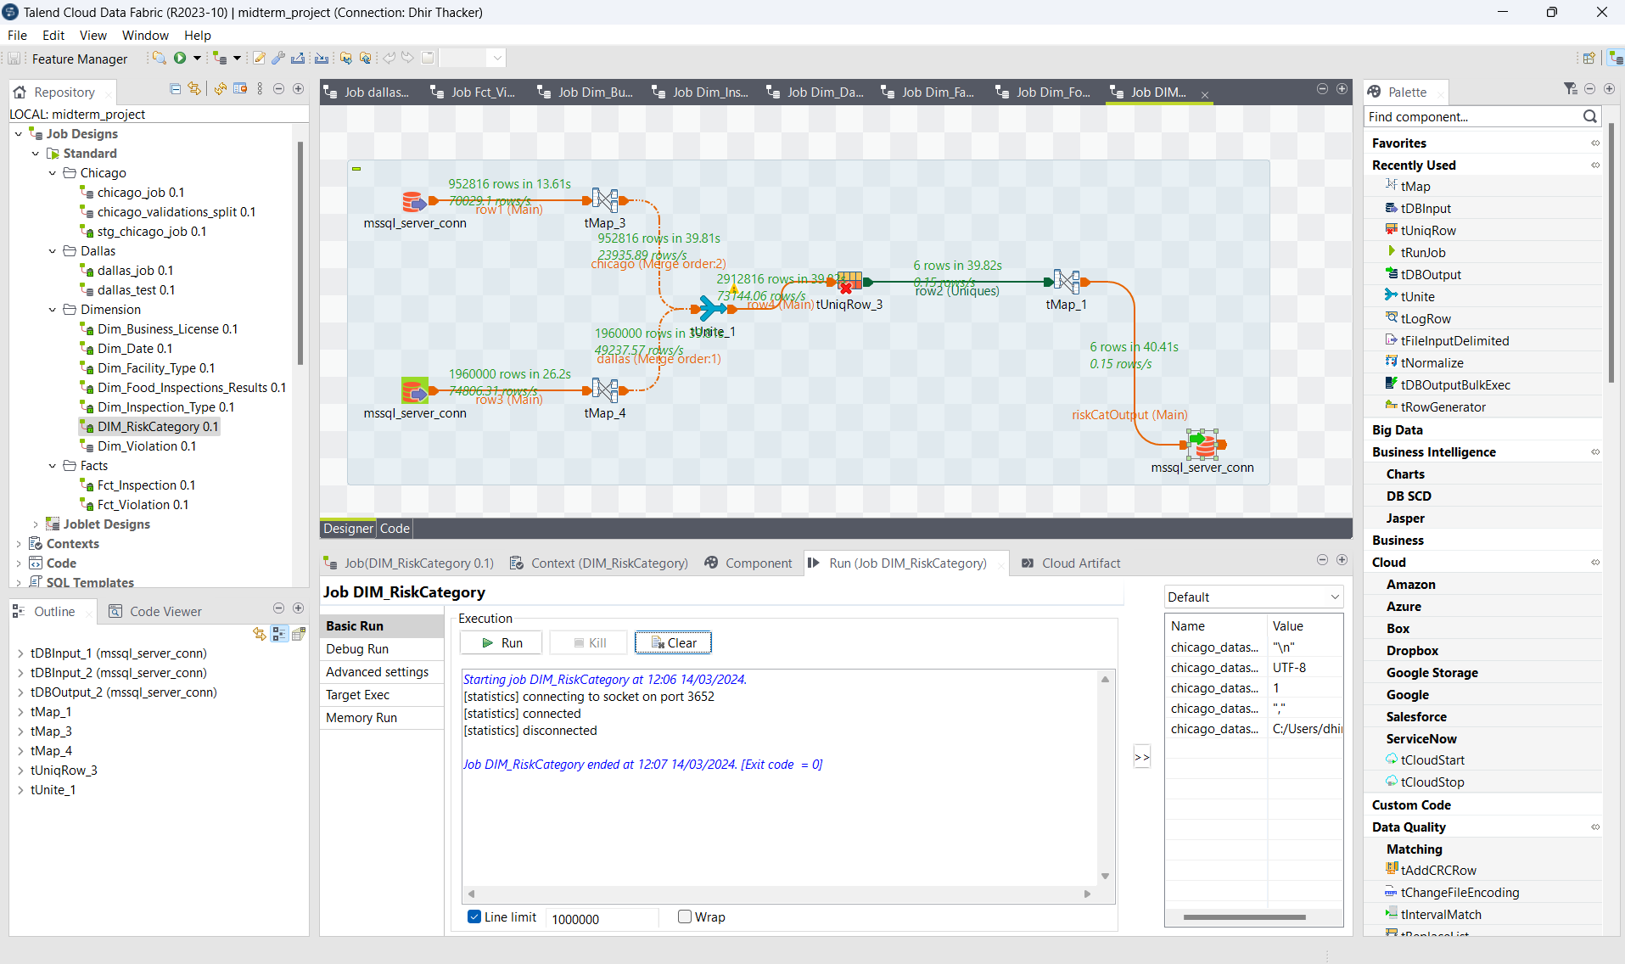

T-Map 1 of Dim_Risk_Category 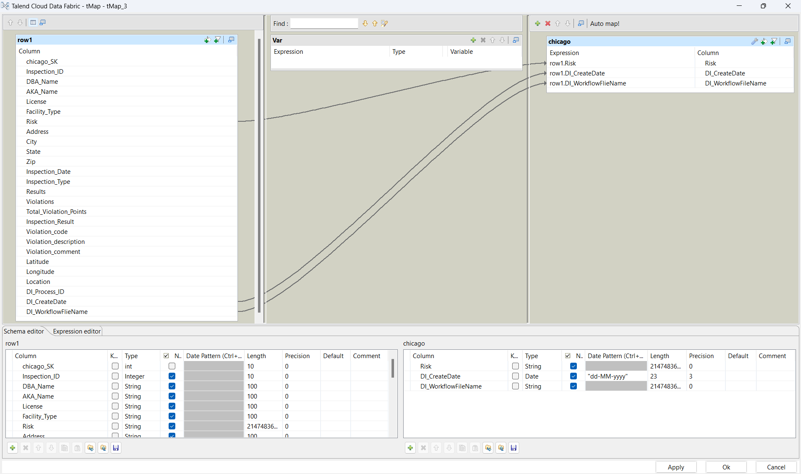

T-Map 2 of Dim_Risk_Category

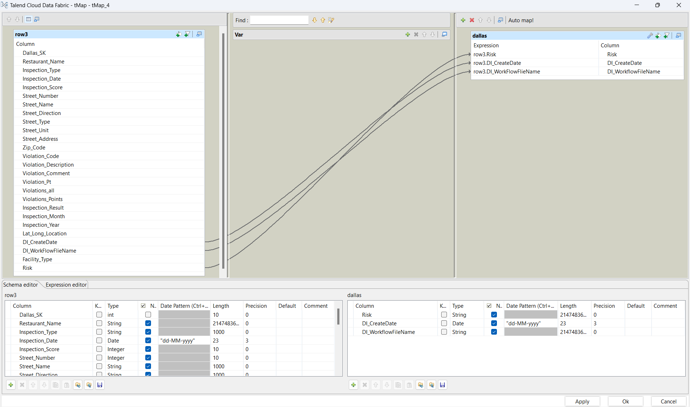

T-Map 3 of Dim_Risk_Category

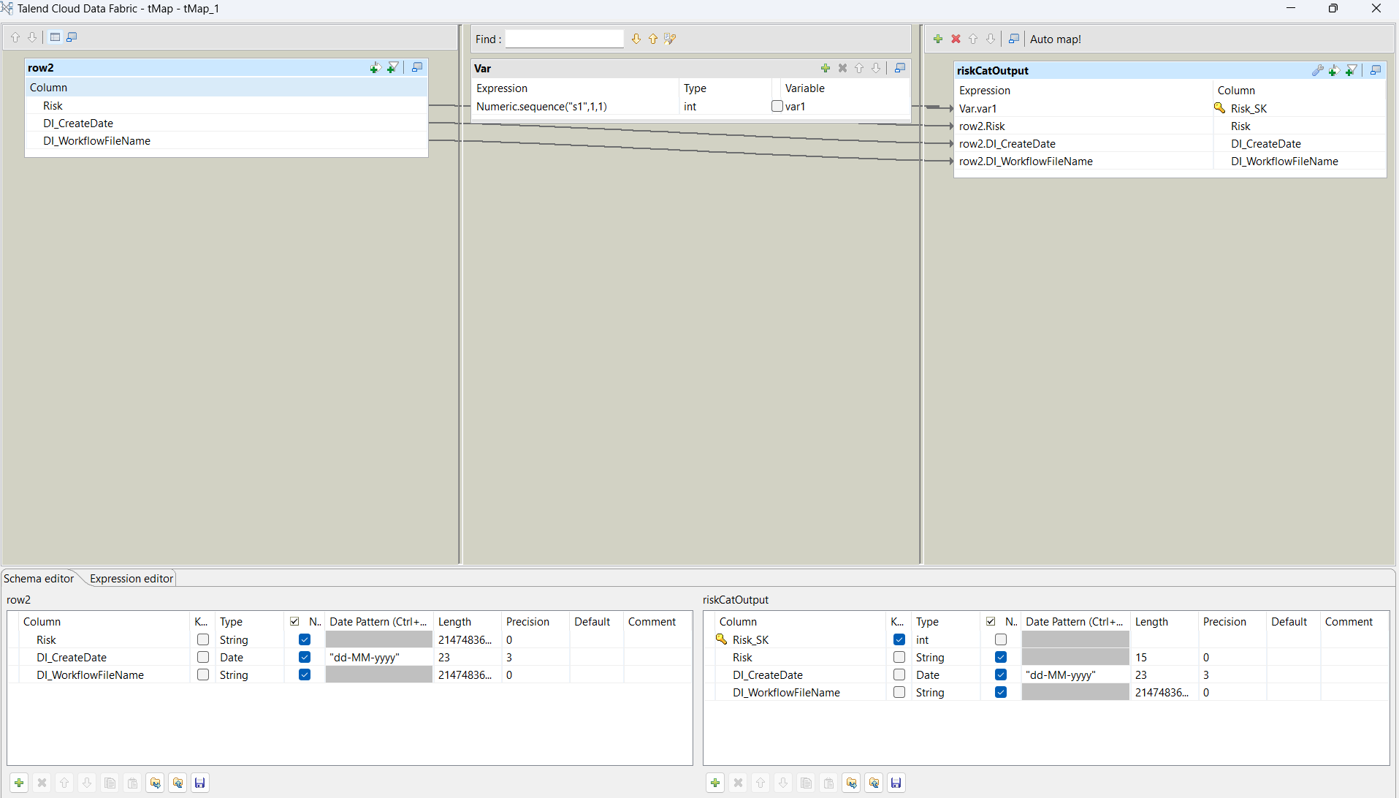

T-UniqRow of Dim_Risk_Category

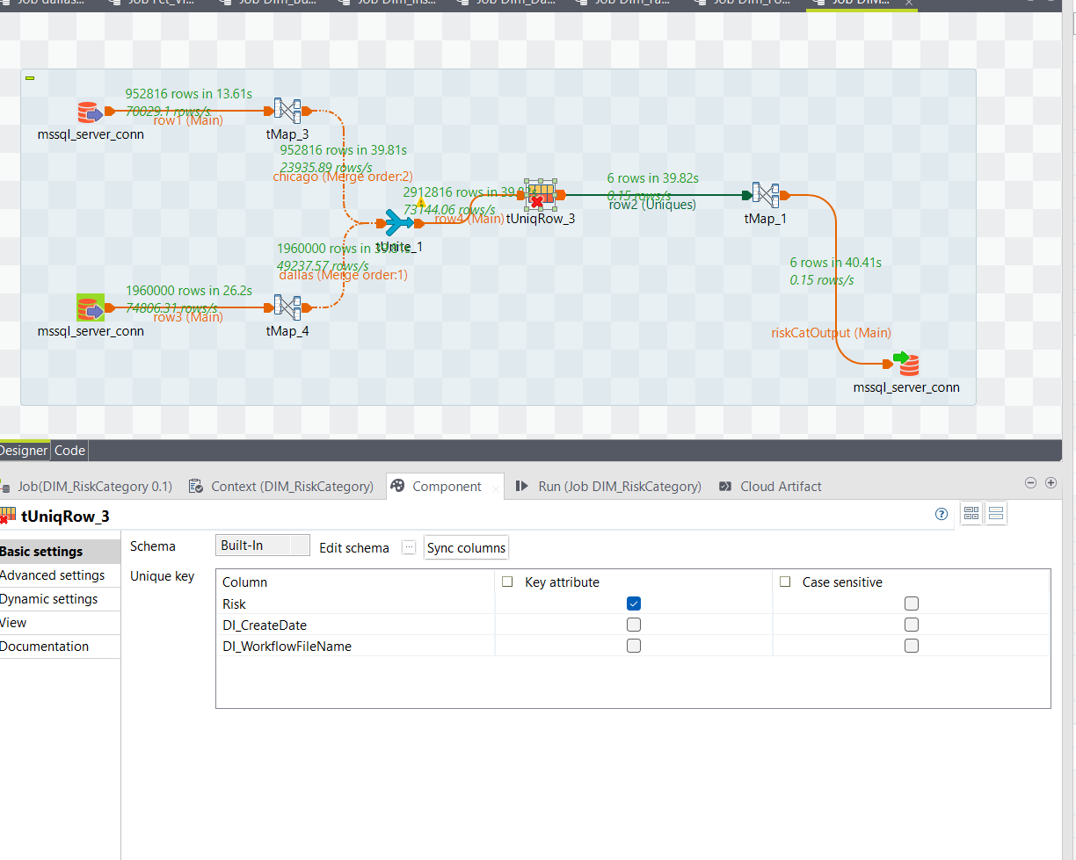

SQL Output:

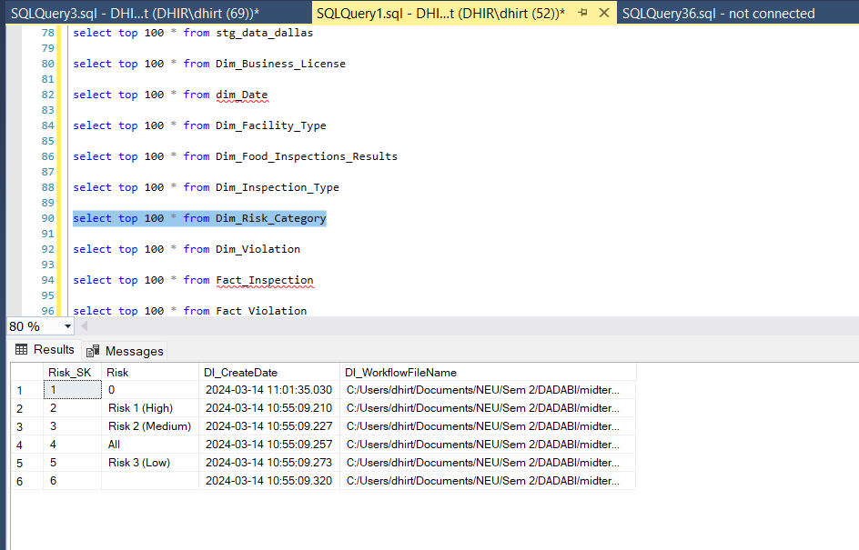

1. **Dim_Violation**

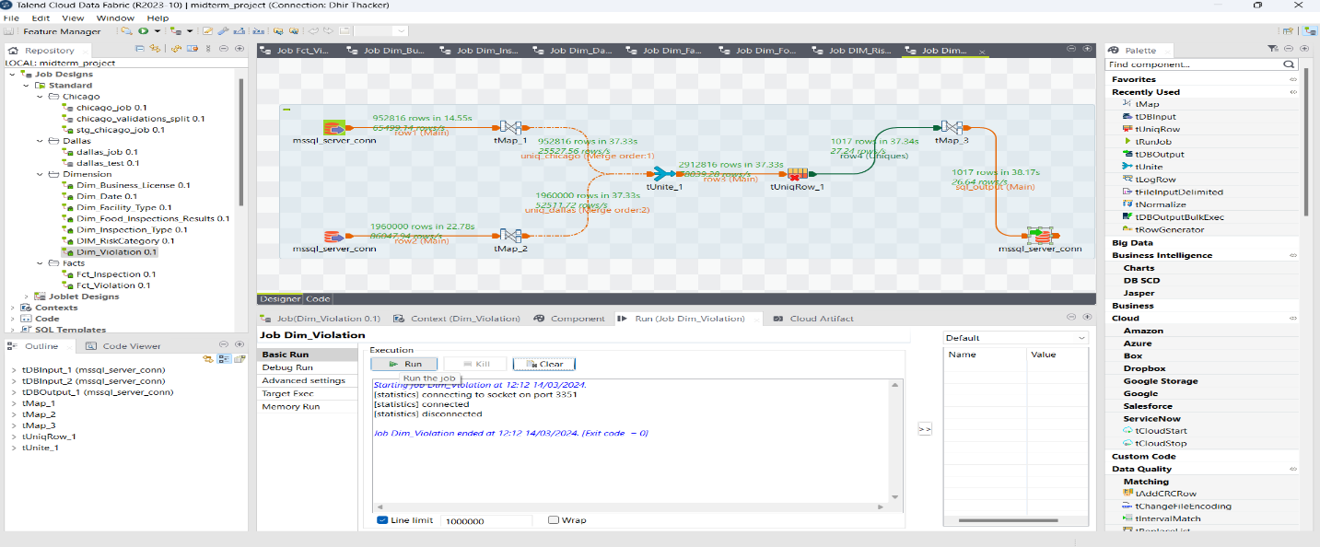

T-Map 1 of Dim_Violation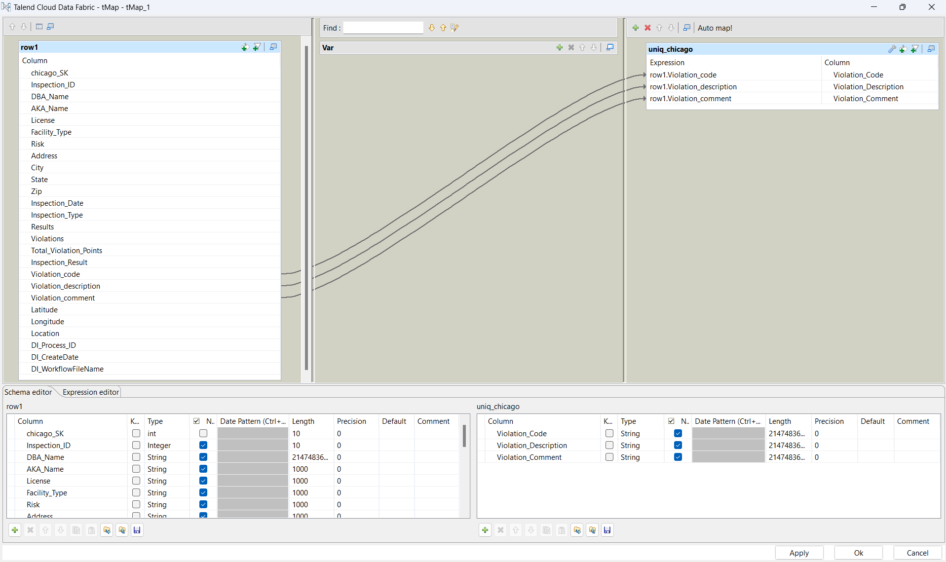

T-Map 2 of Dim_Violation



T-Map 3 of Dim_Violation

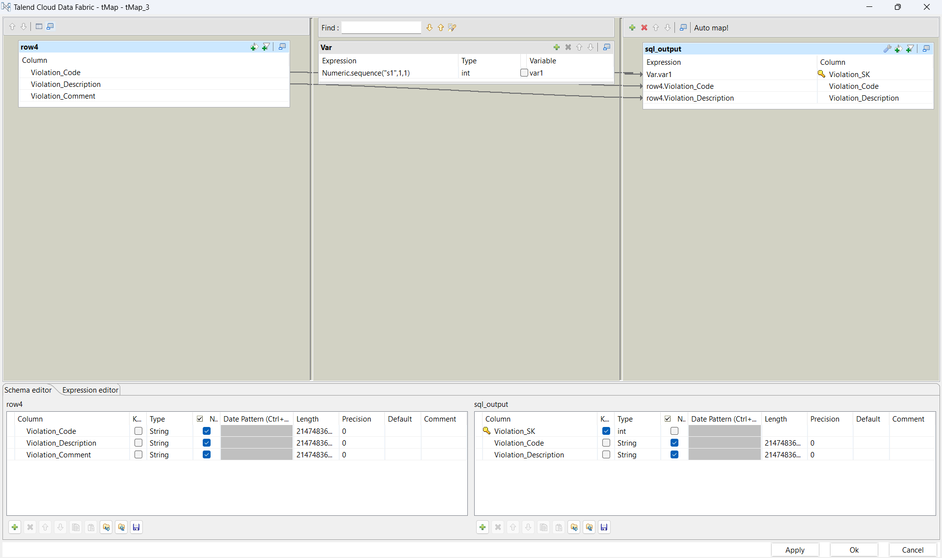

T-UniqRow of Dim_Violation

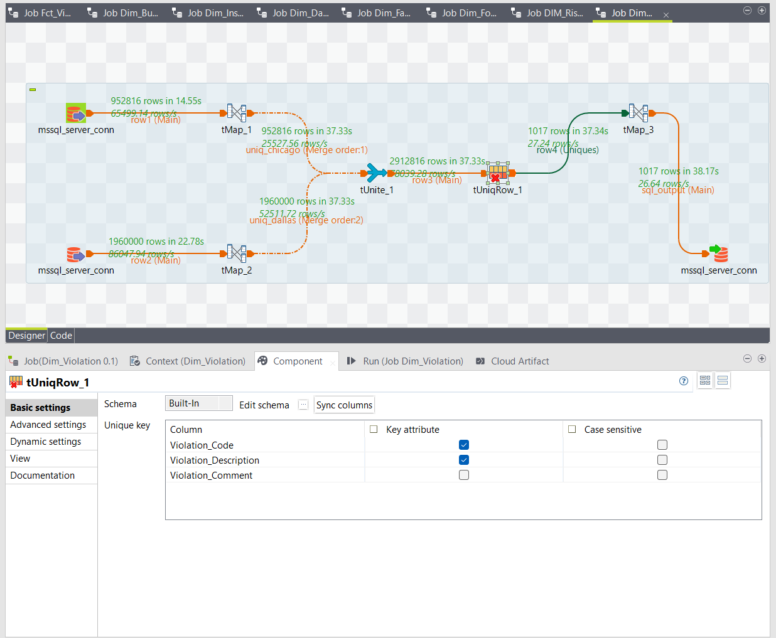

SQL Output:

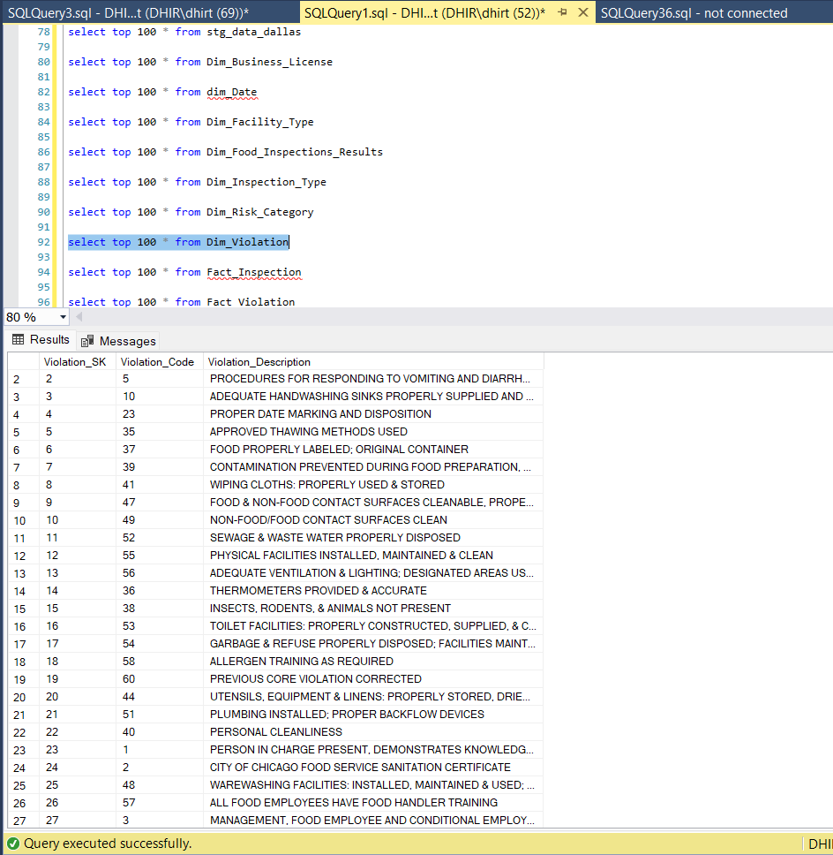

1. **Fact_Inspection**

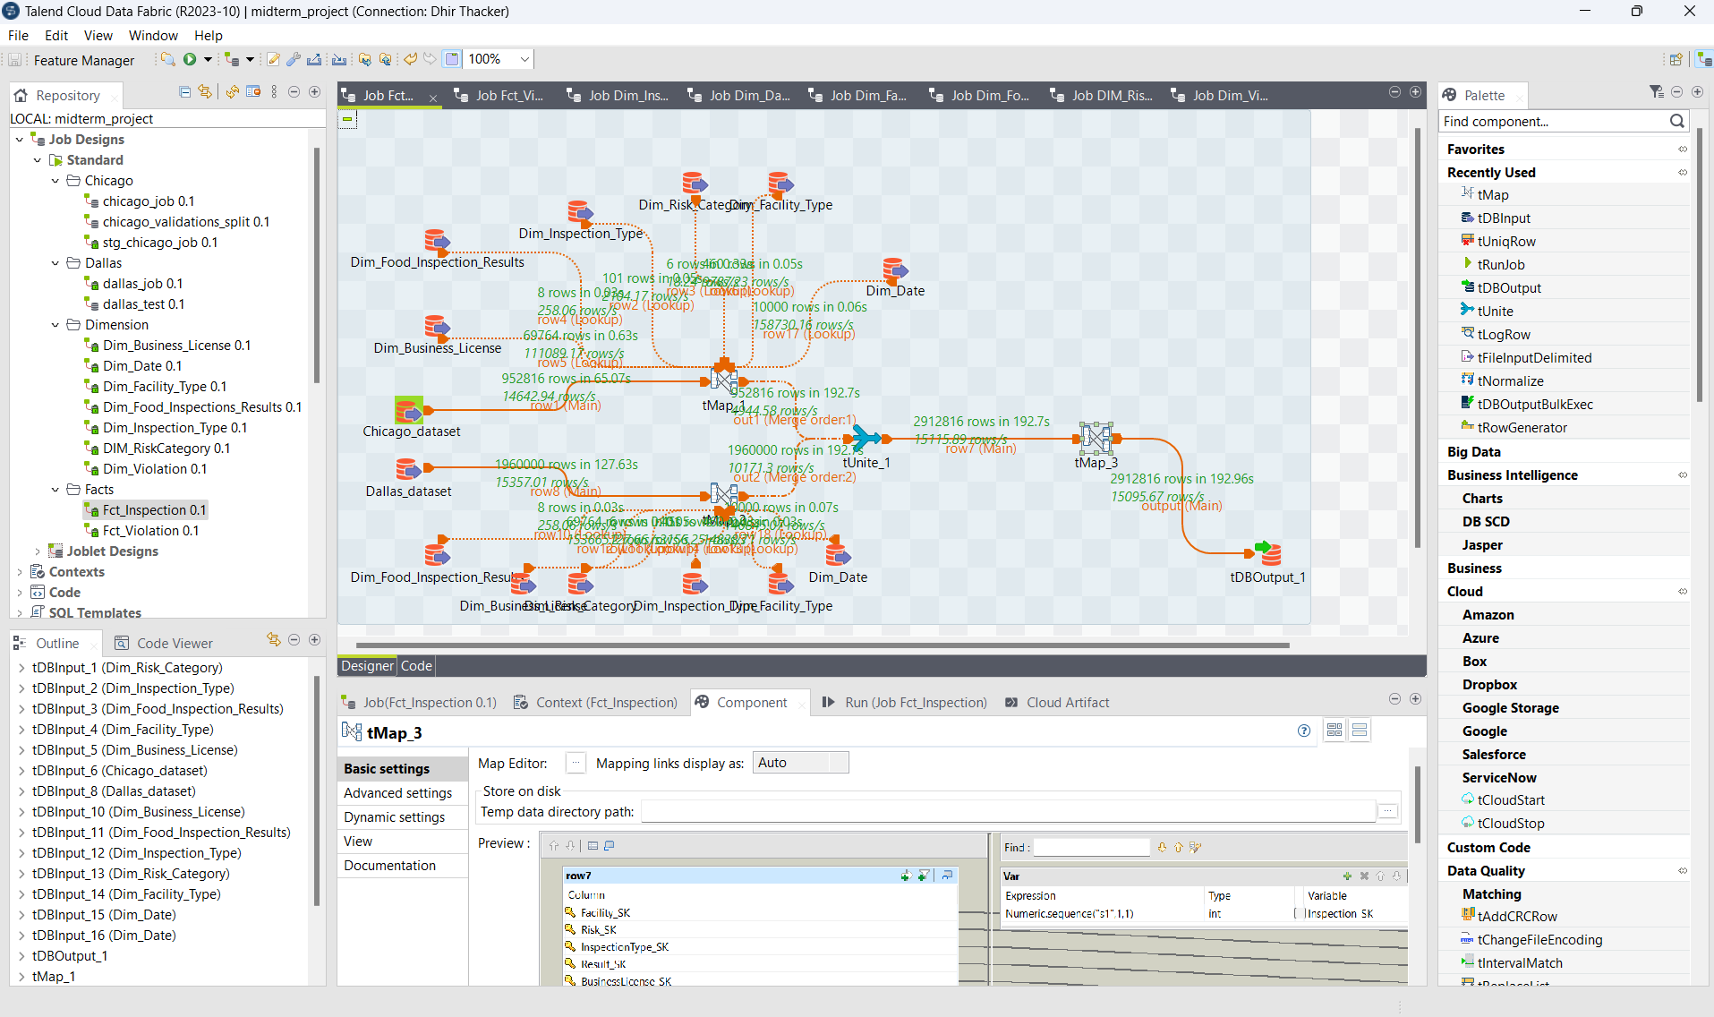

T-Map 1 of Fact_Inspection

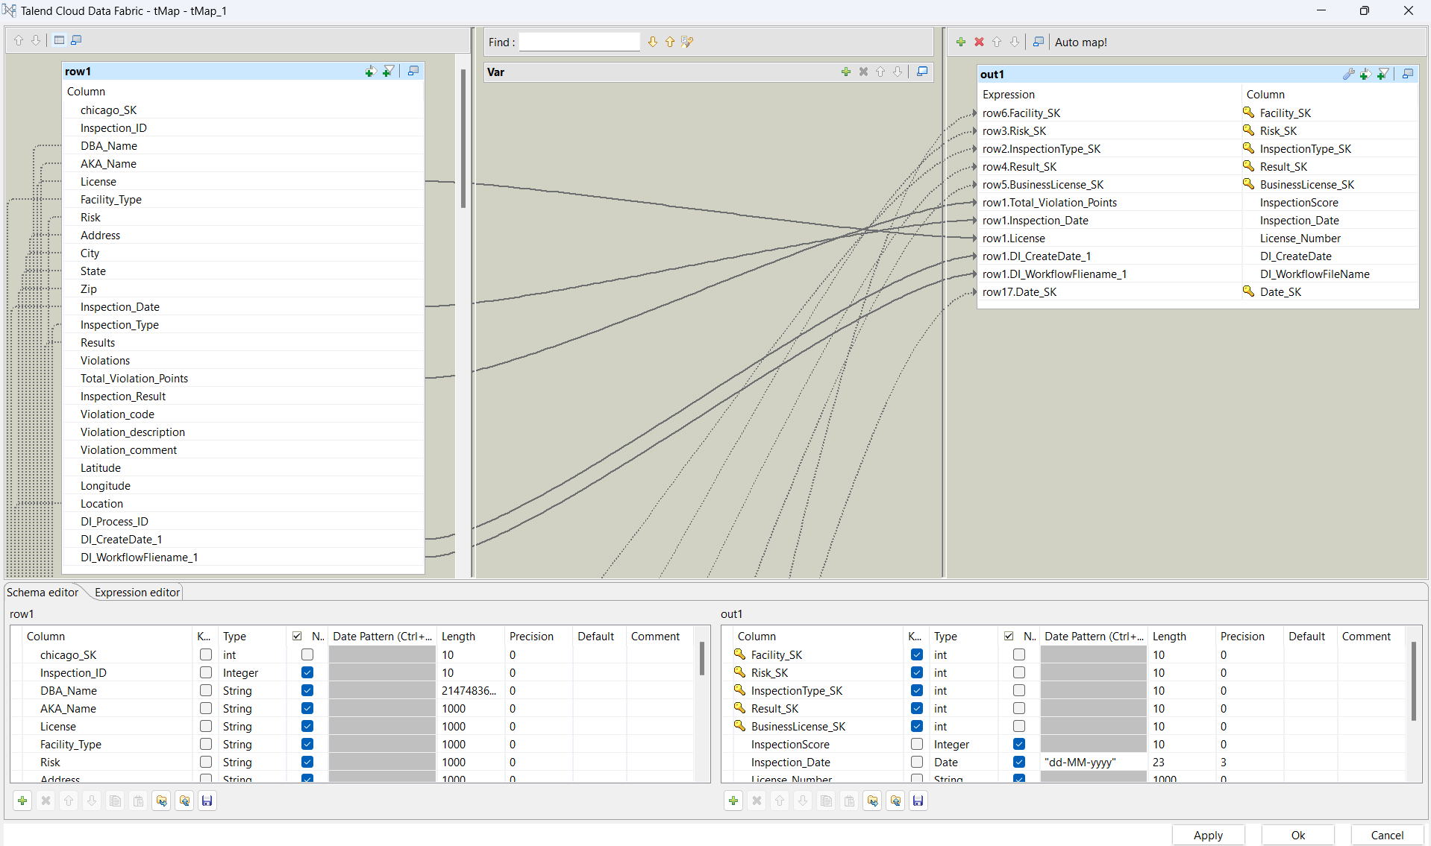

T-Map 2 of Fact_Inspection

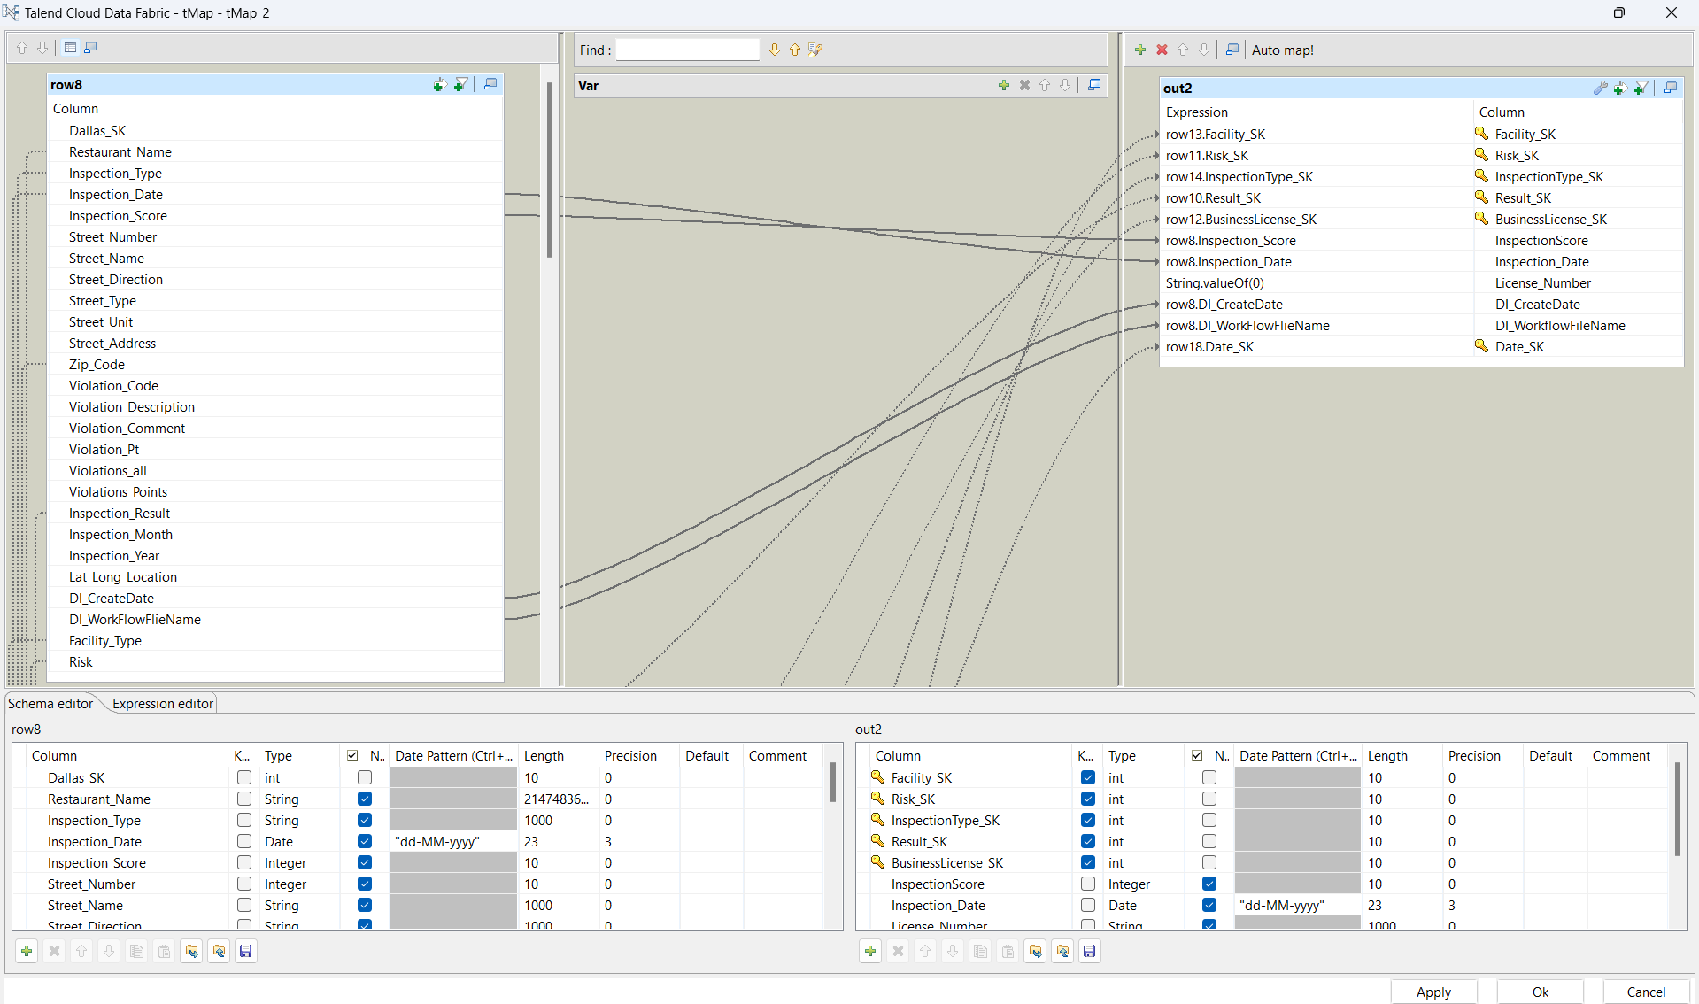

T-Map 3 of Fact_Inspection

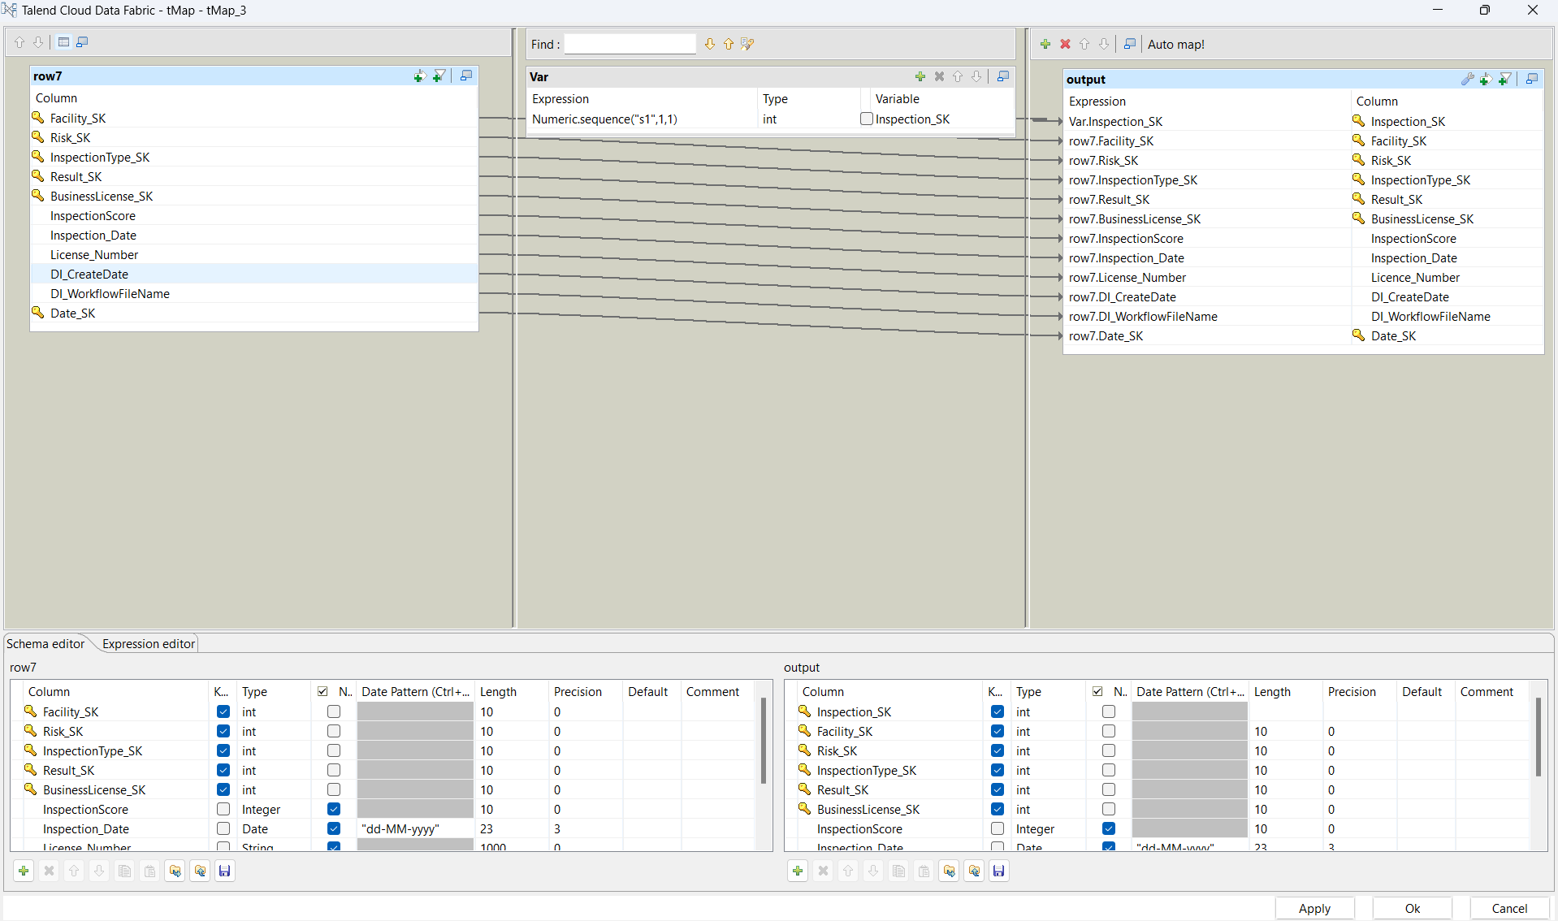

SQL Output:

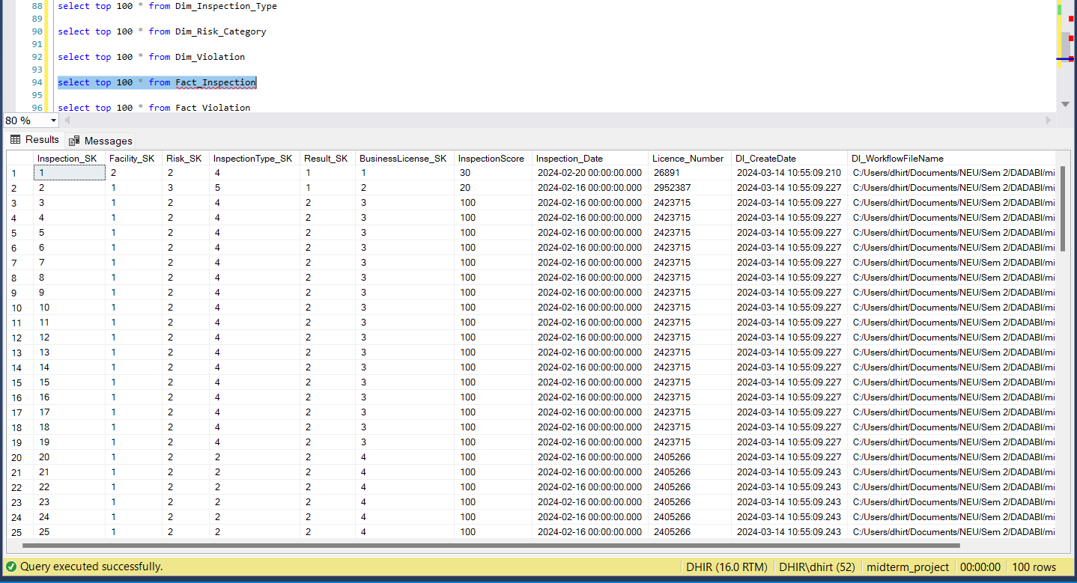

1. **Fact_Violation**

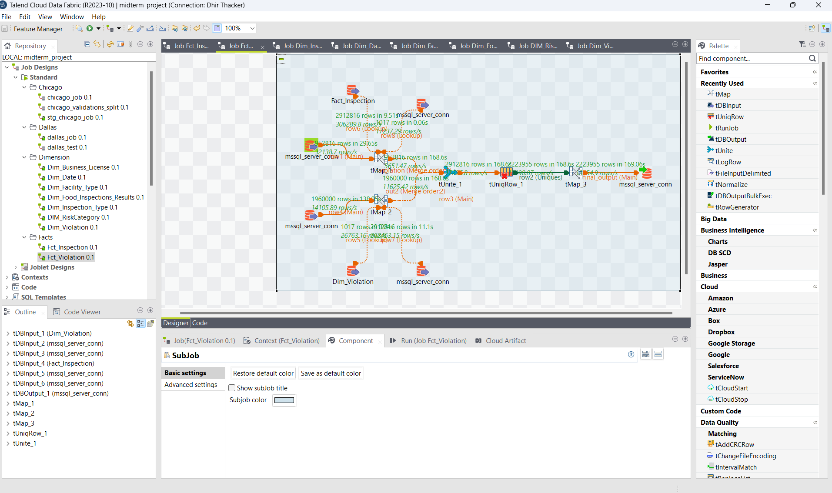

T-Map 1 of Fact_Violation

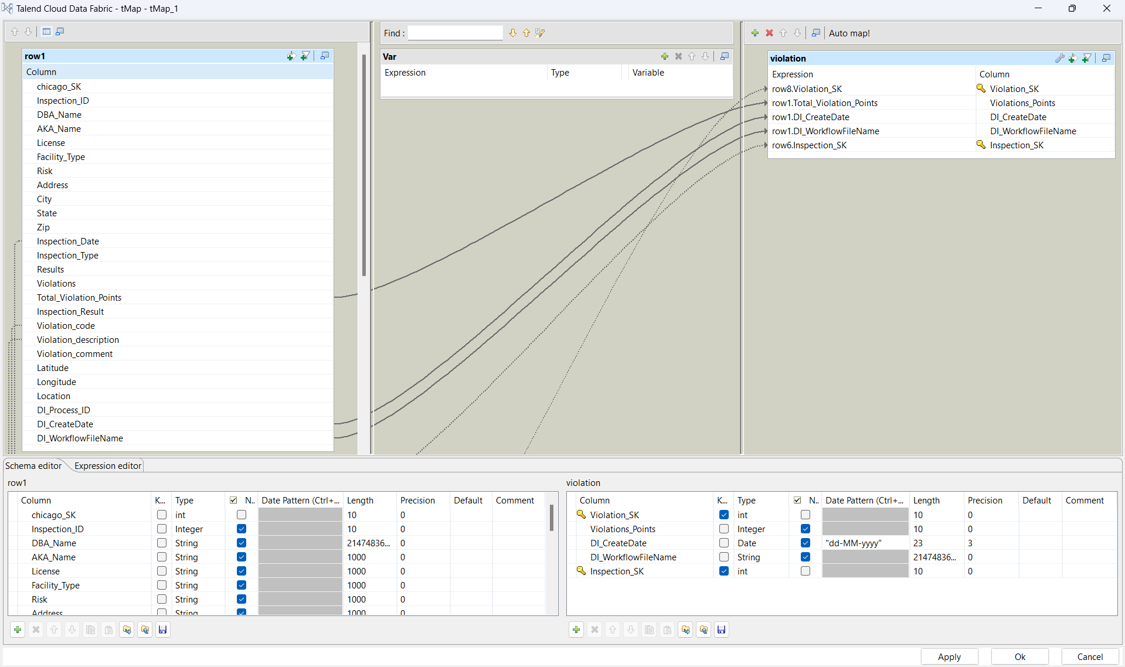

T-Map 2 of Fact_Violation

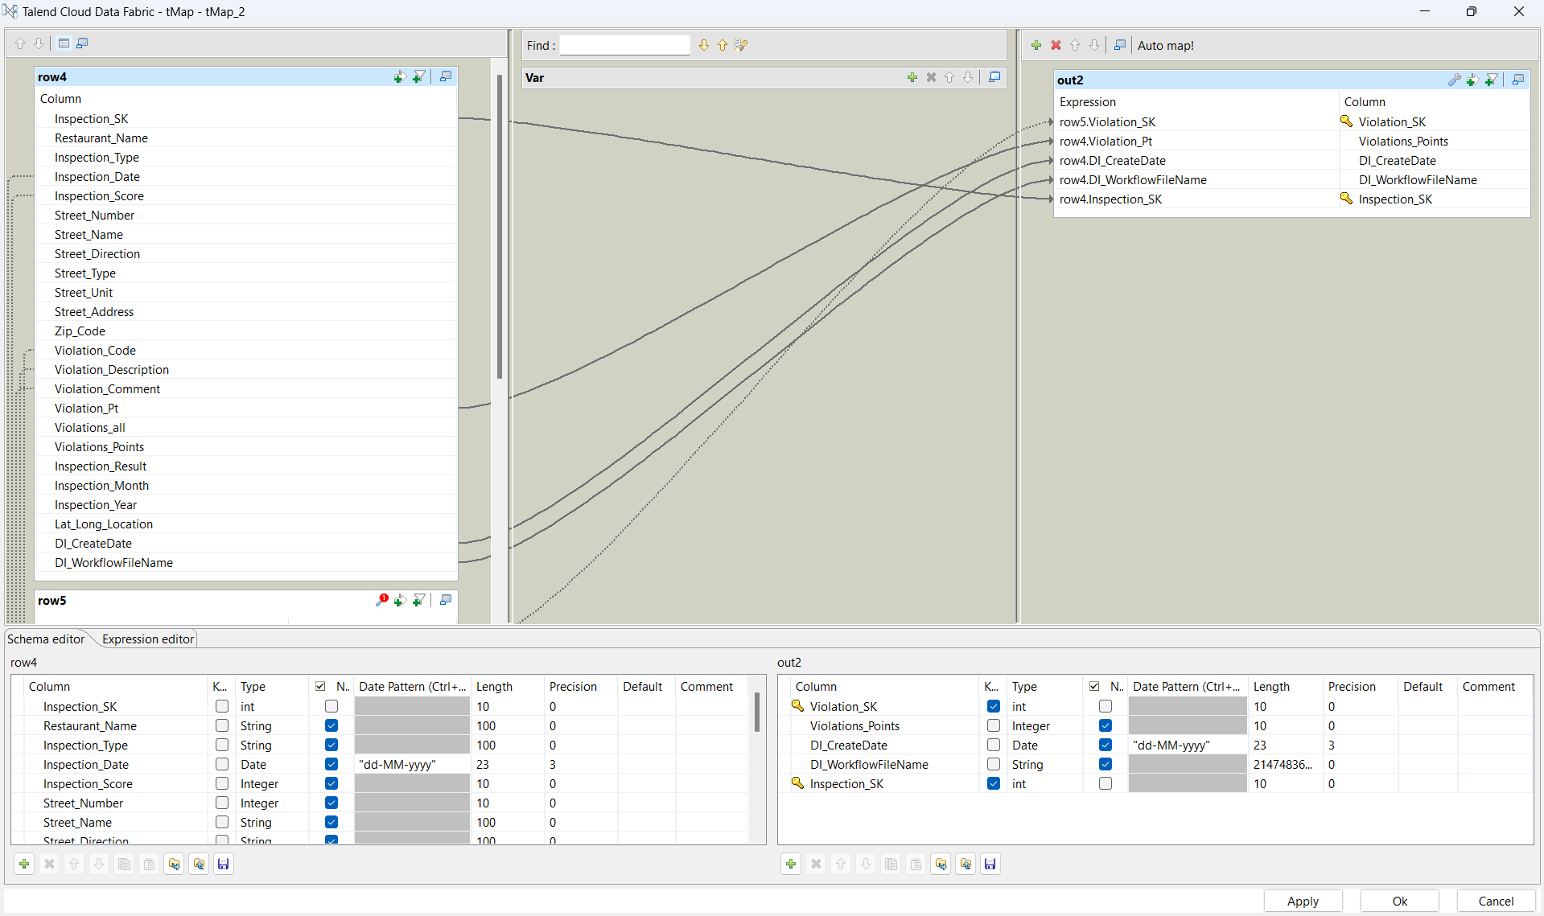

T-Map 3 of Fact_Violation

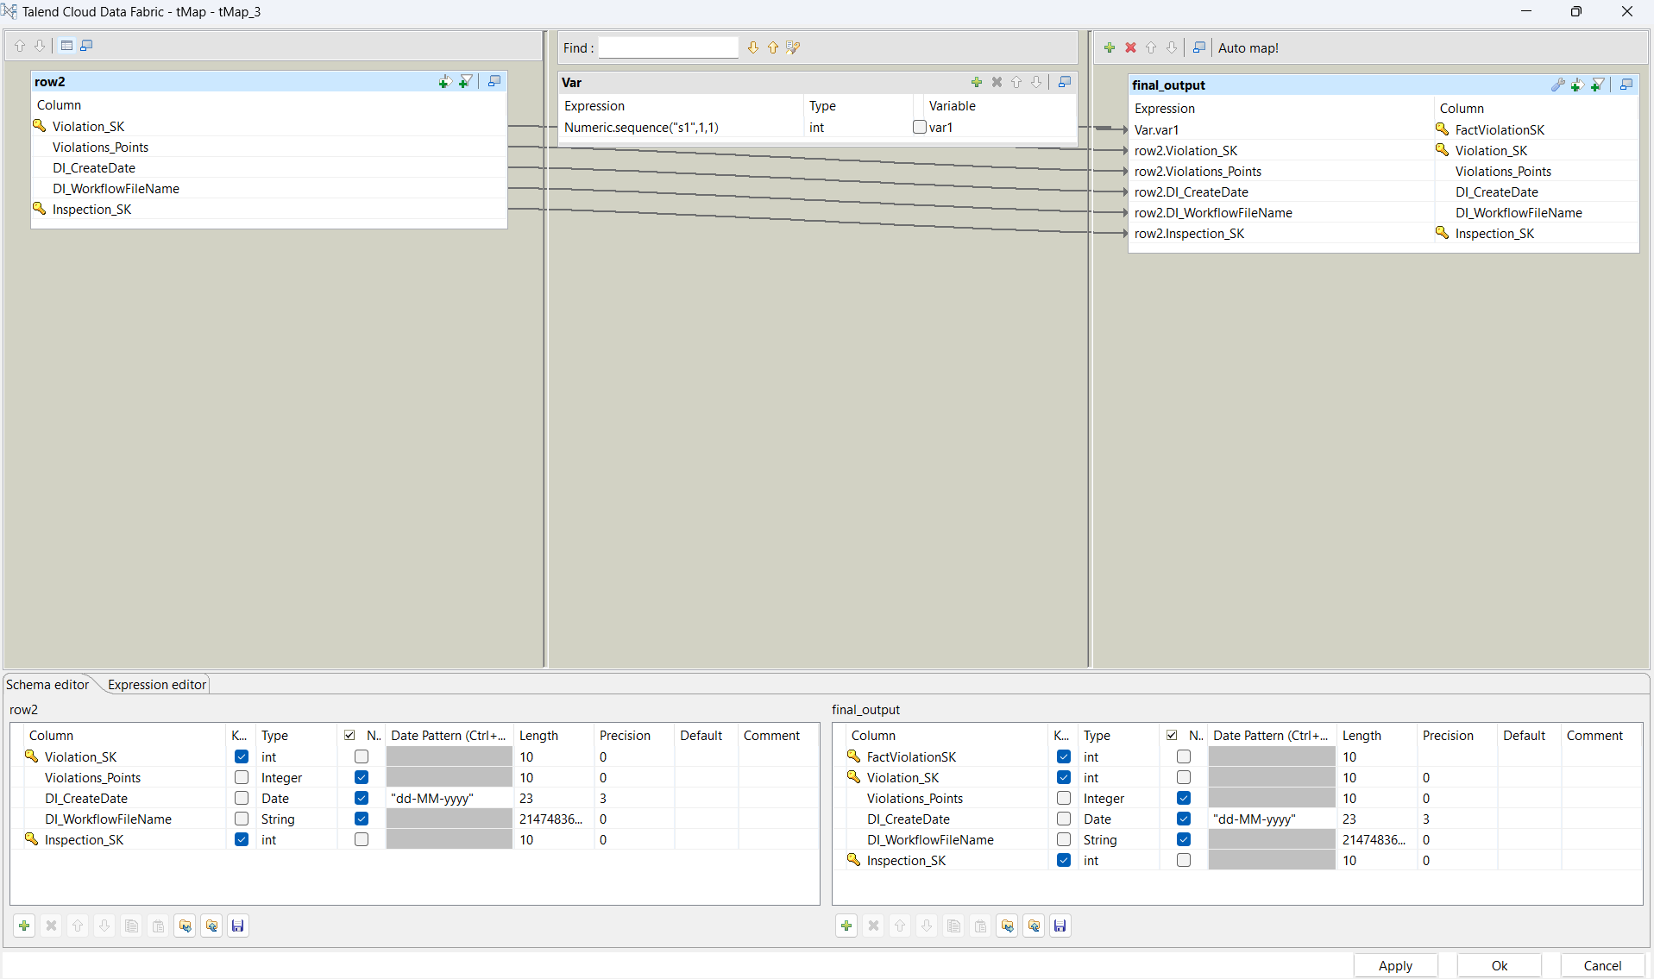

T-UniqRow of Fact_Violation

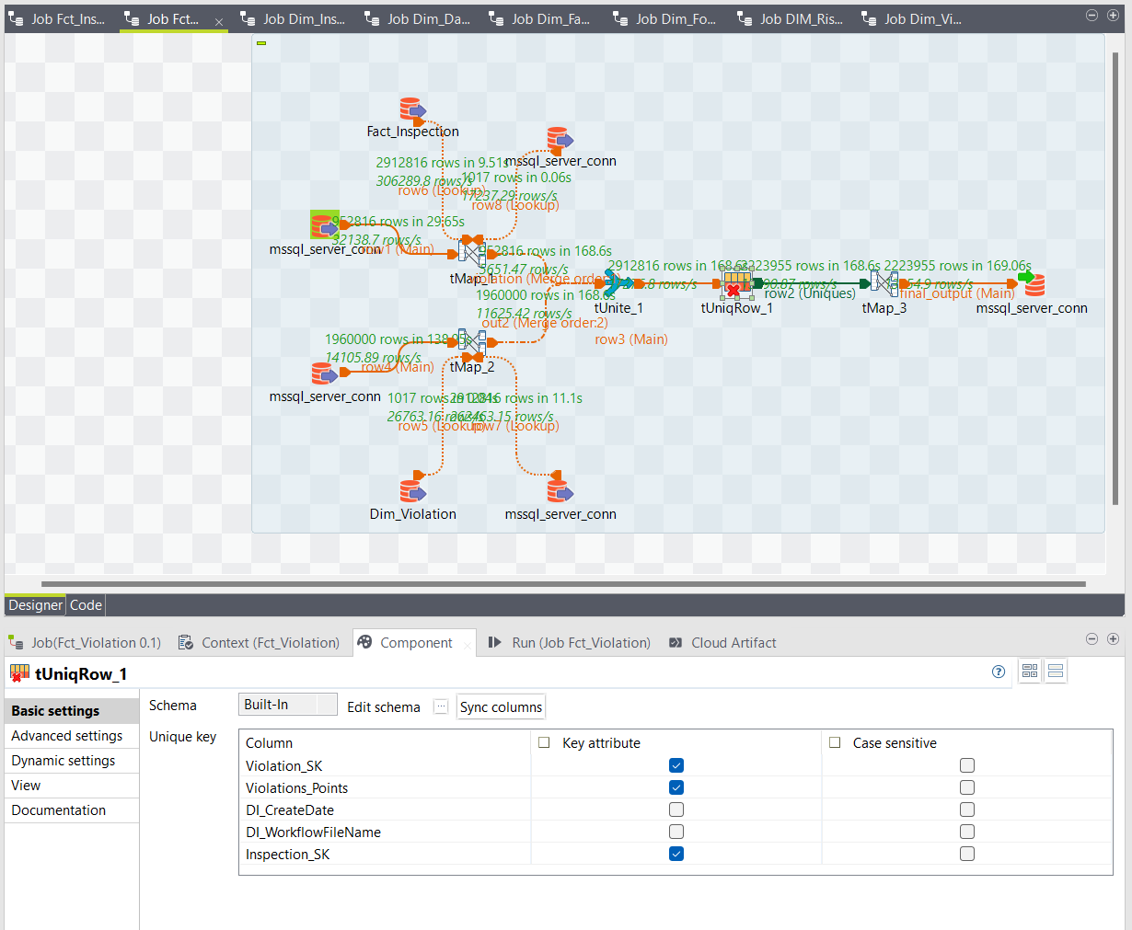

SQL Output:

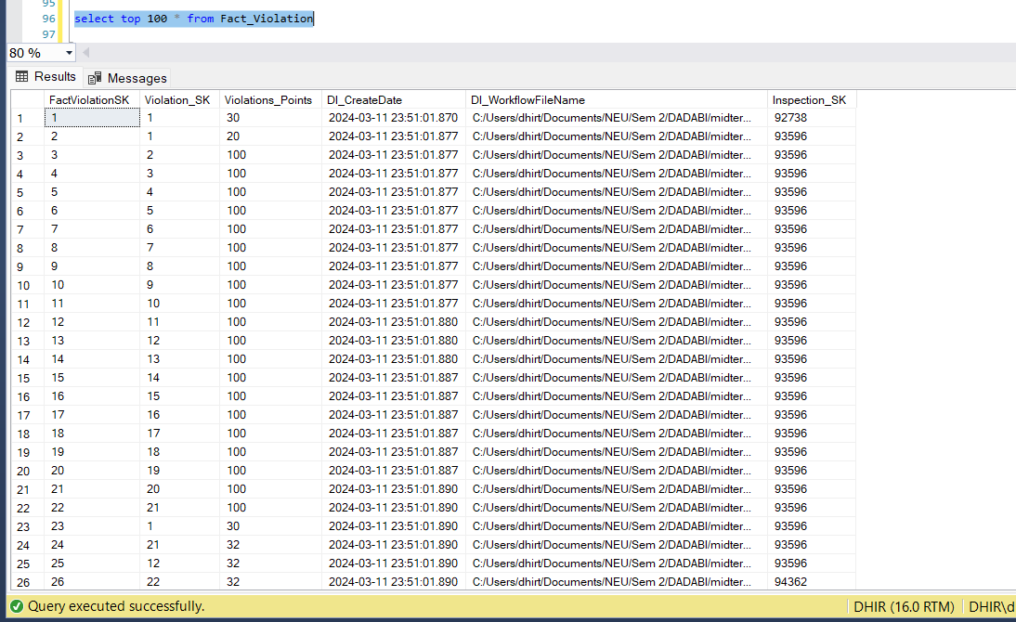

**DELIVERABLES – PART 4:**

**STEP 1:** **CREATE VISUALIZATION DASHBOARDS**

Created visualization Dashboards using both PowerBI and Tableau

PowerBI:

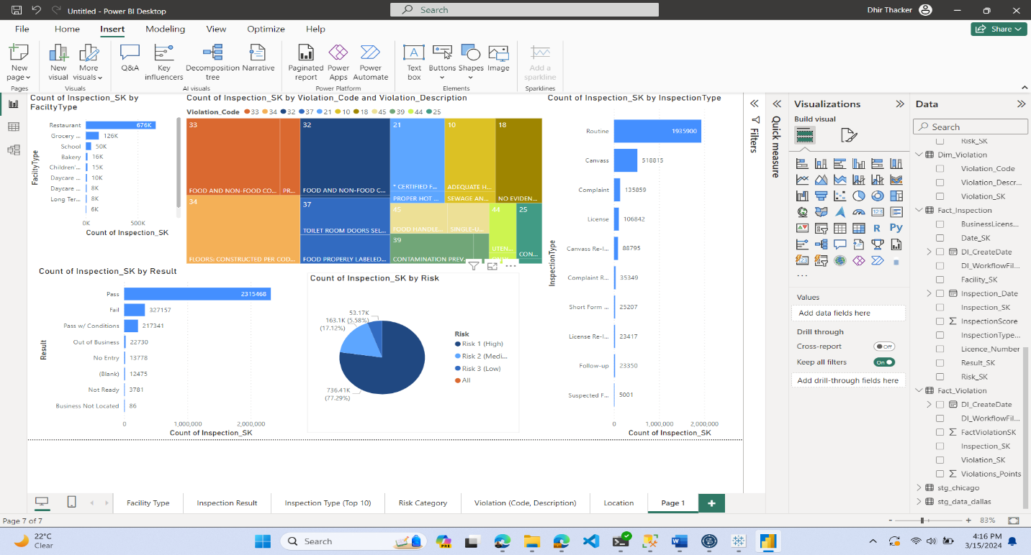

Tableau:

